

COLLABORATION THAT FUELS

GROWTH AND INNOVATION

2025 Annual Report



2025 HIGHLIGHTS

Driving Growth and Innovation Through Collaboration

DMD Top-Line Study Results

We were excited to share positive top-line results from our FIGHT DMD clinical trial. The study evaluated ifetroban, a novel oral therapy for Duchenne muscular dystrophy (DMD) heart disease – the leading cause of death in DMD patients. These findings mark a breakthrough for these patients, as it’s the first successful Phase II study specifically designed to target the cardiac complications of their condition.

New Study Finds Caldolor®

Safe And Effective for Older Adults

We announced publication of a new Caldolor study in Clinical Therapeutics, demonstrating the product’s safety and efficacy for managing post-operative pain in patients 60 years of age and older. The results mark an important advancement in pain management for older individuals, as it’s the first study specifically evaluating injectable ibuprofen in this vulnerable population.

International Progress

Our potent antibiotic Vibativ® received approval from the regulatory authorities in China. That milestone provides us with access to the world’s second-largest pharmaceutical market.

Vibativ was launched in Saudi Arabia in 2025, resulting in the first shipments and initial patients receiving treatment with this potentially life-saving therapy.

Additionally, our ibuprofen injection product received regulatory approval in Mexico in preparation for the launch of the product in that country.


To Our Shareholders, Employees & Partners:

2025 was an outstanding year for Cumberland!

We announced breakthrough clinical study data, reported a strong financial performance, expanded our global reach and added to our commercial portfolio – highlighting a year of consistent progress for our company.

Most importantly, we delivered these results while remaining focused on our mission of delivering unique products to improve the quality of patient care.

Our portfolio of FDA-approved brands generated significant revenue growth in 2025, providing

a turnaround in our profitability and significant cash flow from operations. We also strengthened our balance sheet by increasing assets, growing shareholder equity and reducing the debt on our line of credit.

During the year, we also continued to build our portfolio of FDA-approved branded pharmaceuticals. We added Talicia®, expanding our presence in gastrointestinal care with a leading treatment

for stomach infections associated with H. py ori infection. Talicia complements our existing brands and aligns with our strategy of acquiring the rights to differentiated products with established clinical value and long-term growth potential.

Our development pipeline continued to advance in

2025, highlighted by the release of breakthrough

data from our Duchenne muscular dystrophy (DMD)

clinical program. We have made meaningful progress

in our ongoing efforts with the FDA regarding our

DMD program, resulting in Orph n Dr g, R re

Pedi tric Dise se and then F st Tr ck designations.

These clinical efforts reinforce our commitment to developing medicines for the future through new therapies designed for patients with serious and underserved medical needs.


The accomplishments of 2025 reflect the dedication and expertise of our team.

As a result, Cumberland is well positioned with a stronger financial foundation, an expanding global footprint, a growing portfolio and a promising pipeline. We look forward to building on this momentum.

All the best,

A.J. Kazimi

Chairman and Chief Executive Officer

2025 Annual Report 1

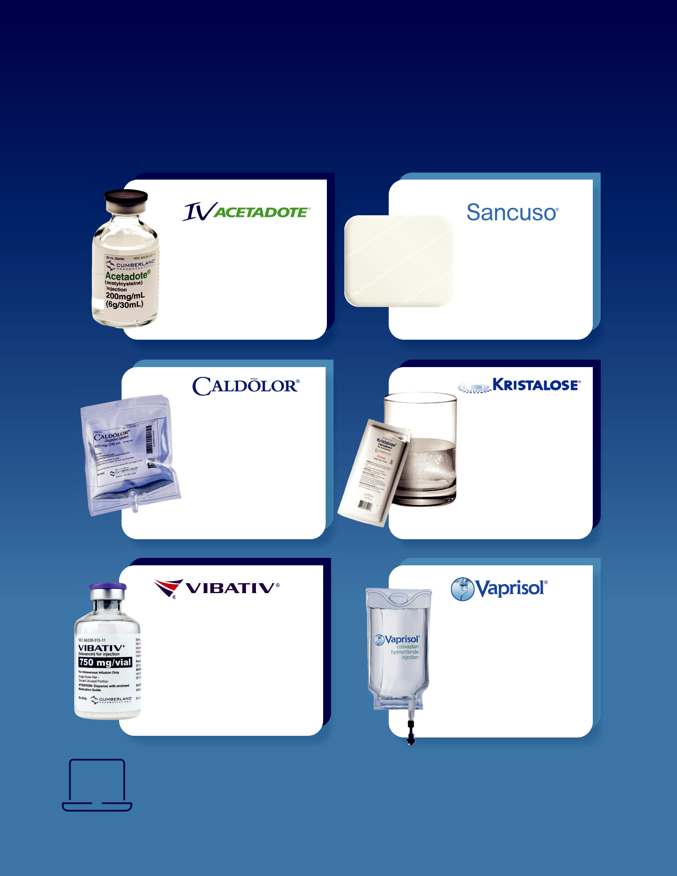
Products to enhance
patients’ lives.

(acetylcysteine) (granisetron)

An injection used for the An innovative

treatment of acetaminophen prescription patch

poisoning, which is the designed to prevent

leading cause of drug toxicity nausea and vomiting in

in the U.S. patients receiving certain

types of chemotherapy treatment

(ibuprofen)

An injectable ibuprofen formulation that reduces pain, fever and inflammation for patients, including those undergoing surgeries

(telavancin)

A potent antibiotic delivered through injection for the treatment of certain serious bacterial infections, including hospital-acquired and ventilator-associated bacterial pneumonia, as well
as complicated skin and skin structure infections

(lactulose)

The only branded prescription laxative that combines the established safety and efficacy of lactulose, with the convenience and portability of
- crystalline, pre-measured dose

(conivaptan)

The only intravenously administered vasopressin receptor antagonist, which is used to raise serum sodium levels in hospitalized patients with euvolemic and hypervolemic hyponatremia (salt imbalances)

For more information on Cumberland’s approved products, including safety and full prescribing information, please visit links to the individual product websites, which can be found on our corporate website, www.cumberlandpharma.com.

Introducing


Talicia® (omepr zo e, moxici in nd rif b tin) is an FDA-approved oral capsule for the treatment of He icob cter py ori (H. py ori) infection, a bacterial infection of the stomach and leading risk factor for gastric cancer. Talicia is listed as a first-line treatment option for the treatment of H. py ori and features three key advantages:

high eradication rates of >90% in confirmed adherent patients,

the simplicity of an all-in-one capsule and

low resistance to its two antibiotics - amoxicillin and rifabutin.

Talicia is distributed by Cumberland under a co-commercialization agreement with Talicia Holdings, Inc.
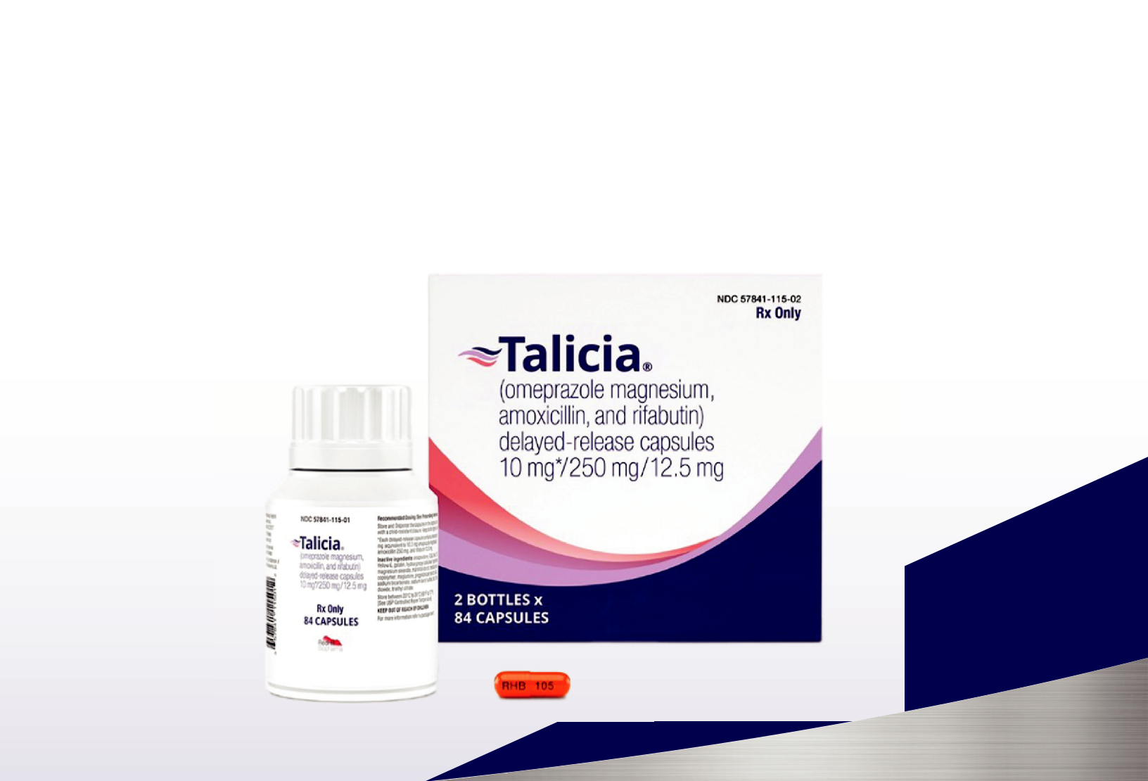

For more information, including full prescribing and important safety data, visit www.talicia.com.

2025 Annual Report 3


Expanded Market Access

New arrangements with leading healthcare organizations are critical in our efforts to expand the number of patients benefiting from our products. Through these collaborations, we can help ensure that providers nationwide can more easily access our FDA-approved brands to support both inpatient and outpatient care.

Vibativ® 4-Vial Starter Pak Added

to Vizient Purchasing Agreement

We announced the availability of Vibativ in its newly introduced 4-Vial Starter Pak through a supply arrangement with Vizient, Inc., significantly expanding access to this therapy across the U.S. Vizient is the nation’s largest provider-driven healthcare performance improvement company, serving more than 65% of the U.S. acute care providers, including 97% of the country’s academic medical centers.

Vibativ® Now Available for Premier Providers

Vibativ was featured in a new national group purchasing agreement with Premier, Inc., further broadening access to the product across healthcare systems. Under this agreement, Premier members can purchase Vibativ in both the traditional 12-vial carton and the new 4-Vial Starter Pak. Premier is a leading healthcare improvement company, uniting an alliance of approximately 4,350 U.S. hospitals and 325,000 other providers and organizations.

- Cumberland Pharmaceuticals


Building a Global Network to Support Patient Care

We continue to deliver our medicines to patients worldwide by working with a network of established international companies.

Our partners are responsible for registering, distributing and marketing select Cumberland products in their respective countries. We support those efforts through regulatory collaboration and product supply to ensure our therapies are accessible to patients internationally.

Australia Russia

Phebra Pty Ltd. is our commercial partner for R-Pharm JSC is our commercial partner

Acetadote® and Caldolor.® for Vibativ.

China

WinHealth Pharma Group is our commercial partner for Caldolor and Acetadote, and an investor in Cumberland Emerging Technologies.

SciClone Pharmaceuticals is our commercial partner for Vibativ.®
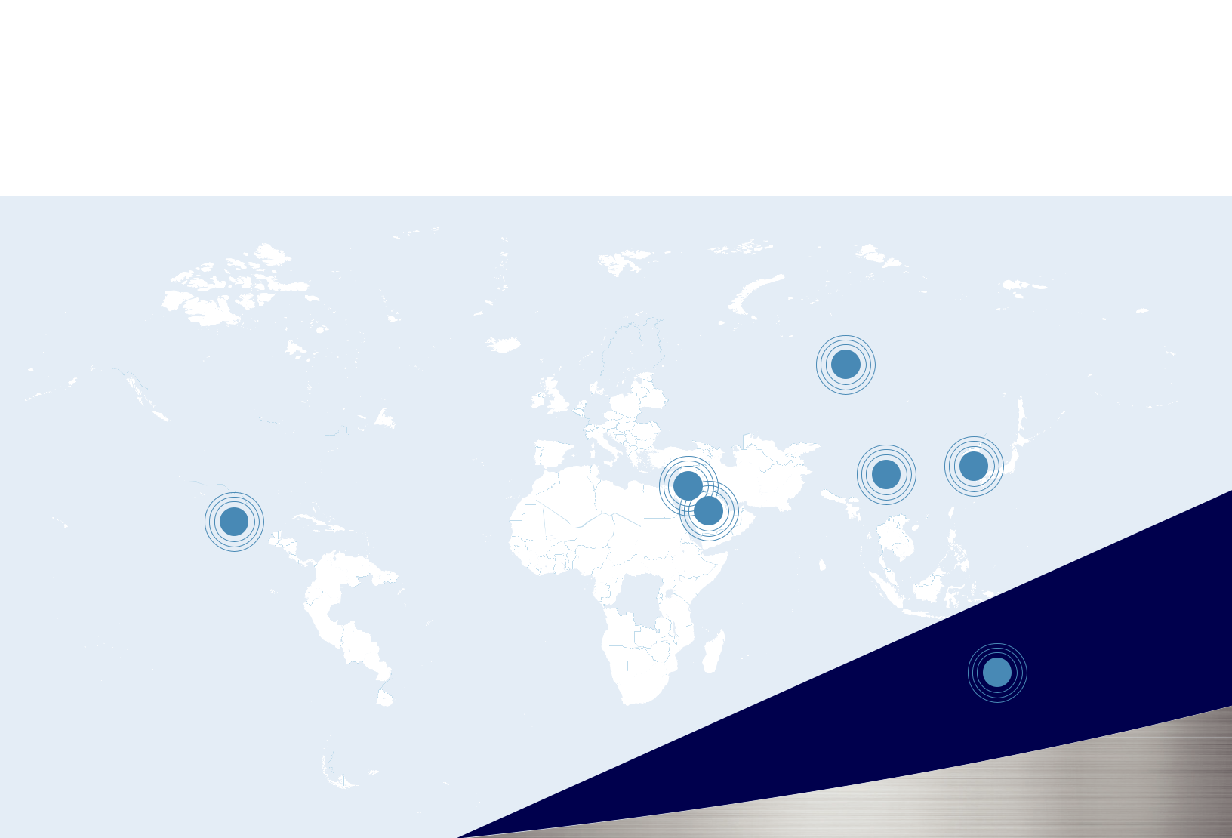
Mexico

PiSA Pharmaceutical is our commercial partner for Caldolor.

Saudi Arabia and Jordan

Tabuk Pharmaceutical Manufacturing Company is our commercial partner for Vibativ.

South Korea

D.B. Pharm Korea Co. Ltd. is our commercial partner for Caldolor, Vibativ and Vaprisol.®

2025 Annual Report 5



Intravenous Ibuprofen

Trusted Relief Across
Every Stage of Life



Non-

Opioid

Caldolor for All

Newborns Children Adults

Proven Pain Management Solution for Patients of All Ages

Caldolor may now be administered in adults, children and infant patients. As the first FDA-approved IV ibuprofen, Caldolor delivers reliable, non-opioid pain and fever management across the continuum of care. Backed by clinical experience and a strong safety profile, Caldolor provides healthcare professionals with a trusted option to help reduce pain, lower fever and support enhanced recovery in a wide range of patient populations.


A Pipeline to Address Unmet Medical Needs

In addition to our portfolio of FDA-approved brands, we continue to advance our pipeline of new product candidates. We are developing our first new chemical entity, ifetroban, which has now been dosed in nearly 1,400 subjects – resulting in an outstanding safety database.

Our development programs include:

Preclinical IND Phase I Phase II Phase III NDA

Dyscorban®
An or c ps e to tre t c rdiomyop thy ssoci ted
with D chenne m sc r dystrophy, f t , genetic
ne rom sc r dise se

Following our announcement of favorable top-line results from our Phase II study, we completed the data analysis and submitted the study report to the FDA. We subsequently held two FDA meetings to present the study findings and discuss the product’s path to approval.

Vasculan®
An or c ps e to tre t systemic sc erosis (SSc), so known s sc eroderm , r re, debi it ting toimm ne disorder th t res ts in thickening of the skin nd intern org ns

We completed patient enrollment in the study during 2025. We then monitored the clinical sites and began analysis of the study data in preparation for the announcement of top-line results.

Fibroban®
We re deve oping n or c ps e to tre t idiop thic
p mon ry fibrosis (IPF), the most common form of
progressive fibrosing interstiti ng dise se

Patient enrollment is well underway in medical
centers across the U.S. An interim safety analysis
was completed with favorable results, and an interim
efficacy analysis is planned.

- Cumberland Pharmaceuticals



Cumberland Emerging Technologies

Advancing Biomedical Innovation Through Collaboration

The U.S. remains a global leader in biomedical innovation, driving the discovery and development of new medicines. To support our long-term product pipeline and strengthen the regional life sciences ecosystem, we established Cumberland Emerging Technologies (CET).

A majority-owned subsidiary of Cumberland Pharmaceuticals, CET is focused on advancing promising biomedical innovations toward commercialization by supporting inventor-scientists and emerging life science companies.

CET represents a collaborative initiative between Cumberland Pharmaceuticals, Vanderbilt University, WinHealth Pharmaceuticals, our international partners and Launch Tennessee, a state-backed network supporting entrepreneurship. Through these relationships, we work closely with academic research groups, providing expertise in intellectual property, regulatory pathways, manufacturing and marketing to accelerate the development of promising biomedical products. We also partner with major academic research institutions to identify and develop early-stage biopharmaceutical innovations that can enhance patient care.

Nashville Life Sciences Center

Supporting Growth Within the Regional Life Sciences Ecosystem

CET established and manages the Nashville Life Sciences Center (LSC), which houses Cumberland’s formulation and testing laboratories, while also serving as an incubator for Middle Tennessee’s emerging biopharmaceutical industry.

The facility offers flexible wet lab, dry lab and office space, with opportunities for custom build-outs, as well as shared laboratory space and essential equipment. This model helps tenants reduce overhead, maximize resources and focus capital on advancing their scientific and commercial objectives.

With a dynamic group of current tenants and a growing base of successful graduates, the Life Sciences Center continues to play a meaningful role in building a sustainable and competitive life sciences ecosystem in Middle Tennessee by supporting innovation, collaboration and economic growth.

2025 Annual Report 9

Sustainability 2025 at a Glance
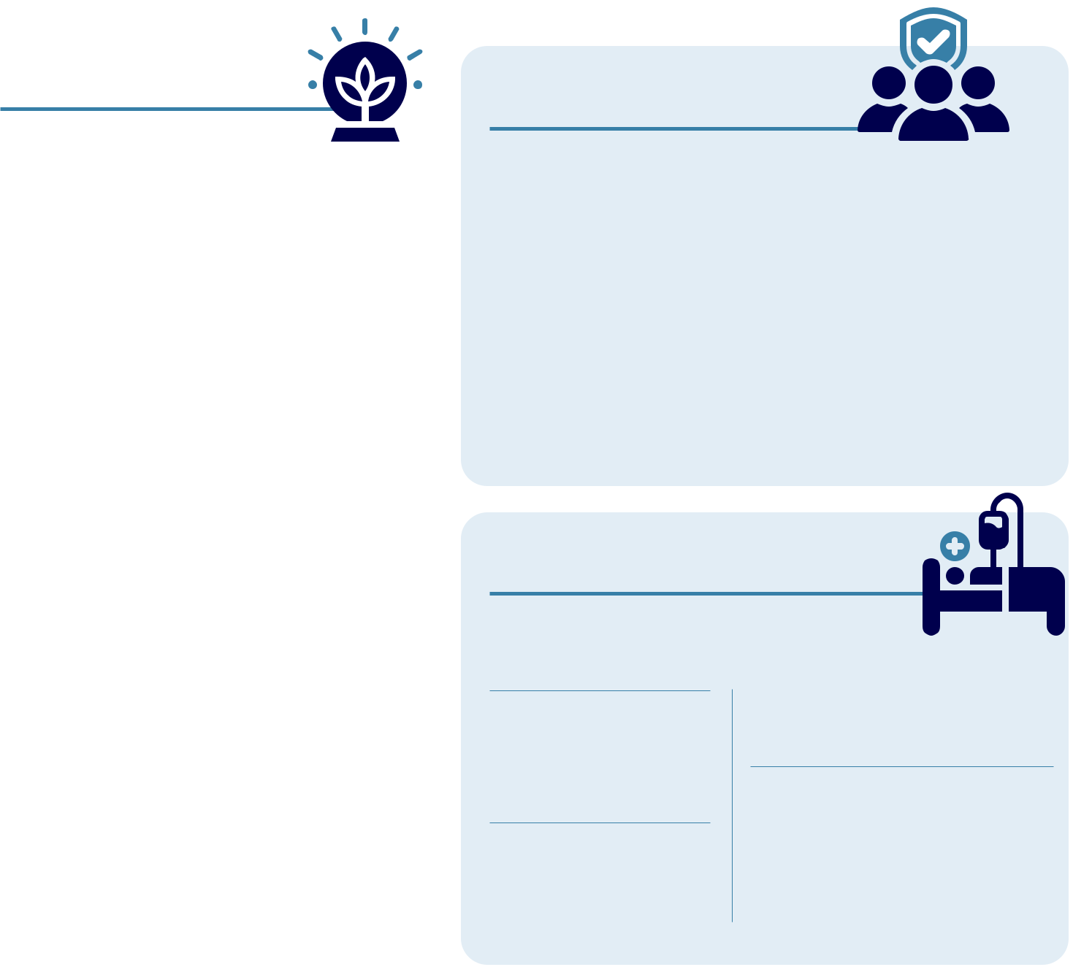

ENVIRONMENT

Supplies |  | Waste
Contracted with third- |  | Ensured strict
party companies for the |  | guidelines and
manufacturing, packaging |  | processes for the safe,
and warehousing of our |  | permanent disposal
products |  | of all unused products

Returns

Received and disposed of 5,515 pounds of damaged and expired products


SOCIAL
Community Involvement

Cumberland Pharma Foundation

Contributed to Belmont University Health Care Hall of Fame, Denver Health, Mary Parish Center, Easter Seals Nashvillian of the Year, FIGHT DMD Golf Tournament, World Bible School, AACA Museum Endowment Fund, University of Mississippi CPI Researcher of the Year and

SOCIAL
Employees

Male – 50% |  |  |  | Turnover – 3% for corporate team
Female – 50% |  |  |  |  |  | 4% for sales team
 |  |  |  | Additions – 15%
Minorities – 30%
 |  |  |  |  |  | Career Development Program
Ages |  |  |  | Available to all corporate employees
8% below 30
 |  |  |  | Cumberland Academy
30% between 30 & 50
 |  |  |  | Provides industry training for
62% over 50
 |  |  |  | corporate employees
Tenures |  |  |  |  |  | Training |  | Work-related
38% @ 5 or more years |  |  |  |  |  | Average $600 |  | injuries
22% @ 10 or more years |  |  |  |  |  | per full-time |  | None
20% @ 15 or more years |  |  |  |  |  | employee

SOCIAL
Patients
Provided 4.9million doses

of our products to patients

the Duchenne Program at UMass Chan Medical School

Associations

- Nashville Health Care Council

- Life Science Tennessee

- Nashville Chamber of Commerce

Life Sciences Center

Sponsoring an incubator to help build the biomedical industry in our area


Drug Safety Results

- No products listed in the FDA’ s MedWatch Safety Alerts

- No products recalled

Patient Affordability

We cover up to 80% of patient Rx costs through coupons for our GI and oncology support brands


Clinical Trials Safety

No trials terminated due to failure to practice good clinical standards

Advocacy Groups Supported

- Muscular Dystrophy Association

- Parent Project Muscular Dystrophy


GOVERNANCE
Board

Independent – 6 of 7 Tenure – Average 11.8 years Age – Average 68 years Male/ Female – 6/1 Turnover – None

Board
Meeting |  | GOVERNANCE
Attendance |  | GOVERNANCE
100% |  | Government Relations
Standing |  | Cumberland Health
Committee |  | & Wellness PAC
Attendance |  | Supports candidates,
100% |  | elected officials and
100% |  | relevant legislation

GOVERNANCE
Compliance

Code of Conduct
Establishes guidelines for all Board members and employees

Ethical Marketing |  | Health Care
No government |  | Professionals
judgments, decrees |  | All reports regarding
or fines |  | relations filed on time


Selected Financial Data

Our strategy involves maximizing the potential of our existing brands while continuing to build a portfolio of unique, differentiated products. The result of these efforts has strengthened our market presence and diversified our revenue stream in 2025.

(dollars in thousands except per share data) | 2021 |  |  | 2022 |  | 2023 |  | 2024 |  |  | 2025
Net Revenues | $35,985 |  |  | $42,011 |  | $39,553 |  | $37,868 |  |  | $44,521
Less Total Expenses | 39,493 |  |  | 47,661 |  | 45,884 |  | 44,312 |  |  | 47,386
Net Income (Loss)
Net Income (Loss) | (3,508) |  |  | (5,650) |  | (6,331) |  | (6,444) |  |  | (2,865)
Cash Flow from Operating Activities | 6,342 |  |  | 8,453 |  | 6,094 |  | (612) |  |  | 4,932
Total Assets | 84,460 |  |  | 92,925 |  | 81,776 |  | 75,583 |  |  | 76,824
Total Liabilities | 41,858 |  |  | 56,951 |  | 52,516 |  | 53,037 |  |  | 52,280
Total Equity | 42,602 |  |  | 35,974 |  | 29,260 |  | 22,546 |  |  | 24,544


Reconciliation of Net Income (Loss) Attributable to Common Shareholders to Adjusted Earnings and Adjusted Diluted Earnings Per Share (1) (Unaudited)

(dollars in thousands except per share data) | 2021 |  |  | 2022 |  |  | 2023 |  | 2024 |  |  | 2025
Net Income (Loss) from Continuing
Operations | ($5,597) |  |  | ($5,650) |  |  | ($6,331) |  | ($6,444) |  |  | ($2,865)
Adjustments to Net Income (Loss)
Income Tax Expense (Benefit) | 35 |  |  | 69 |  |  | 46 |  | (23) |  |  | 40
Depreciation and Amortization | 4,606 |  |  | 5,328 |  |  | 8,280 |  | 4,902 |  |  | 4,145
Share-Based Compensation | 742 |  |  | 447 |  |  | 365 |  | 302 |  |  | 408
Other Adjustments to Net Income (1) | (1,051) |  |  | 1,368 |  |  | - |  | - |  |  | -
Interest Income | (26) |  |  | (98) |  |  | (287) |  | (334) |  |  | (476)
Interest Expense |  | 98 |  |  | 586 |  | 668 |  |  | 606 |  | 496
Adjusted Earnings
Adjusted Earnings |  | ($1,193) |  |  | $2,050 |  | $2,741 |  |  | ($991) |  | $1,748
Adjusted Diluted Earnings per Share |  | ($0.08) |  |  | $0.14 |  | $0.20 |  |  | ($0.07) |  | $0.12
Diluted Weighted-Average Common
Shares Outstanding: | 14,905 |  |  | 14,809 |  |  | 14,526 |  | 14,060 |  |  | 15,145

(1) The supplemental financial measures are Non-GAAP as defined, the reconciliation of these supplemental measures is above.

2025 Annual Report 11



Board of Directors

A.J. Kazimi
Chairman

Chief Executive Officer

Cumberland Pharmaceuticals

Kenneth J. Krogulski
Lead Director

Managing Partner and Chief Investment Officer

Berkshire Asset Management

Dr. Gordon R. Bernard
Director

Professor of Medicine

Division of Pulmonary & Critical Care Medicine Vanderbilt University Medical Center

Caroline R. Young
Director

Vice President of Partnership Development

Frist Cressey Ventures

Former President

Nashville Health Care Council

James R. Jones
Director

Former Managing Partner

KPMG LLP-Nashville

Joseph C. Galante
Director

Former Chairman

Sony Music Nashville

Former President

RCA Records

Martin S. Brown
Director

Attorney of Counsel

Adams and Reese LLP

Former Board Director

Brown-Forman Corporation

- Cumberland Pharmaceuticals



Corporate Information

Stock Listing

Nasdaq Global Select

Market Ticker Symbol: CPIX

Annual Meeting

9:30 a.m. Central Time

Tuesday, April 21, 2026

Cumberland Headquarters

1600 West End Avenue, Suite 1300 Nashville, TN 37203

Independent Registered Public Accounting Firm

Carr, Riggs & Ingram, LLC 3011 Armory Drive, Suite 300 Nashville, TN 37204 (615) 665-1811

Transfer Agent and

Registrar

Continental Stock Transfer

& Trust Company

1 State Street, 30th Floor

New York, NY 10004

- 509-5586

- 509-4000 cstmail@continentalstock.com

Forward-Looking

Statements

This annual report includes forward-looking statements regarding expected future results of the Company. A variety of factors could cause actual results to differ materially from expected results. Please see the risk factors more fully described in our Annual Report on Form 10- K for the year ended December 31, 2025, which is filed with the U.S. Securities and Exchange Commission.

Company Headquarters

Cumberland Pharmaceuticals Inc. 1600 West End Avenue, Suite 1300 Nashville, TN 37203 Phone: (615) 255-0068 Toll Free: (877) 484-2700 Fax: (615) 255-0094

2025 Annual Report 13



NASHVILLE’S SPECIALTY

PHARMACEUTICAL COMPANY

