UNITED STATES

SECURITIES AND EXCHANGE COMMISSION

WASHINGTON, DC 20549

FORM 10-Q

(Mark One)
- QUARTERLY REPORT PURSUANT TO SECTION 13 OR 15(d) OF THE SECURITIES EXCHANGE ACT OF 1934

For the quarterly period ended June 30, 2020

OR
- TRANSITION REPORT PURSUANT TO SECTION 13 OR 15(d) OF THE SECURITIES EXCHANGE ACT OF 1934

For the transition period from

to

.

Commission file number: 001-33637

Cumberland Pharmaceuticals Inc.
(Exact Name of Registrant as Specified In Its Charter)
Tennessee | 62-1765329
(State or Other Jurisdiction of | (I.R.S. Employer
Incorporation or Organization) | Identification No.)
2525 West End Avenue, Suite 950, | 37203
Nashville, Tennessee | 37203
(Address of Principal Executive Offices) | (Zip Code)
(615) 255-0068
(Registrant’s Telephone Number, Including Area Code)

Indicate by check mark whether the registrant (1) has filed all reports required to be filed by Section 13 or 15(d) of the Securities Exchange Act of 1934 during the preceding 12 months (or for such shorter period that the registrant was required to file such reports), and (2) has been subject to such filing requirements for the past 90 days. Yes ☒ No ☐

Indicate by check mark whether the registrant has submitted electronically every Interactive Data File required to be submitted pursuant to Rule 405 of Regulation S-T (§232.405 of this chapter) during the preceding 12 months (or for such shorter period that the registrant was required to submit such files.) Yes ☒ No ☐

Indicate by check mark whether the registrant is a large accelerated filer, an accelerated filer, a non-accelerated filer, smaller reporting company, or an emerging growth company. See the definitions of “large accelerated filer,” “accelerated filer,” “smaller reporting company,” and “emerging growth company” in Rule 12b-2 of the Exchange Act. (Check one):
Large accelerated filer | ☐ | Accelerated filer | ☐
Non-accelerated filer | ☒ | Smaller reporting company | ☒
Emerging growth company | ☐

If an emerging growth company, indicate by check mark if the registrant has elected not to use the extended transition period for complying with any new or revised financial accounting standards provided pursuant to Section 13(a) of the Exchange Act. ☐

Indicate by check mark whether registrant is a shell company (as defined in Rule 12b-2 of the Exchange Act). Yes ☐ No ☒ Indicate the number of shares outstanding of each of the issuer’s classes of common stock, as of the latest practicable date. Securities registered pursuant to Section 12(b) of the Act:

Class |  | Trading Symbol |  | Name of exchanged on which registered |  | Outstanding at August 10, 2020
Common stock, no par value |  | CPIX |  | NASDAQ Global Select Market |  | 15,138,623

CUMBERLAND PHARMACEUTICALS INC.

INDEX

PART I – FINANCIAL INFORMATION |  |  |  | 1
 | Item 1. Financial Statements (Unaudited) |  |  | 1
 | Condensed Consolidated Balance Sheets |  |  | 1
 | Condensed Consolidated Statements of Operations |  |  | 2
 | Condensed Consolidated Statements of Cash Flows |  |  | 3
 | Condensed Consolidated Statements of Equity |  |  | 4
 | Notes to the Unaudited Condensed Consolidated Financial Statements |  |  | 5
 | Item 2. Management’s Discussion and Analysis of Financial Condition and Results of Operations |  |  | 15
 | Item 3. Quantitative and Qualitative Disclosures About Market Risk |  |  | 26
 | Item 4. Controls and Procedures |  |  | 27
PART II – OTHER INFORMATION |  |  |  | 28
 | Item 1. | Legal Proceedings |  | 28
 | Item 1A. Risk Factors |  |  | 28
 | Item 2. | Unregistered Sales of Equity Securities and Use of Proceeds |  | 28
 | Item 5. | Submission of Matters to a Vote of Security Holders |  | 28
 | Item 6. | Exhibits |  | 29
SIGNATURES |  |  |  | 30

 | PART I – FINANCIAL INFORMATION
Item 1. Financial Statements (Unaudited)
 | CUMBERLAND PHARMACEUTICALS INC. AND SUBSIDIARIES
 | Condensed Consolidated Balance Sheets
 | (Unaudited)
 |  |  | June 30, 2020 |  |  | December 31, 2019
ASSETS
Current assets:
Cash and cash equivalents | $ |  | 27,373,737 |  | $ | 28,212,635
Accounts receivable, net |  |  | 7,924,338 |  |  | 7,843,917
Inventories |  |  | 7,627,270 |  |  | 8,871,254
Current assets of discontinued operations |  |  | 744,403 |  |  | 2,477,813
Prepaid and other current assets |  |  | 2,085,230 |  |  | 2,757,456
Total current assets |  |  | 45,754,978 |  |  | 50,163,075
Non-current inventories |  |  | 15,640,060 |  |  | 15,554,992
Property and equipment, net |  |  | 631,534 |  |  | 747,796
Intangible assets, net |  |  | 29,151,228 |  |  | 30,920,324
Goodwill |  |  | 882,000 |  |  | 882,000
Deferred tax assets, net |  |  | 21,802 |  |  | 21,802
Operating lease right-of-use assets |  |  | 2,502,850 |  |  | 2,960,569
Other assets |  |  | 2,939,003 |  |  | 3,298,725
Total assets |  | $ | 97,523,455 |  | $ | 104,549,283
LIABILITIES AND EQUITY
Current liabilities:
Accounts payable | $ |  | 10,829,982 |  | $ | 9,993,578
Current liabilities of discontinued operations |  |  | — |  |  | 1,918,868
Operating lease current liabilities |  |  | 967,656 |  |  | 920,431
Other current liabilities |  |  | 10,866,765 |  |  | 11,317,358
Total current liabilities |  |  | 22,664,403 |  |  | 24,150,235
Revolving line of credit |  |  | 17,000,000 |  |  | 18,500,000
Operating lease noncurrent liabilities |  |  | 1,580,203 |  |  | 2,076,472
Other long-term liabilities |  |  | 7,867,679 |  |  | 8,737,323
Total liabilities |  |  | 49,112,285 |  |  | 53,464,030
Commitments and contingencies
Equity:
Shareholders’ equity:
Common stock—no par value; 100,000,000 shares authorized; 15,181,276 and 15,263,355 shares issued and |  |  | 49,246,129 |  |  | 49,914,478
outstanding as of June 30, 2020 and December 31, 2019, respectively |  |  | 49,246,129 |  |  | 49,914,478
Retained earnings (deficit) |  |  | (765,500) |  |  | 1,208,395
Total shareholders’ equity |  |  | 48,480,629 |  |  | 51,122,873
Noncontrolling interests |  |  | (69,459) |  |  | (37,620)
Total equity |  |  | 48,411,170 |  |  | 51,085,253
Total liabilities and equity |  | $ | 97,523,455 |  | $ | 104,549,283

See accompanying Notes to Unaudited Condensed Consolidated Financial Statements.

1

CUMBERLAND PHARMACEUTICALS INC. AND SUBSIDIARIES

Condensed Consolidated Statements of Operations

(Unaudited)

 |  | Three months ended June 30, |  |  |  |  |  | Six months ended June 30,
 |  | 2020 |  |  | 2019 |  |  | 2020 |  |  | 2019
Net revenues | $ | 9,598,177 |  | $ | 9,417,443 |  | $ | 17,928,911 |  | $ | 18,147,303
Costs and expenses:
Cost of products sold |  | 2,609,982 |  |  | 1,792,293 |  |  | 4,244,163 |  |  | 3,451,082
Selling and marketing |  | 3,865,406 |  |  | 3,982,379 |  |  | 7,573,082 |  |  | 7,419,311
Research and development |  | 1,421,502 |  |  | 1,716,169 |  |  | 3,144,057 |  |  | 3,115,856
General and administrative |  | 2,190,764 |  |  | 2,270,318 |  |  | 4,227,048 |  |  | 4,807,057
Amortization |  | 1,091,485 |  |  | 1,029,708 |  |  | 2,167,524 |  |  | 2,051,353
Total costs and expenses |  | 11,179,139 |  |  | 10,790,867 |  |  | 21,355,874 |  |  | 20,844,659
Operating income (loss) |  | (1,580,962) |  |  | (1,373,424) |  |  | (3,426,963) |  |  | (2,697,356)
Interest income |  | 28,661 |  |  | 130,565 |  |  | 58,549 |  |  | 246,426
Interest expense |  | (119,455) |  |  | (91,200) |  |  | (152,520) |  |  | (152,111)
Income (loss) from continuing operations before income taxes |  | (1,671,756) |  |  | (1,334,059) |  |  | (3,520,934) |  |  | (2,603,041)
Income tax (expense) benefit |  | (7,455) |  |  | (4,462) |  |  | (41,695) |  |  | 76,966
Net income (loss) from continuing operations |  | (1,679,211) |  |  | (1,338,521) |  |  | (3,562,629) |  |  | (2,526,075)
Discontinued operations |  | 738,622 |  |  | 771,709 |  |  | 1,556,895 |  |  | 1,918,845
Net income (loss) |  | (940,589) |  |  | (566,812) |  |  | (2,005,734) |  |  | (607,230)
Net (income) loss at subsidiary attributable to noncontrolling interests |  | 22,314 |  |  | 17,305 |  |  | 31,839 |  |  | (16,155)
Net income (loss) attributable to common shareholders | $ | (918,275) |  | $ | (549,507) |  | $ | (1,973,895) |  | $ | (623,385)
Earnings (loss) per share attributable to common shareholders
- Continuing operations - basic | $ | (0.11) |  | $ | (0.09) |  | $ | (0.23) |  | $ | (0.16)
- Discontinued operations - basic |  | 0.05 |  |  | 0.05 |  |  | 0.10 |  |  | 0.12
 | $ | (0.06) |  | $ | (0.04) |  | $ | (0.13) |  | $ | (0.04)
- Continuing operations - diluted | $ | (0.11) |  | $ | (0.09) |  | $ | (0.23) |  | $ | (0.16)
- Discontinued operations - diluted |  | 0.05 |  |  | 0.05 |  |  | 0.10 |  |  | 0.12
 | $ | (0.06) |  | $ | (0.04) |  | $ | (0.13) |  | $ | (0.04)
Weighted-average shares outstanding
- basic |  | 15,241,463 |  |  | 15,523,628 |  |  | 15,241,020 |  |  | 15,497,989
- diluted |  | 15,241,463 |  |  | 15,523,628 |  |  | 15,241,020 |  |  | 15,497,989

See accompanying Notes to Unaudited Condensed Consolidated Financial Statements.

2

CUMBERLAND PHARMACEUTICALS INC. AND SUBSIDIARIES

Condensed Consolidated Statements of Cash Flows

(Unaudited)

Six months ended June 30,

 |  | 2020 |  |  | 2019
Cash flows from operating activities:
Net income (loss) | $ | (2,005,734) |  | $ | (607,230)
Discontinued operations |  | 1,556,895 |  |  | 1,918,845
Net income (loss) from continuing operations |  | (3,562,629) |  |  | (2,526,075)
Adjustments to reconcile net income (loss) from continuing operations to net cash provided by (used in) operating activities:
Depreciation and amortization expense |  | 2,334,669 |  |  | 2,174,397
Deferred tax expense |  | — |  |  | 43,605
Share-based compensation |  | 542,923 |  |  | 760,982
Decrease in non-cash contingent consideration |  | (645,571) |  |  | (321,894)
Noncash interest expense |  | 22,973 |  |  | 28,111
Noncash investment gains |  | — |  |  | (125,804)
Net changes in assets and liabilities affecting operating activities:
Accounts receivable |  | (80,421) |  |  | (652,652)
Inventories |  | 1,158,916 |  |  | 883,545
Other current assets and other assets |  | 1,017,650 |  |  | 141,577
Accounts payable and other current liabilities |  | 2,413,768 |  |  | (163,530)
Other long-term liabilities |  | (869,644) |  |  | (342,940)
Net cash provided by (used in) operating activities from continuing operations |  | 2,332,634 |  |  | (100,678)
Discontinued operations |  | 1,371,437 |  |  | 1,565,604
Net cash provided by (used in) operating activities |  | 3,704,071 |  |  | 1,464,926
Cash flows from investing activities:
Additions to property and equipment |  | (50,883) |  |  | (89,070)
Purchases of marketable securities |  | — |  |  | (9,627,191)
Proceeds from sale of marketable securities |  | — |  |  | 8,563,988
Cash paid for acquisition |  | — |  |  | (5,000,000)
Additions to intangible assets |  | (722,131) |  |  | (395,005)
Net cash used in investing activities |  | (773,014) |  |  | (6,547,278)
Cash flows from financing activities:
Borrowings on line of credit |  | 35,500,000 |  |  | 36,000,000
Repayments on line of credit |  | (37,000,000) |  |  | (36,000,000)
Cash payment of contingent consideration |  | (260,735) |  |  | (684,738)
Repurchase of subsidiary shares from noncontrolling interest |  | (800,000) |  |  | —
Repurchase of common shares |  | (1,209,220) |  |  | (1,220,690)
Net cash used in financing activities |  | (3,769,955) |  |  | (1,905,428)
Net decrease in cash and cash equivalents |  | (838,898) |  |  | (6,987,780)
Cash and cash equivalents at beginning of period | $ | 28,212,635 |  | $ | 27,938,960
Cash and cash equivalents at end of period | $ | 27,373,737 |  | $ | 20,951,180

See accompanying Notes to Unaudited Condensed Consolidated Financial Statements.

3

CUMBERLAND PHARMACEUTICALS INC. AND SUBSIDIARIES

Condensed Consolidated Statements of Equity

(Unaudited)

 |  |  | Common stock
 |  |  | Shares |  |  |  |  | Amount |  |  |  |  | Retained earnings |  |  |  | Noncontrolling interests |  |  |  |  |  | Total equity
 | Balance, December 31, 2018 |  | 15,481,497 |  | $ |  |  | 51,098,613 |  | $ |  |  | 4,746,154 |  | $ |  |  | (274,266) |  | $ |  |  | 55,570,501
 | Share-based compensation |  | 187,486 |  |  |  |  | 364,434 |  |  |  |  | — |  |  |  |  | — |  |  |  |  | 364,434
 | Repurchase of common shares |  | (121,466) |  |  |  |  | (703,790) |  |  |  |  | — |  |  |  |  | — |  |  |  |  | (703,790)
 | Net loss |  | — |  |  |  |  | — |  |  |  |  | (73,878) |  |  |  |  | 33,460 |  |  |  |  | (40,418)
 | Balance, March 31, 2019 |  | 15,547,517 |  | $ |  |  | 50,759,257 |  | $ |  |  | 4,672,276 |  | $ |  |  | (240,806) |  | $ |  |  | 55,190,727
Balance, March 31, 2019 |  |  | 15,547,517 |  | $ |  |  | 50,759,257 |  | $ |  |  | 4,672,276 |  | $ |  |  | (240,806) |  | $ |  |  | 55,190,727
Share-based compensation |  |  | 8,000 |  |  |  |  | 396,548 |  |  |  |  | — |  |  |  |  | — |  |  |  |  | 396,548
Repurchase of subsidiary shares from noncontrolling interest |  |  | — |  |  |  |  | (685,805) |  |  |  |  | — |  |  |  |  | (114,195) |  |  |  |  | (800,000)
Repurchase of common shares |  |  | (84,447) |  |  |  |  | (531,746) |  |  |  |  | — |  |  |  |  | — |  |  |  |  | (531,746)
Net loss |  |  | — |  |  |  |  | — |  |  |  |  | (549,507) |  |  |  |  | (17,305) |  |  |  |  | (566,812)
Balance, June 30, 2019 |  |  | 15,471,070 |  |  | $ |  | 49,938,254 |  |  | $ |  | 4,122,769 |  |  | $ |  | (372,306) |  |  | $ |  | 53,688,717

 | Common stock |  |  |  |  |  | Retained earnings
 | Shares |  |  | Amount |  |  | (deficit) |  | Noncontrolling interests |  |  |  | Total equity
Balance, December 31, 2019 | 15,263,555 |  | $ | 49,914,478 | $ |  | 1,208,395 |  | $ | (37,620) |  | $ | 51,085,253
Share-based compensation | 219,850 |  |  | 264,574 |  |  | — |  |  | — |  |  | 264,574
Repurchase of common shares | (164,866) |  |  | (441,624) |  |  | — |  |  | — |  |  | (441,624)
Net loss | — |  |  | — |  |  | (1,055,620) |  |  | (9,525) |  |  | (1,065,145)
Balance, March 31, 2020 | 15,318,539 |  | $ | 49,737,428 | $ |  | 152,775 |  | $ | (47,145) |  | $ | 49,843,058
Balance, March 31, 2020 | 15,318,539 |  | $ | 49,737,428 | $ |  | 152,775 |  | $ | (47,145) |  | $ | 49,843,058
Share-based compensation | 4,200 |  |  | 278,349 |  |  | — |  |  | — |  |  | 278,349
Repurchase of common shares | (141,463) |  |  | (769,648) |  |  | — |  |  | — |  |  | (769,648)
Net loss | — |  |  | — |  |  | (918,275) |  |  | (22,314) |  |  | (940,589)
Balance, June 30, 2020 | 15,181,276 |  | $ | 49,246,129 | $ |  | (765,500) |  | $ | (69,459) |  | $ | 48,411,170

See accompanying Notes to Unaudited Condensed Consolidated Financial Statements.

4

CUMBERLAND PHARMACEUTICALS INC. AND SUBSIDIARIES

Notes to Condensed Consolidated Financial Statements

(Unaudited)

(1) ORGANIZATION AND BASIS OF PRESENTATION

Cumberland Pharmaceuticals Inc. (“Cumberland,” the “Company,” or as used in the context of “we,” “us,” or “our”) is a specialty pharmaceutical company focused on the acquisition, development and commercialization of branded prescription products. The Company's primary target markets are hospital acute care and gastroenterology. These medical specialties are characterized by relatively concentrated prescriber bases that the Company believes can be penetrated effectively by small, targeted sales forces. Cumberland is dedicated to providing innovative products that improve quality of care for patients and address unmet or poorly met medical needs.

Cumberland focuses its resources on maximizing the commercial potential of its products, as well as developing new product candidates, and has both internal development and commercial capabilities. The Company’s products are manufactured by third parties, which are overseen by Cumberland’s quality control and manufacturing professionals. The Company works closely with its third-party distribution partners to make its products available in the United States.

In the opinion of management, the accompanying unaudited condensed consolidated financial statements of the Company have been prepared on a basis consistent with the December 31, 2019 audited consolidated financial statements and include all adjustments, consisting of only normal recurring adjustments, necessary to fairly present the information set forth herein. All significant intercompany accounts and transactions have been eliminated in consolidation. The unaudited condensed consolidated financial statements have been prepared in accordance with the regulations of the Securities and Exchange Commission (the “SEC”), and certain information and disclosures have been condensed or omitted as permitted by the SEC for interim period presentation. These unaudited condensed consolidated financial statements should be read in conjunction with the audited consolidated financial statements and notes included in our Annual Report on Form 10-K for the year ended December 31, 2019 (the “2019 Annual Report on Form 10-K”). The results of operations for the three and six months ended June 30, 2020 are not necessarily indicative of the results to be expected for the entire fiscal year or any future period.

Discontinued Operations

As discussed further in Note 10, during May 2019, Cumberland entered into a Dissolution Agreement ("Dissolution Agreement") with Clinigen Healthcare Limited ("Clinigen") in which the Company returned the exclusive rights to commercialize Ethyol and Totect in the United States to Clinigen. Under the terms of the Dissolution Agreement, Cumberland is no longer involved directly or indirectly with the distribution, marketing and promotion of either Ethyol or Totect or any competing products following December 31, 2019. The Company's exit from the products meets the accounting criteria to be reported as discontinued operations and the discontinued operating results have been reclassified on the face of the financial statements and footnotes for all periods presented to reflect the discontinued status of these products. Refer to Note 10, for additional information.

Reclassification of prior period amounts

The Company has made certain reclassifications to prior period amounts to conform to the current-year presentation of the reporting of research and development expense and general and administrative expense on the condensed consolidated statements of operations. Certain costs and expenses related to research and development were previously reported as general and administrative expenses on the condensed consolidated statements of operations. These reclassifications have no effect on the reported operating loss or equity for the 2019 periods presented.

COVID-19 Pandemic

In March 2020, the U.S. declared a health care emergency following the outbreak of the (SARS-CoV-2), a novel strain of coronavirus that causes COVID-19, a respiratory illness.

Cumberland has remained open for business, as the Company is considered to be essential by the United States Department of Homeland Security. The Company has implemented measures to address the impact of the novel coronavirus on the business and taken appropriate action to protect the employees, secure the supply chain, and support the patients who can benefit from its medicines. All of the Company's corporate, sales and Cumberland Emerging Technologies (“CET”) employees have been given the opportunity to work remotely, and those that wish to work from Cumberland's office and laboratories are encouraged to practice the behaviors outlined by the Centers for Disease Control.

Cumberland's sales organization has continued to interact with medical professionals, providing information and product samples as requested. However, much of their contact has shifted from in person to telephonic and electronic communications. Travel across the organization and attendance at medical meetings have largely been discontinued.

5

Cumberland relies on third-party organizations around the world to supply components, manufacture and distribute its products. The Company is aware that it may experience revenue loss, supply interruptions, time delays and incur unplanned expenses as a result of the impact of the ongoing COVID-19 pandemic. Given the uncertainty, magnitude and impact of such changes, the Company is unable to quantify the impact on the future results as of the date of this filing.

The Company continues to monitor the COVID-19 pandemic situation both in the U.S. and internationally in order to maintain the employees’ safety and well-being, while also keeping its business operating.

Recent Accounting Guidance

Recent Adopted Accounting Pronouncement

In November 2018, the FASB issued ASU No. 2018-18, “Collaboration Arrangements: Clarifying the Interaction between Topic 808 and Topic 606” (ASU 2018-18). The issuance of ASU 2014-09 raised questions about the interaction between the guidance on collaborative arrangements and revenue recognition. ASU 2018-18 addresses this uncertainty by (1) clarifying that certain transactions between collaborative arrangement participants should be accounted for as revenue under ASU 2014-09 when the collaboration arrangement participant is a customer, (2) adding unit of account guidance to assess whether the collaboration arrangement or a part of the arrangement is with a customer and (3) precluding a company from presenting transactions with collaboration arrangement participants that are not directly related to sales to third parties together with revenue from contracts with customers. Cumberland adopted the standard effective January 1, 2020 with no impact on the Company's consolidated financial statements.

In January 2017, the FASB issued ASU No. 2017-04, “Simplifying the Test for Goodwill Impairment” (ASU 2017-04). The guidance removes Step 2 of the goodwill impairment test, which requires a hypothetical purchase price allocation. As a result of the revised guidance, a goodwill impairment will be the amount by which a reporting unit's carrying value exceeds its fair value, not to exceed the carrying amount of goodwill. The new standard was adopted by Cumberland effective January 1, 2020 and was applied prospectively with no impact on the Company's consolidated financial statements.

Recent Accounting Pronouncements - Not Yet Adopted

In June 2016, the FASB issued ASU No. 2016-13, “Financial Instruments-Credit Losses,” which changes the impairment model for most financial assets and certain other instruments. For trade and other receivables, held-to-maturity debt securities, loans and other instruments, companies will be required to use a new forward-looking “expected loss” model that generally will result in the earlier recognition of allowances for losses. For available-for-sale debt securities with unrealized losses, companies will measure credit losses in a manner similar to what they do today, except that the losses will be recognized as allowances rather than as reductions in the amortized cost of the securities. Companies will have to disclose additional information, including information they use to track credit quality by year of origination for most financing receivables. Companies will apply the ASU’s provisions as a cumulative-effect adjustment, if any, to retained earnings as of the beginning of the first reporting period in which the guidance is adopted.

Related to ASU No. 2016-13 discussed above, in May 2019, the FASB issued ASU 2019-05, "Financial Instruments-Credit Losses (Topic 326): Targeted Transition Relief" which provides transition relief for ASU 2016-13 by providing entities with an alternative to irrevocably electing the fair value option for eligible financial assets measured at amortized cost upon adoption of the new credit losses standard. Certain eligibility requirements must be met and the election must be applied on an instrument-by-instrument basis. The election is not available for either available-for-sale or held-to-maturity debt securities. The Company will adopt both ASU 2016-13 and ASU 2019-05 on January 1, 2023 . The adoption of ASU 2016-13 and ASU 2019-05 are not expected to have a material impact on the Company’s consolidated financial statements.

Accounting Policies:

Use of Estimates

The preparation of the condensed consolidated financial statements in conformity with U.S. generally accepted accounting principles requires management of the Company to make estimates and assumptions that affect the reported amounts of assets and liabilities and disclosure of contingent liabilities at the date of the consolidated financial statements and the reported amounts of revenues and expenses during the period. Actual results could differ from those estimates under different assumptions and conditions. The Company's most significant estimates include: (1) its allowances for chargebacks and accruals for rebates and product returns (2) the allowances for obsolescent or unmarketable inventory (3) assumptions used in estimating acquisition date fair value of assets acquired in business combinations and (4) valuation of contingent consideration liability associated with business combinations.

6

Operating Segments

The Company has one operating segment which is specialty pharmaceutical products. Management has chosen to organize the Company based on the type of products sold. Operating segments are identified as components of an enterprise about which separate discrete financial information is evaluated by the chief operating decision maker, or decision-making group, in making decisions regarding resource allocation and assessing performance. The Company, which uses consolidated financial information in determining how to allocate resources and assess performance, has concluded that our specialty pharmaceutical products compete in similar economic markets and similar circumstances. Substantially all of the Company’s assets are located in the United States and total revenues are primarily attributable to U.S. customers.

(2) INVESTMENTS IN CASH EQUIVALENTS AND MARKETABLE SECURITIES

The Company invests in marketable securities in order to maximize its return on cash. Marketable securities consist of short-term cash investments, U.S. Treasury notes and bonds, corporate bonds and commercial paper. At the time of purchase, the Company classifies marketable securities as either trading securities or available-for-sale securities, depending on the intent at that time. As of June 30, 2020 and December 31, 2019, marketable securities were comprised solely of trading securities. Trading securities are carried at fair value with unrealized gains and losses recognized as a component of interest income in the consolidated statements of operations. As of June 30, 2020 and December 31, 2019, all trading securities were investments with original maturities of less than ninety days and as a result, were classified as cash equivalents.

The Company's fair value measurements follow the appropriate rules as well as the fair value hierarchy that prioritizes the information used to develop the measurements. It applies whenever other guidance requires (or permits) assets or liabilities to be measured at fair value and gives the highest priority to unadjusted quoted prices in active markets for identical assets or liabilities (Level 1 measurements) and the lowest priority to unobservable inputs (Level 3 measurements).

A summary of the fair value hierarchy that prioritizes observable and unobservable inputs used to measure fair value into three broad levels is described below:

Level 1 - Quoted prices for identical instruments in active markets.

Level 2 - Quoted prices for similar instruments in active markets; quoted prices for identical or similar instruments in markets that are not active; and model-derived valuations whose inputs are observable or whose significant value drivers are observable.

Level 3 - Significant inputs to the valuation model are unobservable.

The Company's fair values of marketable securities are determined based on valuations provided by a third-party pricing service, as derived from such service's pricing models, and are considered either Level 1 or Level 2 measurements, depending on the nature of the investment. The Company has no marketable securities in which the fair value is determined based on Level 3 measurements. The level of management judgment required in evaluating fair value for Level 1 investments is minimal. Similarly, there is little subjectivity or judgment required for Level 2 investments valued using valuation models that are standard across the industry and whose parameter inputs are quoted in active markets. Inputs to the models may include, but are not limited to, reported trades, executable bid and ask prices, broker/dealer quotations, prices or yields of securities with similar characteristics, benchmark curves or information pertaining to the issuer, as well as industry and economic events. Based on the information available, the Company believes that the valuations provided by the third-party pricing service, as derived from such service's pricing models, are representative of prices that would be received to sell the assets at the measurement date (exit prices). There were no transfers of assets between levels within the fair value hierarchy.

The following table summarizes the fair value of our marketable securities, by level within the fair value hierarchy, as of each period end:

 |  |  |  | June 30, 2020 |  |  |  |  |  |  |  |  | December 31, 2019
 | Level 1 |  |  | Level 2 |  |  | Total |  |  | Level 1 |  |  |  | Level 2 |  |  | Total
Commercial paper |  | — |  |  | — |  |  | — |  |  | — |  | $ | 2,119,607 |  | $ | 2,119,607
Total fair value of marketable securities |  | — |  |  | — |  |  | — |  |  | — |  | $ | 2,119,607 |  | $ | 2,119,607

7

(3) EARNINGS (LOSS) PER SHARE

The following table reconciles the numerator and denominator used to calculate diluted earnings (loss) per share for the three and six months ended June 30, 2020 and 2019:

 |  | Three months ended June 30,
 | 2020 |  |  |  | 2019
Numerator:
Net income (loss) from continuing operations | $ | (1,679,211) | $ |  | (1,338,521)
Discontinued operations |  | 738,622 |  |  | 771,709
Net (income) loss at subsidiary attributable to noncontrolling interest |  | 22,314 |  |  | 17,305
Net income (loss) attributable to common shareholders | $ | (918,275) |  | $ | (549,507)
Denominator:
Weighted-average shares outstanding – basic |  | 15,241,463 |  |  | 15,523,628
Dilutive effect of other securities |  | — |  |  | —
Weighted-average shares outstanding – diluted |  | 15,241,463 |  |  | 15,523,628

 |  | Six months ended June 30,
 | 2020 |  |  |  | 2019
Numerator:
Net income (loss) from continuing operations | $ | (3,562,629) |  | $ | (2,526,075)
Discontinued operations |  | 1,556,895 |  |  | 1,918,845
Net income (loss) at subsidiary attributable to noncontrolling interest |  | 31,839 |  |  | (16,155)
Net income (loss) attributable to common shareholders | $ | (1,973,895) |  | $ | (623,385)
Denominator:
Weighted-average shares outstanding – basic |  | 15,241,020 |  |  | 15,497,989
Dilutive effect of other securities |  | — |  |  | —
Weighted-average shares outstanding – diluted |  | 15,241,020 |  |  | 15,497,989

As of June 30, 2020 and 2019, restricted stock awards and options to purchase 199,210 and 13,500 shares of common stock, respectively, were outstanding but were not included in the computation of diluted earnings per share because the effect would be antidilutive.

8

(4) REVENUES

Product Revenues

The Company accounts for revenues from contracts with customers under ASC 606, which became effective January 1, 2018. As part of the adoption of ASC 606, the Company applied the new standard on a modified retrospective basis analyzing open contracts as of January 1, 2018.

The Company’s net revenues consisted of the following for the three and six months ended June 30, 2020 and 2019:

 |  | Three months ended June 30, |  |  |  |  |  | Six months ended June 30,
 |  | 2020 |  |  | 2019 |  |  | 2020 |  |  | 2019
Products:
Acetadote | $ | 595,310 |  | $ | 983,473 |  | $ | 1,308,711 |  | $ | 1,832,976
Omeclamox-Pak |  | 10,948 |  |  | 478,604 |  |  | 124,371 |  |  | 678,141
Kristalose |  | 3,477,471 |  |  | 3,476,807 |  |  | 6,771,433 |  |  | 6,785,050
Vaprisol |  | 174,159 |  |  | 212,526 |  |  | 382,016 |  |  | 499,202
Caldolor |  | 1,166,569 |  |  | 1,054,718 |  |  | 2,261,286 |  |  | 2,372,599
Vibativ |  | 3,299,507 |  |  | 2,599,280 |  |  | 5,721,708 |  |  | 4,659,471
Other revenue |  | 874,213 |  |  | 612,035 |  |  | 1,359,386 |  |  | 1,319,864
Total net revenues | $ | 9,598,177 |  | $ | 9,417,443 |  | $ | 17,928,911 |  | $ | 18,147,303

Other Revenues

The Company has agreements with international partners for commercialization of the Company's products with associated payments included in other revenues. Those agreements provide that each of the partners are responsible for seeking regulatory approvals for the product, and following approval, each partner will be responsible for the ongoing distribution and sales in the respective international territories. The Company provides a dossier for product registration and maintains responsibility for the relevant intellectual property. Cumberland is typically entitled to receive a non-refundable, up-front payment at the time each agreement is executed as consideration for the product dossier and for the rights to the distinct intellectual property rights in the respective international territory. These agreements also typically provide for additional payments upon a partner’s achievement of a defined regulatory approval and sales milestones. The Company may also be entitled to

receive royalties on future sales of the products and a transfer price on supplies. The contractual payments associated with the partner’s achievement of regulatory approvals, sales milestones and royalties on future sales are recognized as revenue upon occurrence, or at such time that the Company has a high degree of confidence that the revenue would not be reversed in a subsequent period.

Other revenues also include funding from federal grant programs including those secured by CET through the Small Business Administration as well as lease income generated by CET’s Life Sciences Center. The Life Sciences Center is a research center that provides scientists with access to flexible lab space and other resources to develop biomedical products. Grant revenue from these programs totaled approximately $0.1 million and $0.2 million for the three months ended June 30, 2020 and 2019, and $0.3 million and $0.8 million for the six months ended June 30, 2020 and 2019, respectively.

(5) INVENTORIES

The Company works closely with third parties to manufacture and package finished goods for sale. Based on the arrangements with the manufacturer or packager, the Company will either take title to

the finished goods at the time of shipment or at the time of arrival at the Company’s warehouses. The Company then holds such goods in inventory until distribution and sale. These finished goods inventories are stated at the lower of cost or net realizable value with cost determined using the first-in, first-out method.

The Company evaluates inventory for potential losses due to excess, obsolete or slow-moving goods by comparing sales history and projections to the inventory on hand. When evidence indicates that the carrying value may not be recoverable, a charge is taken to reduce the inventory to its current net realizable value. At June 30, 2020 and December 31, 2019, there were no cumulative obsolescence and discontinuance losses necessary.

The Company is responsible for the purchase of the active pharmaceutical ingredient (“API”) for Kristalose and maintains the inventory at multiple locations. As that API is consumed in production, the value of the API is transferred from raw materials to finished goods inventory. Cumberland also maintains API for its Vaprisol brand which is classified as raw materials inventory.

9

The consigned inventory represents Authorized Generic product which is shipped to the Company’s distribution partner and stored until sale.

As part of the Vibativ acquisition, Cumberland acquired API and work in process inventories that are classified as non-current inventories. The Company also has obtained $0.4 million in non-current inventory for API related to its ifetroban clinical initiatives.

At June 30, 2020 and December 31, 2019, total non-current inventory, including Vibativ and ifetroban, was $15.6 million. The Company did not have any finished goods included in the non-current inventories at June 30, 2020 or December 31, 2019, respectively.

The Company's net inventories consisted of the following:

 |  | June 30, 2020 |  |  | December 31, 2019
Raw materials and work in process | $ | 19,660,890 |  | $ | 19,345,723
Consigned inventory |  | 219,228 |  |  | 416,468
Finished goods |  | 3,387,212 |  |  | 4,664,055
Total inventories |  | 23,267,330 |  |  | 24,426,246
less non-current inventories |  | (15,640,060) |  |  | (15,554,992)
Total inventories classified as current | $ | 7,627,270 |  | $ | 8,871,254

(6) LEASES

In March 2016, the FASB issued ASU 2016-02. ASU 2016-02’s core principle is to increase transparency and comparability among organizations by recognizing lease assets and liabilities on the balance sheet and disclosing key information. The primary effect of adopting ASU 2016-02 to the Company was to record right-of-use assets and obligations for the leases classified as operating leases.

Cumberland’s significant operating leases include the lease of approximately 25,500 square feet of office space in Nashville, Tennessee for its corporate headquarters. This lease currently expires in October 2022. The operating leases also include the lease of approximately 14,200 square feet of wet laboratory and office space in Nashville, Tennessee by CET, our majority-owned subsidiary, where it operates the CET Life Sciences Center. This lease currently expires in April 2023.

Operating lease liabilities are recorded as the present value of remaining lease payments not yet paid for the lease term discounted using the incremental borrowing rate associated with each lease. Operating lease right-of-use assets represent operating lease liabilities adjusted for lease incentives and initial direct costs. As Cumberland’s leases do not contain implicit borrowing rates, the incremental borrowing rates were calculated based on information available at January 1, 2019. Incremental borrowing rates reflect the Company’s estimated interest rates for collateralized borrowings over similar lease terms. The weighted-average incremental borrowing rate used to discount the present value of the remaining lease payments is 7.42%. The weighted-average remaining lease term at June 30, 2020 is 2.5 years.

Lease Position

At June 30, 2020 and December 31, 2019 , the Company's lease assets and liabilities were as follows:

Right-of-Use Assets |  |  |  | June 30, 2020 |  |  | December 31, 2019
Operating lease right-of-use assets |  |  | $ | 2,502,850 |  | $ | 2,960,569
Lease Liabilities |  |  |  | June 30, 2020 |  |  | December 31, 2019
Operating lease current liabilities | $ |  |  | 967,656 |  | $ | 920,431
Operating lease noncurrent liabilities |  |  |  | 1,580,203 |  |  | 2,076,472
Total |  |  | $ | 2,547,859 |  | $ | 2,996,903
 | 10

Maturity of Leases Liabilities at June 30, 2020 |  |  | Operating Leases
2020 |  | $ | 566,713
2021 |  |  | 1,144,889
2022 |  |  | 1,019,313
2023 |  |  | 92,478
After 2023 |  |  | —
Total lease payments |  |  | 2,823,393
Less: Interest |  |  | (275,534)
Present value of lease liabilities |  | $ | 2,547,859

(7) SHAREHOLDERS’ EQUITY AND DEBT

Share repurchases

Cumberland currently has a share repurchase program to repurchase up to $10 million of its common stock pursuant to Rule 10b-18 of the Securities Exchange Act of 1934. In January 2019, the Company's Board of Directors established the current $10 million repurchase program to replace the prior authorizations. During the six months ended June 30, 2020 and June 30, 2019, the Company repurchased 306,329 shares and 205,913, respectively, of common stock for approximately $1.2 million during both 2020 and 2019.

Share purchases and sales

During the Company's March 2020 trading window, several members of Cumberland's Board of Directors entered into share purchase agreements of the Company's stock pursuant to Rule 10b-18 of the Securities Exchange Act of 1934. These purchases are designed to increase ownership in the Company by the members of the Board.

Share Sale

In November 2017, Cumberland filed a Shelf Registration on Form S-3 with the SEC associated with the sale of up to $100 million in corporate securities. The Shelf Registration was declared effective in January 2018 including an At-The-Market ("ATM") feature enabling the Company to sell shares at market prices. The Company did not issue any shares under the ATM during the six months ended June 30, 2020 or June 30, 2019.

Restricted Share Grants

During the six months ended June 30, 2020, and June 30, 2019, the Company issued 229,141 shares and 222,469 shares of restricted stock to employees and directors, respectively. Restricted stock issued to employees generally cliff-vests on the fourth anniversary of the date of grant and for directors on the one-year anniversary of the date of grant. Stock compensation expense is presented as a component of general and administrative expense in the condensed consolidated statements of operations.

Cumberland Emerging Technologies

In April 2019, Cumberland Emerging Technologies ("CET"), our majority-owned subsidiary, entered into an agreement whereby Hongkong WinHealth Pharma Group Ltd. ("WinHealth") made a $1 million investment in CET through the purchase of shares of its common stock. As part of the agreement, WinHealth obtained the rights to name an individual for appointment to the CET Board of Directors as well as the first opportunity to license CET products for the Chinese market. In connection with WinHealth's investment in CET, during 2019, Cumberland also made an additional $1 million investment in CET. Cumberland purchased additional CET common shares through contribution of $0.3 million in cash and a conversion of $0.7 million in intercompany loans payable. Upon completion of the additional investment by WinHealth and Cumberland, Gloria Pharmaceuticals returned its shares in CET in exchange for $0.8 million that was funded during 2020.

Debt Agreement

On May 10, 2019, the Company entered into a third amendment ("Third Amendment") to the Revolving Credit Loan Agreement, dated July 28, 2017, with Pinnacle Bank (“Pinnacle Agreement”). The Third Amendment extended the term of the Pinnacle Agreement through July 31, 2021 as well as modified certain definitions and terms of the existing financial covenants, including the definition of the Funded Debt Ratio and the compliance target of the Tangible Capital Ratio. Both Third Amendment modifications were related to the Vibativ transaction. Under the Pinnacle Agreement, Cumberland was initially subject to one financial covenant, the maintenance of a Funded Debt Ratio, as such term is defined in the agreement and determined on a quarterly basis. On August 14, 2018, the Company amended the Pinnacle Agreement ("First Amendment") to replace the single financial covenant with the maintenance of either the Funded Debt Ratio or a Tangible Capital Ratio, as

11

defined in the First Amendment. The Company was in compliance with the Tangible Capital Ratio financial covenant as of June 30, 2020.

The initial revolving line of credit under the Pinnacle Agreement was for up to an aggregate principal amount of $12.0 million with the ability to increase the principal amount available for borrowing up to $20.0 million, upon the satisfaction of certain conditions. On October 17, 2018, the Company entered into a second amendment (“Second Amendment”) which increased the maximum aggregate principal available for borrowing under the Pinnacle Agreement to $20.0 million.

The interest rate on the Pinnacle Agreement is based on LIBOR plus an interest rate spread. There is no LIBOR minimum and the LIBOR pricing provides for an interest rate spread of 1.75% to 2.75% (representing an interest rate of 2.92% at June 30, 2020). In addition, a fee of 0.25% per year is charged on the unused line of credit. Interest and the unused line fee are payable quarterly. Borrowings under the line of credit are collateralized by substantially all of our assets. As of June 30, 2020 and December 31, 2019, the Company had $17.0 million and $18.5 million in borrowings outstanding under our revolving credit facility, respectively.

Paycheck Protection Program Loan

On April 20, 2020, Cumberland received the funding of a loan from Pinnacle Bank in the aggregate amount of $2,187,140 pursuant to the Paycheck Protection Program (the “PPP”) under the Federal Coronavirus Aid, Relief, and Economic Security Act ("CARES Act"), which was enacted March 27, 2020.

The PPP is administered by the U.S. Small Business Administration. The loan matures April 14, 2022, and bears interest at a rate of 1.0% per year, payable monthly commencing during November 2020. The note may be prepaid at any time prior to maturity with no prepayment penalties. Funds from the loan are to be used to maintain payroll, continue group health care benefits and pay for rent and utilities.

Under the terms of the PPP, certain amounts of the loan may be forgiven if they are used for qualifying expenses as described in the CARES Act, including qualifying payroll costs, covered rent

payments, and covered utilities. From the date of funding the Company has used the loan amount for such qualifying expenses. Cumberland has elected to account for the proceeds of the loan as a government grant under International Accounting Standard 20 ("IAS 20"), Accounting for Government Grants and Disclosure of Government Assistance. The permitted analogous use of IAS 20 outlines a model for the accounting for government assistance, including forgivable loans. As result, the Company has recorded the $2,187,140 as a deferred income liability, which is included as a component of other current liabilities on the condensed consolidated balance sheet. The Company intends to apply IAS 20 to the PPP loan forgiveness and has presented the amounts expected to be forgiven as deferred income. The Company will account for the anticipated forgiveness of the PPP loan under IAS 20 when the Company believes that the forgiveness is reasonably assured.

Cumberland applied for this loan after carefully considering, with its bank, the eligibility criteria to participate in this program, and determining that Cumberland met these criteria. The Company evaluated and provided information on our payroll and other qualifying expenses to determine the amount of PPP funds to apply for.

Cumberland has not laid off or furloughed any employees as a result of the COVID-19 pandemic and, based on assistance from the PPP loan, the Company currently does not foresee doing so.

Cumberland will continue to monitor and evaluate changes to this program as they emerge and will take appropriate action, if necessary.

(8) INCOME TAXES

As of June 30, 2020, the Company has approximately $56.3 million in federal net operating loss carryforwards including approximately $44.1 million of net operating loss carryforwards resulting from the exercise of nonqualified stock options. These have historically been used to significantly offset income tax obligations. The Company expects it will continue to pay minimal income taxes during 2020 and beyond, through the continued utilization of these net operating loss carryforwards, on any taxable income generated from our operations. The Company does not allocate any portion of its income tax expense (benefit) to discontinued operations.

12

(9) COLLABORATIVE AGREEMENTS

Cumberland is a party to several collaborative arrangements with research institutions to identify and pursue promising pharmaceutical product candidates. The funding for these programs is primarily provided through Federal Small Business Administration (SBIR/STTR) and other grant awards. The Company has determined that these collaborative agreements, with the exception of the collaborative payment discussed in Note 10 do not meet the criteria for accounting under ASC Topic 808, Collaborative Agreements. The agreements do not specifically designate each party’s rights and obligations to each other under the collaborative arrangements. Except for patent defense costs, expenses incurred by one party are not required to be reimbursed by the other party. Expenses incurred under these collaborative agreements are included in research and development expenses and funding received from grants are recorded as net revenues in the condensed consolidated statements of operations.

(10) ADDITIONS AND RETURN OF PRODUCT RIGHTS

Vibativ

During November 2018, the Company closed on an agreement with Theravance Biopharma ("Theravance") to acquire the global responsibility for Vibativ including the marketing, distribution, manufacturing and regulatory activities associated with the brand. Vibativ is a patented, Food and Drug Administration ("FDA") approved injectable anti-infective for the treatment of certain serious bacterial infections including hospital-acquired and ventilator-associated bacterial pneumonia and complicated skin and skin structure infections. It addresses a range of Gram-positive bacterial pathogens, including those that are considered difficult-to-treat and multidrug-resistant. Cumberland acquired Vibativ to further add to its product offerings, increase its net revenue and positively contribute to the Company's operating results. The Company expects to deduct the goodwill acquired in the acquisition for tax purposes.

Cumberland has accounted for the transaction as a business combination in accordance with ASC 805 and the product sales are included in the results of operations subsequent to the acquisition date. The Company made an upfront payment of $20.0 million at the closing of the transaction and a $5.0 million milestone payment in early April 2019. In addition, Cumberland has agreed to pay a royalty of up to 20% on future net sales of the product. The future royalty payments are required to be recognized at their acquisition-date fair value as part of the contingent consideration transferred in the business combination.

The following table summarizes the initial payments and consideration for the business combination:
Consideration:
Cash paid at closing | $ |  | 20,000,000
Cash payment during 2019 |  |  | 5,000,000
Fair value of contingent consideration - net sales royalty |  |  | 9,182,000
Total consideration | $ |  | 34,182,000
The following table summarizes the final allocation of the fair values of the assets acquired as part of the acquisition of Vibativ:
Finished goods inventory | $ |  | 6,624,000
Work in process - unlabeled vials |  |  | 3,970,000
Work in process - validation vials |  |  | 1,827,000
Raw materials |  |  | 9,129,000
Total inventory | $ |  | 21,550,000
Intellectual property amortizable intangible assets |  |  | 11,750,000
Goodwill |  |  | 882,000
Total intangibles and goodwill |  |  | 12,632,000
Total assets acquired |  | $ | 34,182,000

The contingent consideration liability represents the future net sales royalty payments discussed above. Cumberland prepared the valuations of the contingent consideration liability and the intangible assets utilizing significant unobservable inputs. As a result, the valuations are classified as Level 3 fair value measurements.

13

The following table presents the changes in the fair value of the contingent consideration liability that is remeasured on a recurring basis. The contingent consideration earned and accrued in operating expenses is paid to the seller quarterly.

Balance at December 31, 2019 | $ | 8,633,589
Cash payment of royalty during the period |  | (260,735)
Change in fair value of contingent consideration included in operating expenses |  | (645,571)
Contingent consideration earned and accrued in operating expenses |  | 573,279
Balance at June 30, 2020 | $ | 8,300,562

The contingent consideration liability of $8.3 million was classified as other current liabilities of $2.8 million and other long-term liabilities of $5.5 million on the condensed consolidated balance sheet as of June 30, 2020.

RediTrex

In November 2016, the Company announced an agreement with the Nordic Group B.V.’ ("Nordic") to acquire the exclusive U.S. rights to Nordic’s injectable methotrexate product line designed for the treatment of active rheumatoid arthritis, juvenile idiopathic arthritis, severe psoriatic arthritis, and severe disabling psoriasis.

As consideration for the license Cumberland paid a deposit of $100,000 at closing. The Company provided $0.9 million in consideration through a grant of 180,000 restricted shares of Cumberland common stock to be vested upon the FDA approval of the first Nordic product. Cumberland also agreed to provide Nordic a series of payments tied to the products’ FDA approval, launch and achievement of certain sales milestones. Under the terms of the agreement, Cumberland is responsible for the product registration and commercialization in the U.S. Nordic is responsible for product manufacturing and supply.

On November 27, 2019, Cumberland received FDA approval for the first Nordic injectible product and authorization to market them under the RediTrex brand name. The 180,000 shares of restricted Cumberland common stock previously provided to Nordic vested upon approval and were valued at $0.9 million on the vesting date. The FDA approval also resulted a $1.0 million milestone payment due to Nordic. This milestone payment was paid in July 2020 and is recorded as an other current liability at both June 30, 2020 and December 31, 2019. During the three months ended June 30, 2020, Cumberland recognized $0.5 million of other revenue in its condensed consolidated statement of operations for a collaborative payment due from Nordic. The payment was received during July 2020.

Ethyol and Totect

During May 2019, Cumberland entered into the Dissolution Agreement with Clinigen in which the Company returned the exclusive rights to commercialize Ethyol and Totect (“the Products”) in the United States to Clinigen. This Dissolution Agreement originally targeted a transition from the Company's arrangements with Clinigen effective September 30, 2019, but was then amended to change the transition date to December 31, 2019. Under the terms of the Dissolution Agreement, Cumberland was no longer responsible for the distribution, marketing and promotion of either the Products

or any competing products after December 31, 2019. In exchange for the return of these product license rights and the non-compete provisions of the Dissolution Agreement, Cumberland is receiving $5 million in financial consideration paid in quarterly installments over the two-years following the transition date. Cumberland recorded the first two quarterly installments totaling $1.5 million during the six months ended June 30, 2020 as discontinued operations and will record each future quarterly installment over the two year period. As there are no expenses associated with these payments, approximately $1.5 million in discontinued operations income was recorded during the period ended June 30, 2020.

The Products provided $5.3 million in revenue, with $3.4 million in direct expenses resulting in $1.9 million in discontinued operations income during the six months ended June 30, 2019. These

direct expenses do not reflect the direct selling and marketing costs attributable to the individuals at Cumberland responsible for promotion of the Products. Those sales and marketing individuals who supported the Products have subsequently shifted their efforts to support other Cumberland brands.

The December 31, 2019 current assets of discontinued operations included $0.5 million in remaining inventory for the Products sold and returned to Clinigen as part of the transaction. As of June 30, 2020, and December 31, 2019, the remaining balance of the current assets of discontinued operations were accounts receivable and the current liabilities of discontinued operations were accounts payable associated with Ethyol and Totect. The accounts receivable and accounts payable balances were not sold or disposed of as part of the Dissolution Agreement.

14

Item 2. Management’s Discussion and Analysis of Financial Condition and Results of Operations Disclosure regarding forward-looking statements

The following discussion contains certain forward-looking statements which reflect management’s current views of future events and operations. These statements involve certain risks and uncertainties, and actual results may differ materially from them. Forward-looking statements are made pursuant to the safe harbor provisions of the Private Securities Litigation Reform Act of 1995. Actual results may differ significantly from the results discussed in these forward-looking statements. Some important factors which may cause results to differ from expectations include: availability of additional debt and equity capital; market conditions at the time additional capital is required; our ability to continue to acquire branded products; product sales; management of our growth and integration of our acquisitions and impacts on our business as well as national and international markets and economies resulting from the 2020 COVID-19 pandemic. While forward-looking statements reflect our beliefs and best judgment based upon current information, they are not guarantees of future performance. Other important factors that may cause actual results to differ materially from forward-looking statements are discussed in the sections entitled “Risk Factors” and “Special Note Regarding Forward-Looking Statements” of our Annual Report on Form 10-K for

the year ended December 31, 2019, our Quarterly Report on Form 10-Q for the quarter ended March 31, 2020, and other filings with the SEC. We do not undertake to publicly update or revise any of our forward-looking statements, even in the event that experience or future changes indicate that the anticipated results will not be realized. The following presentation of management’s discussion and analysis of financial condition and results of operations should be read in conjunction with our unaudited condensed consolidated financial statements and related notes included in this report on Form 10-Q.

15

OVERVIEW

Our Business

Cumberland Pharmaceuticals Inc. (“Cumberland,” the “Company,” or as used in the context of “we,” “us,” or “our”), is a specialty pharmaceutical company focused on the acquisition, development and commercialization of branded prescription products. Our primary target markets are hospital acute care and gastroenterology. These medical specialties are characterized by relatively concentrated prescriber bases that we believe can be penetrated effectively by small, targeted sales forces. Cumberland is dedicated to providing innovative products that improve the quality of care

for patients and address unmet or poorly met medical needs. We promote our approved products through our hospital and field sales forces in the United States and are establishing a network of international partners to bring our medicines to patients in their countries.

Our portfolio of FDA approved brands includes:

- Acetadote® (acetylcysteine) Injection, for the treatment of acetaminophen poisoning;

- Caldolor® (ibuprofen) Injection, for the treatment of pain and fever;

- Kristalose® (lactulose) for Oral Solution, a prescription laxative, for the treatment of chronic and acute constipation;

- Omeclamox®-Pak, (omeprazole, clarithromycin, and amoxicillin) for the treatment of Helicobacter pylori (H. pylori) infection and related duodenal ulcer disease;

- Vaprisol® (conivaptan) Injection, to raise serum sodium levels in hospitalized patients with euvolemic and hypervolemic hyponatremia;

- Vibativ® (telavancin) Injection, for the treatment of certain serious bacterial infections including hospital-acquired and ventilator-associated bacterial pneumonia, as well as complicated skin and skin structure infections, and

- RediTrex® (methotrexate) Injection, for the treatment of active rheumatoid, juvenile idiopathic and severe psoriatic arthritis, as well as disabling psoriasis.

Additionally, we have Phase II clinical programs underway evaluating our ifetroban product candidates in patients with cardiomyopathy associated with Duchenne Muscular Dystrophy, Systemic Sclerosis, and Aspirin-Exacerbated Respiratory Disease. We have also completed initial Phase II clinical studies with ifetroban in patients with Hepatorenal Syndrome and patients with Portal Hypertension.

The Company has both product development and commercial capabilities, and we believe we can leverage our existing infrastructure to support our expected growth. Our management team consists of pharmaceutical industry veterans experienced in business development, product development, regulatory, manufacturing, sales, marketing, and finance. Our business development team identifies, evaluates and negotiates product acquisition, licensing and co-promotion agreements. Our product development team creates proprietary formulations, manages our clinical studies, prepares all regulatory submissions and staffs our medical call center. Our quality and manufacturing professionals oversee the manufacture, release and shipment of our products. Our marketing and sales team is responsible for our commercial activities, and we work closely with our distribution partners to ensure availability and delivery of our products.

Growth Strategy

Cumberland's growth strategy involves maximizing the potential of our existing brands while continuing to build a portfolio of differentiated products. We currently market six FDA-approved

products in the United States and expect to market our seventh product, RediTrex, before the end of 2020. Through our international partners, we are working to bring our medicines to patients in their countries. Our clinical team is developing a pipeline of new product candidates largely to address unmet medical needs. We also look for opportunities to expand the approved use of our products for additional patient populations through clinical trials, through new presentations, and through our support for select, investigator-initiated studies. Through our active business development initiative, we are pursuing the acquisition of additional marketed brands and late-stage development product candidates in our target medical specialties.

Furthermore, we are supplementing these activities with the earlier stage drug development at Cumberland Emerging Technologies ("CET"), our majority-owned subsidiary. CET partners with academic research institutions to identify and progress promising, new product candidates, which Cumberland has the opportunity to further develop and commercialize.

16

Specifically, we are seeking long term sustainable growth by executing on the following:

Support and expand the use of our marketed products. We continue to evaluate our products following their FDA approval to determine if additional clinical data could expand their market and

use. We will continue to explore opportunities for label expansion to bring our products to new patient populations. As examples, we have secured pediatric approval, expanding the labeling for both our Acetadote and Caldolor brands.

Selectively add complementary brands. In addition to our product development activities, we are also seeking to acquire products and late-stage development product candidates to continue to build a portfolio of complementary brands. We focus on under-promoted, FDA approved drugs, as well as late-stage development products that address poorly met medical needs. We will continue to target product acquisition candidates that are competitively differentiated, have valuable intellectual property or other protective features, and allow us to leverage our existing infrastructure. Our acquisition of Vibativ represents the largest product acquisition we have completed.

Progress clinical pipeline and incubate future product opportunities at CET. We believe it is important to build a pipeline of innovative new product opportunities. Our ifetroban Phase II development programs represent the implementation of this strategy. At CET, we are supplementing our acquisition and late-stage development activities with the early-stage drug development activities. CET partners with universities and other research organizations to develop promising, early-stage product candidates, which Cumberland has the opportunity to further develop and commercialize.

Leverage our infrastructure through co-promotion partnerships. We believe that our commercial infrastructure can help drive prescription volume and product sales. We also look for strategic co-promotion partners that can complement our capabilities and enhance the opportunity for our brands. Our co-promotion arrangements with Poly Pharmaceuticals, Inc. and Foxland Pharmaceuticals, Inc allow us to expand current promotional support for Kristalose across the U.S.

Build an international contribution to our business. We have established our own commercial capabilities, including two sales divisions to promote our approved brands in the U.S. We have also entered into agreements with a group of international partners to register our products and make them available to patients in their countries.

The acquisition of Vibativ resulted in several new international partners and market opportunities. We will continue to support and selectively expand our network of international partners, while assisting with the registration and commercialization efforts in their respective territories.

Manage our operations with financial discipline. We work to manage our expenses in line with our revenues in order to deliver positive cash flow from operations. Our goal is to maintain a healthy financial position, with favorable gross margins, and a strong balance sheet.

We were incorporated in 1999 and have been headquartered in Nashville, Tennessee since inception. During 2009, we completed an initial public offering of our common shares and listing on the Nasdaq stock exchange. Our website address is www.cumberlandpharma.com. We make available through our website our Annual Reports on Form 10-K, Quarterly Reports on Form 10-Q, Current Reports on Form 8-K and all material press releases and other reports as soon as reasonably practicable after their filing with the U.S. Securities and Exchange Commission, (“SEC”). These filings are also available to the public at www.sec.gov. In April 2020, we issued our inaugural Environmental, Social and Governance (“ESG”) report which is also available on our website.

17

RECENT DEVELOPMENTS

COVID-19 Pandemic

In March 2020, the U.S. declared a health care emergency following the outbreak of the (SARS-CoV-2) strain of coronavirus that causes COVID-19, a respiratory illness.

Cumberland has remained open for business, as we are considered to be essential by the United States Department of Homeland Security. We have implemented measures to address the impact of the novel coronavirus on our business and taken appropriate action to protect our employees, secure our supply chain, and support the patients who can benefit from our medicines. All our corporate, sales and CET employees have been provided the opportunity to work remotely, and those who wish to work at our offices are encouraged to follow the health guidelines outlined by the Centers for Disease Control.

Our sales organization has continued to interact with medical professionals, providing information and product samples as requested. However, their contact has largely shifted from in person to telephonic and electronic communications. Travel across the organization and attendance at medical meetings have largely been discontinued.

We rely on third-party organizations around the world to supply components, manufacture and distribute our products. We are aware that we may experience revenue loss, supply interruptions, time delays and incur unplanned expenses as a result of the impact of the ongoing COVID-19 pandemic. Given the uncertainty, magnitude and impact of such changes, the Company is unable to quantify the impact on our future results as of the date of this filing.

We continue to monitor the coronavirus situation both in the U.S. and internationally in order to maintain our employees’ safety and well-being, while also keeping our business operating. Acute Care Product Special Supply Arrangements

In March 2020, Cumberland announced an initiative to expand the availability of Vibativ® along with special financial arrangements for hospitals and clinics to help ensure supply during this unprecedented health care crisis. In addition, we sponsored a national program with infectious disease experts to provide information on the management of complicated respiratory infections resulting from COVID-19.

Also in March 2020, we announced an initiative to expand the availability of Caldolor® with special supply and financial arrangements, including favorable pricing and payment terms for hospitals and clinics to help ensure timely access to Caldolor during this health care crisis.

Additionally, in April 2020, the Company announced a third COVID-19-related initiative. This initiative increases the availability of Vaprisol® to hospitals and clinics including special supply and financial arrangements, with favorable pricing and payment terms, to help ensure timely access to Vaprisol during this health care crisis.

Vibativ Clinical Manuscripts

In May 2020, Cumberland announced a new study published in Drugs - Real World Outcomes, detailing the positive clinical outcomes that resulted from treating patients with bacteremia or endocarditis with Vibativ. This publication is a sub analysis of The Telavancin Observational Use Registry (TOUR™), a study conducted to record population characteristics, prescription information, and real-world clinical outcomes of patients with Gram-positive infections treated with Vibativ. The analysis suggests Vibativ is a promising and viable option for patients with bacteremia or endocarditis, including those with MRSA or another S. aureus pathogen.

Additionally, in May 2020, we announced the publication of two studies confirming the continued in vitro potency of telavancin. Both publications were part of continued surveillance of telavancin

activity since 2011. The first publication tested a global collection of 24,408 Gram-positive clinical isolates, and the second publication tested a U.S. collection of 15,882 S. aureus isolates. Both studies documented the sustained in vitro antimicrobial activity and spectrum of telavancin—many years after its clinical approval—against Gram-positive clinical isolates collected worldwide over 7 years, from 2011 through 2017.

Vibativ is a patented, FDA-approved injectable anti-infective for the treatment of certain serious bacterial infections including hospital-acquired and ventilator-associated bacterial pneumonia and

complicated skin and skin structure infections. It addresses a range of Gram-positive bacterial pathogens, including those that are considered difficult-to-treat and multidrug-resistant. In November 2018, Cumberland reached an agreement to acquire Vibativ from Theravance Biopharma and assume global responsibility for the product.

18

Environmental, Social and Governance (ESG) Activities

In April 2020, we released our first Sustainability Report. This report describes the Company’s activities pertaining to Environmental, Social and Governance (“ESG”) matters, otherwise known as corporate sustainability. It includes details about Cumberland’s community involvement, ethical marketing, and drug safety.

Our board appointed Caroline R. Young, former president of the Nashville Health Care Council, as the company’s first ESG board director.

The report notes that, during 2019, Cumberland provided nearly 4 million patient doses of products, safely disposed of over 9,700 pounds of expired and damaged products and had no product recalls. We also had no product listings on the FDA’s Safety Alerts Database and no products identified in the FDA Adverse Event Reporting System during 2019.

Paycheck Protection Program

On April 20, 2020, Cumberland received the funding of a loan from Pinnacle Bank in the aggregate amount of $2,187,140 pursuant to the Paycheck Protection Program (the “PPP”) under the Federal Coronavirus Aid, Relief, and Economic Security Act ("CARES Act"), which was enacted March 27, 2020.

The PPP is administered by the U.S. Small Business Administration. The loan matures April 14, 2022, and bears interest at a rate of 1.0% per year, payable monthly commencing during November 2020.

The loan may be prepaid at any time prior to maturity with no prepayment penalties. Funds from the loan are to be used to maintain payroll, continue group health care benefits and pay for rent and utilities.

Under the terms of the PPP, certain amounts of the loan may be forgiven if they are used for qualifying expenses as described in the CARES Act, including qualifying payroll costs, covered rent payments, and covered utilities. From the date of funding we have used the loan amount for such qualifying expenses.

We applied for this loan after carefully considering, with our bank, the eligibility criteria to participate in this program, and determining that Cumberland met these criteria. We evaluated and provided information on our payroll and other qualifying expenses to determine the amount of PPP funds to apply for.

Cumberland has not laid off or furloughed any employees as a result of the COVID-19 pandemic and, based on assistance from our PPP loan, we currently do not foresee doing so. We will continue to monitor and evaluate changes to this program as they emerge and will take appropriate action, if necessary.

Ifetroban Phase II Clinical Programs

We have been evaluating our ifetroban product candidate in a series of clinical studies. We have completed three pilot Phase II studies involving 1) patients suffering from Hepatorenal Syndrome, a life-threatening condition involving liver and kidney failure, 2) patients with Portal Hypertension associated with chronic liver disease and 3) patients suffering from Aspirin-Exacerbated Respiratory Disease, a severe form of asthma. A follow-up Phase II study is currently underway for this asthma indication.

In addition, we are currently evaluating ifetroban in two pilot Phase II studies of 1) patients with Systemic Sclerosis or scleroderma, a debilitating autoimmune disorder characterized by diffuse fibrosis of the skin and internal organs and 2) patients with cardiomyopathy associated with Duchenne Muscular Dystrophy. This rare, fatal, genetic neuromuscular disease results in deterioration of the skeletal, heart and lung muscles.

Additional pilot studies of ifetroban are underway, including several investigator-initiated trials.

Enrollment in our clinical studies declined during the first and second quarters of 2020 due to the COVID-19 pandemic. While enrollment of new patients is currently limited, we are working to ensure that patients already entered into a trial continue to receive their study drug. We are awaiting further study results before deciding on the best path for approval for ifetroban, our first new chemical entity.

19

New Hospital Product Candidate

Cumberland was responsible for the formulation, development and FDA approval of both Acetadote and Caldolor. Our Medical Advisory Board has helped us identify additional opportunities that address unmet or poorly met medical needs. As a result, Cumberland has successfully designed, formulated and completed the preclinical studies for a cholesterol-reducing agent for use in the hospital setting.

During 2017, we completed a Phase I study which defined the pharmacokinetic properties and provided a favorable safety profile for this new product candidate. The study results and a proposed clinical development plan were discussed with the FDA. A Phase II study has been initiated and patient enrollment completed. We are now evaluating the results from this study and will then determine the next steps for this product development program.

CRITICAL ACCOUNTING POLICIES AND SIGNIFICANT JUDGMENTS AND ESTIMATES

Please see a discussion of our critical accounting policies and significant judgments and estimates in Note 1 to the Company's Condensed Consolidated Financial Statements accompanying this report and the section entitled “Management’s Discussion and Analysis of Financial Condition and Results of Operations” in our 2019 Annual Report on Form 10-K.

Accounting Estimates and Judgments

The preparation of condensed consolidated financial statements in conformity with U.S. generally accepted accounting principles requires management to make estimates, judgments and assumptions that affect the reported amounts of assets and liabilities and disclosure of contingent liabilities at the date of the financial statements and the reported amounts of revenues and expenses during the period. We base our estimates on past experience and on other factors we deem reasonable given the circumstances. Past results help form the basis of our judgments about the carrying value of assets and liabilities that cannot be determined from other sources. Actual results could differ from these estimates. These estimates, judgments and assumptions are most critical with respect to our accounting for revenue recognition, fair value of marketable securities, inventories, provision for income taxes, fair value of contingent consideration liability, share-based compensation, research and development expenses and intangible assets.

20

RESULTS OF OPERATIONS
Three months ended June 30, 2020 compared to the three months ended June 30, 2019
The following table presents the unaudited interim statements of operations for continuing operations for the three months ended June 30, 2020 and 2019:
 |  |  |  |  |  | Three months ended June 30,
 |  | 2020 |  |  |  |  | 2019 |  |  |  |  | Change
Net revenues | $ | 9,598,177 |  |  | $ |  | 9,417,443 |  |  | $ |  | 180,734
Costs and expenses:
Cost of products sold |  | 2,609,982 |  |  |  |  | 1,792,293 |  |  |  |  | 817,689
Selling and marketing |  | 3,865,406 |  |  |  |  | 3,982,379 |  |  |  |  | (116,973)
Research and development |  | 1,421,502 |  |  |  |  | 1,716,169 |  |  |  |  | (294,667)
General and administrative |  | 2,190,764 |  |  |  |  | 2,270,318 |  |  |  |  | (79,554)
Amortization |  | 1,091,485 |  |  |  |  | 1,029,708 |  |  |  |  | 61,777
Total costs and expenses |  | 11,179,139 |  |  |  |  | 10,790,867 |  |  |  |  | 388,272
Operating income (loss) |  | (1,580,962) |  |  |  |  | (1,373,424) |  |  |  |  | (207,538)
Interest income |  | 28,661 |  |  |  |  | 130,565 |  |  |  |  | (101,904)
Interest expense |  | (119,455) |  |  |  |  | (91,200) |  |  |  |  | (28,255)
Income (loss) from continuing operations before income taxes |  | (1,671,756) |  |  |  |  | (1,334,059) |  |  |  |  | (337,697)
Income tax (expense) benefit |  | (7,455) |  |  |  |  | (4,462) |  |  |  |  | (2,993)
Net income (loss) from continuing operations | $ | (1,679,211) |  |  | $ |  | (1,338,521) |  |  | $ |  | (340,690)
The following table summarizes net revenues by product for the periods presented:
 |  |  |  |  |  | Three months ended June 30,
 |  | 2020 |  |  |  |  | 2019 |  |  |  |  | Change
Products:
Acetadote | $ | 595,310 |  |  | $ |  | 983,473 |  |  | $ |  | (388,163)
Omeclamox-Pak |  | 10,948 |  |  |  |  | 478,604 |  |  |  |  | (467,656)
Kristalose |  | 3,477,471 |  |  |  |  | 3,476,807 |  |  |  |  | 664
Vaprisol |  | 174,159 |  |  |  |  | 212,526 |  |  |  |  | (38,367)
Caldolor |  | 1,166,569 |  |  |  |  | 1,054,718 |  |  |  |  | 111,851
Vibativ |  | 3,299,507 |  |  |  |  | 2,599,280 |  |  |  |  | 700,227
Other revenue |  | 874,213 |  |  |  |  | 612,035 |  |  |  |  | 262,178
Total net revenues | $ | 9,598,177 |  |  | $ |  | 9,417,443 |  |  | $ |  | 180,734

Net revenues. Net revenues for the three months ended June 30, 2020, were $9.6 million compared to $9.4 million for the three months ended June 30, 2019. As detailed in the table above, net revenue increased for three of our marketed products: Vibativ, Caldolor, and Kristalose during the quarter. There were decreases in Acetadote, Omeclamox-Pak and Vaprisol. We returned the exclusive rights to commercialize Ethyol and Totect in the United States to Clinigen effective January 1, 2020. As a result, the 2019 revenues and expenses associated with the products are combined and reclassified into discontinued operations in our financial statements. In exchange for the return of these product license rights and associated not-compete provisions, Cumberland is receiving $5 million in financial consideration paid over the two-years following the return date. The second installment of $0.8 million due from Clinigen was recorded during the three months ended June 30, 2020, as discontinued operations. We do not incur expenses associated with these payments from Clinigen.

Vibativ revenue was $3.3 million for the three months ended June 30, 2020, an increase of $0.7 million over the same period last year. The 26.9% increase was a result of improved sales volumes.

Kristalose revenue increased slightly during the second quarter of 2020, when compared to the prior year period. The increase was primarily the result of increased sales volumes for the product.

21

Vaprisol revenue was $0.2 million for the second quarter of 2020, and this slight decrease of net sales compared to the second quarter of 2019 is primarily due to lower sales volumes.

Omeclamox-Pak revenue decreased $0.5 million for the second quarter of 2020, compared to the second quarter of 2019, primarily due to a decrease in sales volumes.

Acetadote revenue includes net sales of our Acetadote brand and our share of net sales from our Authorized Generic. During the quarter, there was a decrease of $0.4 million in the product's revenue when compared to the prior year period as a result of lower sales volumes.

Caldolor revenue was $1.2 million for the second quarter of 2020, an increase of $0.1 million compared to the same period last year. The improvement in net revenue was the result of an increase in international shipments of Caldolor when compared to the prior year period, which were partially offset by lower domestic shipments of the product, significantly impacted by COVID - 19 and a reduction in elective surgeries.

Cost of products sold. Cost of products sold for the second quarter of 2020 and 2019 were $2.6 million and $1.8 million, respectively. Cost of products sold, as a percentage of net revenues, were 27.2% during the three months ended June 30, 2020, compared to 19.0% during the three months ended June 30, 2019. This change in costs of products sold as a percentage of revenue was attributable to a change in the product sales mix, particularly the increase in sales of Vibativ.

Selling and marketing. Selling and marketing expense for the second quarter of 2020 decreased $0.1 million compared to the prior year period. This decrease is primarily attributable to decreases in direct sales promotion costs and travel expenses. There were partially offsetting increases in salaries and royalty costs during the quarter.

Research and development. Research and development costs were $1.4 million for the second quarter of 2020 and $1.7 million for the same period last year. A portion of our research and development costs is variable based on the number of trials, study sites, cost of the per patient study protocol and patients involved in the development of our new product candidates. We continue to fund our ongoing clinical initiatives associated with our pipeline products. The decrease in costs were primarily the result of decreased study activity as well as decreases in the costs of our medical science liaison activities partially offset by increases in our annual FDA user fees.

General and administrative. General and administrative expense for the second quarter of 2020 decreased to $2.2 million from $2.3 million during the second quarter of 2019 as a result of decreases in advisory and professional fees as well as a reduction in non-cash stock based compensation during the period. These decreases were partially offset by increases in salary and business development legal costs.

Amortization. Amortization expense is the ratable use of our capitalized intangible assets including product and license rights, patents, trademarks and patent defense costs. Amortization for the three months ended June 30, 2020, and three months ended June 30, 2019, totaled approximately $1.1 million and $1.0 million, respectively.

Income taxes. Income tax expense for the three months ended June 30, 2020, was comparable to the income tax expense for the three months ended June 30, 2019.

As of June 30, 2020, we had approximately $44 million of net operating loss carryforwards resulting from the exercise of nonqualified stock options that have historically been used to significantly offset income tax obligations. We expect to continue to pay minimal income taxes during 2020 and beyond, through the continued utilization of these net operating loss carryforwards, on any taxable income generated from our operations.

22

RESULTS OF OPERATIONS
Six months ended June 30, 2020 compared to the six months ended June 30, 2019
The following table presents the unaudited interim statements of operations for continuing operations for the six months ended June 30, 2020 and 2019:
 |  |  |  |  |  |  | Six months ended June 30,
 |  | 2020 |  |  |  |  | 2019 |  |  |  |  | Change
Net revenues | $ | 17,928,911 |  |  | $ |  | 18,147,303 |  |  | $ |  | (218,392)
Costs and expenses:
Cost of products sold |  | 4,244,163 |  |  |  |  | 3,451,082 |  |  |  |  | 793,081
Selling and marketing |  | 7,573,082 |  |  |  |  | 7,419,311 |  |  |  |  | 153,771
Research and development |  | 3,144,057 |  |  |  |  | 3,115,856 |  |  |  |  | 28,201
General and administrative |  | 4,227,048 |  |  |  |  | 4,807,057 |  |  |  |  | (580,009)
Amortization |  | 2,167,524 |  |  |  |  | 2,051,353 |  |  |  |  | 116,171
Total costs and expenses |  | 21,355,874 |  |  |  |  | 20,844,659 |  |  |  |  | 511,215
Operating income (loss) |  | (3,426,963) |  |  |  |  | (2,697,356) |  |  |  |  | (729,607)
Interest income |  | 58,549 |  |  |  |  | 246,426 |  |  |  |  | (187,877)
Interest expense |  | (152,520) |  |  |  |  | (152,111) |  |  |  |  | (409)
Income (loss) from continuing operations before income taxes |  | (3,520,934) |  |  |  |  | (2,603,041) |  |  |  |  | (917,893)
Income tax (expense) benefit |  | (41,695) |  |  |  |  | 76,966 |  |  |  |  | (118,661)
Net income (loss) from continuing operations | $ | (3,562,629) |  |  | $ |  | (2,526,075) |  |  | $ |  | (1,036,554)
The following table summarizes net revenues by product for the periods presented:
 |  |  |  |  |  |  | Six months ended June 30,
 |  | 2020 |  |  |  |  | 2019 |  |  |  |  | Change
Products:
Acetadote | $ | 1,308,711 |  |  | $ |  | 1,832,976 |  |  | $ |  | (524,265)
Omeclamox-Pak |  | 124,371 |  |  |  |  | 678,141 |  |  |  |  | (553,770)
Kristalose |  | 6,771,433 |  |  |  |  | 6,785,050 |  |  |  |  | (13,617)
Vaprisol |  | 382,016 |  |  |  |  | 499,202 |  |  |  |  | (117,186)
Caldolor |  | 2,261,286 |  |  |  |  | 2,372,599 |  |  |  |  | (111,313)
Vibativ |  | 5,721,708 |  |  |  |  | 4,659,471 |  |  |  |  | 1,062,237
Other revenue |  | 1,359,386 |  |  |  |  | 1,319,864 |  |  |  |  | 39,522
Total net revenues | $ | 17,928,911 |  |  | $ |  | 18,147,303 |  |  | $ |  | (218,392)

Net revenues. Net revenues for the six months ended June 30, 2020, were $17.9 million compared to $18.1 million for the six months ended June 30, 2019. As detailed in the table above, net revenue increased for our marketed product Vibativ during the first six months of 2020. The overall 1.2% revenue decrease was the result of decreases in our other products. We returned the exclusive rights to commercialize Ethyol and Totect in the United States to Clinigen effective January 1, 2020. As a result, the 2019 revenues and expenses associated with the products are combined and reclassified into discontinued operations in our financial statements. In exchange for the return of these product license rights and associated non-compete provision, Cumberland is receiving $5 million in financial consideration paid over the two-years following the return date. The first two installments totaling $1.5 million due from Clinigen was recorded during the six months ended June 30, 2020, as discontinued operations. We do not incur expenses associated with these payments from Clinigen.

Vibativ revenue was $5.7 million for the six months ended June 30, 2020, an increase of $1.1 million over the same period last year. The 22.8% increase in net revenue was a result of improved sales volume for the product.

Kristalose revenue was $6.8 million during the first six months of 2020, consistent with the prior year period.

23

Vaprisol revenue was $0.4 million for the first six months of 2020, which is a decrease of net sales of $0.1 million compared to the first six months of 2019 primarily due to lower sales volumes.

Omeclamox-Pak revenue decreased $0.6 million for the six months ended June 30, 2020, compared to the six months ended June 30, 2019, primarily due to a decrease in sales volumes.

Acetadote revenue includes net sales of our Acetadote brand and our share of net sales from our Authorized Generic. There was a decrease of $0.5 million in the product's year to date revenue for the six months ended June 30, 2020, when compared to the prior year period as a result of lower sales volumes, partially offset by improved net pricing.

Caldolor revenue was $2.3 million for the first two quarters of 2020, a decrease of $0.1 million compared to the same period last year. There were lower domestic shipments of the product, that were significantly impacted by COVID - 19 and a reduction in elective surgeries. These lower domestic sales were partially offset by an increase in international shipments of Caldolor when compared to the prior year period.

Cost of products sold. Cost of products sold for the first six months of 2020 and 2019 were $4.2 million and $3.5 million, respectively. Cost of products sold, as a percentage of net revenues, were 23.7% during the six months ended June 30, 2020, compared to 19.0% during the six months ended June 30, 2019. This change in costs of products sold as a percentage of revenue was attributable to a change in the product sales mix, particularly the increase in sales of Vibativ.

Selling and marketing. Selling and marketing expense for the six months ended June 30, 2020, increased $0.2 million compared to the prior year period. This increase is primarily attributable to increases in salaries as well as an increase in the non-cash expense related to the decrease in the fair value of Cumberland owned life insurance. These increases were partially offset by decreases in royalty costs, direct sales promotion costs and travel expenses.

Research and development. Research and development costs were $3.1 million for both the first six months of 2020 and for the same period last year. A portion of our research and development costs is variable based on the number of trials, study sites, cost of the per patient study protocol and patients involved in the development of our new product candidates. We continue to fund our ongoing clinical initiatives associated with our pipeline products. We experienced a decrease in study activity offset by increases in our annual FDA user fees.

General and administrative. General and administrative expense for the six months ended June 30, 2020, decreased to $4.2 million from $4.8 million during the six months ended June 30, 2019 as a result of decreases in advisory, legal and professional fees. We also experienced a reduction in non-cash stock based compensation during the period. A portion of these decreased costs were related to 2019 expenses related to our acquisition of Vibativ.

Amortization. Amortization expense is the ratable use of our capitalized intangible assets including product and license rights, patents, trademarks and patent defense costs. Amortization for the six months ended June 30, 2020, and six months ended June 30, 2019, totaled approximately $2.2 million and $2.1 million, respectively.

Income taxes. Income tax expense (benefit) for the six months ended June 30, 2020, as a percentage of loss from continuing operations before income taxes, was 1.2%, compared to (3.0)% for the six months ended June 30, 2019.

24

LIQUIDITY AND CAPITAL RESOURCES

Working Capital

Our primary sources of liquidity are cash flows provided by our operations, the proceeds from the Paycheck Protection Program loan, the amounts borrowed and available under our line of credit and the cash proceeds from our initial public offering of common stock that was completed in August 2009. We believe that our internally generated cash flows, existing working capital and our line of credit will be adequate to finance internal growth, finance business development initiatives, and fund capital expenditures for the foreseeable future.

We invest a portion of our cash reserves in marketable securities including short-term cash investments, U.S. Treasury notes and bonds, corporate bonds and commercial paper. At June 30, 2020 and December 31, 2019, all our investments had original maturities of less than ninety days and as a result were classified as cash equivalents.

The following table summarizes our liquidity and working capital as of June 30, 2020 and December 31, 2019:
 |  | June 30, 2020 |  |  | December 31, 2019
Cash and cash equivalents | $ | 27,373,737 |  | $ | 28,212,635
Marketable securities |  | — |  |  | —
Total cash, cash equivalents and marketable securities | $ | 27,373,737 |  | $ | 28,212,635
Working capital (current assets less current liabilities) | $ | 23,090,575 |  | $ | 26,012,840
Current ratio (multiple of current assets to current liabilities) |  | 2.0 |  |  | 2.1
Revolving line of credit availability | $ | 3,000,000 |  | $ | 1,500,000

The following table summarizes our net changes in cash and cash equivalents for the six months ended June 30, 2020 and June 30, 2019:

 |  | Six months ended June 30,
 | 2020 |  |  |  | 2019
Net cash provided by (used in):
Operating activities | $ | 3,704,071 |  | $ | 1,464,926
Investing activities |  | (773,014) |  |  | (6,547,278)
Financing activities |  | (3,769,955) |  |  | (1,905,428)
Net decrease in cash and cash equivalents | $ | (838,898) |  | $ | (6,987,780)

The net $0.8 million decrease in cash and cash equivalents for the six months ended June 30, 2020, was primarily attributable to cash used in investing and financing activities. Cash provided by operating activities of $3.7 million was positively impacted by decreases in inventory of $1.2 million, as well as the add back of non-cash expenses of depreciation, amortization and share-based compensation expense totaling $2.9 million. Cash used by investing activities was the result of additions to intangibles of $0.7 million and equipment of $0.1 million. Our financing activities included the net repayment of $1.5 million on our revolving line of credit, the $1.2 million in cash used to repurchase shares of our common stock as well as the $0.8 million used for the repurchase of subsidiary shares.

The net $7.0 million decrease in cash and cash equivalents for the six months ended June 30, 2019 was attributable to cash used in investing and financing activities, partially offset by the $1.5 million in cash provided by operating activities. Cash provided by operating activities of $1.5 million was positively impacted by the decrease in inventory of $0.8 million as well as the add back of non-cash expenses of depreciation, amortization and share-based compensation expense totaling $2.9 million. Cash used in investing activities included the $5.0 million payment to Theravance as part of the acquisition of Vibativ. Cash used in investing activities also included net cash invested in marketable securities of $1.1 million and additions to intangibles of $0.4 million. Our financing activities reflected the $1.2 million in cash used to repurchase shares of our common stock.

25

Debt Agreement

On May 10, 2019, we entered into a third amendment ("Third Amendment") to the Revolving Credit Loan Agreement, dated July 28, 2017, with Pinnacle Bank (“Pinnacle Agreement”). The Third Amendment extended the term of the Pinnacle Agreement through July 31, 2021, as well as modified certain definitions and terms of the existing financial covenants. On October 17, 2018, we entered into a second amendment (“Second Amendment”) which increased the maximum aggregate principal available for borrowing under the Pinnacle Agreement to $20.0 million. For a summary of the material terms of the Pinnacle Agreement, as amended, see Note 7 to the accompanying unaudited condensed consolidated financial statements.

Under the Pinnacle Agreement, we were initially subject to one financial covenant, the maintenance of a Funded Debt Ratio. On August 14, 2018, we amended the Pinnacle Agreement ("First Amendment") to replace the single financial covenant with the maintenance of either the Funded Debt Ratio or a Tangible Capital Ratio, as defined in the First Amendment. The Third Amendment modified the definition of the Funded Debt Ratio and the compliance target of the Tangible Capital Ratio. Both Third Amendment modifications were related to the Vibativ transaction. We were in compliance with the Tangible Capital Ratio financial covenant as of June 30, 2020. We expect to maintain compliance with the Tangible Capital Ratio financial covenant in future periods.

Paycheck Protection Program Loan

On April 20, 2020, Cumberland received the funding of a loan from Pinnacle Bank in the aggregate amount of $2,187,140 pursuant to the Paycheck Protection Program (the “PPP”) under the Federal Coronavirus Aid, Relief, and Economic Security Act ("CARES Act"), which was enacted March 27, 2020. For a summary of the material terms of the Paycheck Protection Program loan, see Note 7 to the accompanying unaudited condensed consolidated financial statements.

UUnder the terms of the PPP, certain amounts of the loan may be forgiven if they are used for qualifying expenses as described in the CARES Act, including qualifying payroll costs, covered rent payments, and covered utilities. From the date of funding we have used the loan amount for such qualifying expenses.

OFF-BALANCE SHEET ARRANGEMENTS

During the six months ended June 30, 2020 and 2019, we did not engage in any off-balance sheet arrangements.

Item 3. Quantitative and Qualitative Disclosures about Market Risk

Interest Rate Risk

We are exposed to market risk related to changes in interest rates on our cash on deposit in highly-liquid money market accounts and our revolving credit facility. We do not utilize derivative financial instruments or other market risk-sensitive instruments to manage exposure to interest rate changes. The main objective of our cash investment activities is to preserve principal while maximizing interest income through low-risk investments.

We believe that our interest rate risk related to our cash and cash equivalents is not material. The risk related to interest rates for these accounts would produce less income than expected if market interest rates fall. Based on current interest rates, we do not believe we are exposed to significant downside risk related to a change in interest on our money market accounts. The Company did not have any investments classified as marketable securities at June 30, 2020.

Based on current interest rates, we do not believe we are exposed to significant downside risk related to change in interest on our investment accounts.

The interest rate risk related to borrowings under our line of credit is based on LIBOR plus an interest rate spread. There is no LIBOR minimum and the LIBOR pricing provides for an interest rate spread of 1.75% to 2.75% (representing an interest rate of 2.92% at June 30, 2020). As of June 30, 2020, we had $17.0 million in borrowings outstanding under our revolving credit facility.

Exchange Rate Risk

While we operate primarily in the United States, we are exposed to foreign currency risk. Currently, we do not utilize financial instruments to hedge exposure to foreign currency fluctuations. We believe our exposure to foreign currency fluctuation is minimal as our purchases in foreign currency have a maximum exposure of 90 days based on invoice terms with a portion of the exposure being limited to 30 days based on the due date of the invoice. Foreign currency exchange gains and losses were immaterial for the six months ended June 30, 2020 and 2019. Neither a five percent increase nor decrease from current exchange rates would have a material effect on our operating results or financial condition.

26

Item 4. Controls and Procedures

The Company’s management, with the participation of the Company’s Chief Executive Officer and Chief Financial Officer, has evaluated the effectiveness of the Company’s disclosure controls and procedures (as such term is defined in Rules 13a-15(e) and 15d-15(e) under the Exchange Act) as of the end of the period covered by this Quarterly Report on Form 10-Q. Based on such evaluation, the Company’s management has concluded that, as of the end of such period, the Company’s disclosure controls and procedures were effective in recording, processing, summarizing and reporting, on a timely basis, information required to be disclosed by the Company in the reports that it files or submits under the Exchange Act.

During the three months ended June 30, 2020, there has not been any change in our internal control over financial reporting that has materially affected, or is likely to materially affect, our internal control over financial reporting.

27

PART II – OTHER INFORMATION

Item 1. Legal Proceedings

None.

Item 1A. Risk Factors

In addition to the other information set forth in this quarterly report, an investor should consider the risk factors included in its Annual Report on Form 10-K for the year ended December 31, 2019, its Quarterly Report on Form 10-Q for the three months ended March 31, 2020, and other reports that may be filed by the Company.

Item 2. Unregistered Sales of Equity Securities and Use of Proceeds

Purchases of Equity Securities

We currently have a share repurchase program to purchase up to $10 million of our common stock pursuant to Rule 10b-18 of the Exchange Act. In January 2019, our Board of Directors established the current $10 million repurchase program to replace the prior authorizations for repurchases of our outstanding common stock.

The following table summarizes the activity, by month, during the three months ended June 30, 2020:

 |  |  |  |  |  |  |  |  | Maximum Number
 |  |  |  |  |  | Total Number of |  |  | (or Approximate
 | Total |  |  |  |  | Total Number of |  |  | Dollar Value) of
 | Total |  |  | Average |  | Shares (or Units) |  |  | Shares (or Units)
 | Number of |  |  |  |  | Purchased as Part |  |  | that May Yet Be
 | Shares (or |  |  | Price Paid |  | of Publicly |  |  | Purchased Under
Period | Units) |  |  | per Share |  | Announced Plans |  |  | the Plans or
Period | Purchased (1) |  |  | (or Unit) |  | or Programs |  |  | Programs (1)
April | 60,144 | $ |  | 3.96 |  | 60,144 | $ |  | 7,117,585
May | 43,078 |  |  | 3.81 |  | 43,078 |  |  | 6,953,582
June | 38,241 | (1) |  | 3.40 |  | 38,241 |  |  | 6,823,744
Total | 141,463 |  |  |  |  | 141,463

(1) Of this amount, 3,235 shares were repurchased directly through private purchases at the then-current fair market value of common stock.

Item 5. Submission of Matters to a Vote of Security Holders

At its meeting on May 5, 2020 our Board of Directors determined to hold future non-binding shareholder advisory votes on executive compensation every three years until the next non-binding advisory vote on the frequency of shareholder votes on executive compensation, which is required to occur no later that the Company's 2026 annual meeting of shareholders. Such determination is consistent with the previous recommendation of the Board of Directors and the preference of Company shareholders, as represented by their votes at the annual meeting of shareholders on May 5, 2020.

28

Item 6. Exhibits

No.

10.1*

10.2*

10.3*

31.1*

31.2*

32.1**

101.INS*

101.SCH*

101.CAL*

101.DEF*

101.LAB*

101.PRE*

Description

Amendment Number 2 to the Amended and Restated 2007 Long-Term Incentive Compensation Plan.

Amendment Number 2 to the Amended and Restated 2007 Director's Incentive Compensation Plan.

Payment Protection Program Note dated April 20, 2020, by and between Cumberland Pharmaceuticals Inc. and Pinnacle Bank.

Certification of Chief Executive Officer Pursuant to Rule 13-14(a) of the Securities Exchange Act of 1934 as Adopted Pursuant to Section 302 of the Sarbanes-Oxley Act of 2002.

Certification of Chief Financial Officer Pursuant to Rule 13-14(a) of the Securities Exchange Act of 1934 as Adopted Pursuant to Section 302 of the Sarbanes-Oxley Act of 2002.

Certification of Chief Executive and Principal Financial Officer Pursuant to 18 U.S.C. Section 1350, as Adopted Pursuant to Section 906 of the Sarbanes-Oxley Act of 2002.

XBRL INSTANCE DOCUMENT - THE INSTANCE DOCUMENT DOES NOT APPEAR IN THE INTERACTIVE DATA FILE BECAUSE ITS XBRL TAGS ARE EMBEDDED WITHIN THE INLINE XBRL DOCUMENT.

XBRL TAXONOMY EXTENSION SCHEMA DOCUMENT

XBRL TAXONOMY EXTENSION CALCULATION LINKBASE DOCUMENT

XBRL TAXONOMY EXTENSION DEFINITION LINKBASE DOCUMENT

XBRL TAXONOMY EXTENSION LABEL LINKBASE DOCUMENT

XBRL TAXONOMY EXTENSION PRESENTATION LINKBASE DOCUMENT

- Filed herewith.

- Furnished herewith.

29

SIGNATURES

Pursuant to the requirements of the Securities Exchange Act of 1934, the registrant has duly caused this report to be signed on its behalf by the undersigned thereunto duly authorized.

 | Cumberland Pharmaceuticals Inc.
Date: August 14, 2020 | By: | /s/ Michael Bonner
 |  | Michael Bonner
 |  | Chief Financial Officer

30

AMENDMENT NUMBER 2

TO THE CUMBERLAND PHARMACEUTICALS INC.

AMENDED AND RESTATED 2007 LONG-TERM INCENTIVE COMPENSATION PLAN

WHEREAS, Cumberland Pharmaceuticals Inc. (the “Company”), a corporation organized under the laws of Tennessee, originally adopted the Cumberland Pharmaceuticals Inc. 2007 Long-Term Incentive Compensation Plan on April 18, 2007, amended and restated by that certain amended and restated 2007 Long-Term Incentive Compensation Plan, effective as of April 17, 2012 (the "Plan");

WHEREAS, under Section 12 of the Plan, the Board of Directors of the Company (the “Board”) may, at any time, amend the Plan as permitted by applicable statutes, except that it may not revoke or alter the Plan in a manner unfavorable to the grantees of any Incentives awarded under the Plan or any Incentives then outstanding, nor may the Board amend the Plan without shareholder approval if such approval is required by any applicable law or regulation;

WHEREAS, the Board has determined that it is advantageous to the Company to amend the Plan to allow Incentives to be granted after April 18, 2020, the date currently specified in Section 12 as the last date upon which an Incentive may be granted under the Plan; and

WHEREAS, capitalized terms used and not defined herein shall have the meanings set forth in the Plan.

NOW, THEREFORE, the Plan is hereby amended as follows:

The last sentence of Section 12 of the Plan is hereby stricken in its entirety and replaced with the following: “No Incentive may be awarded under the Plan after the earlier of the following dates: (a) the date that no shares of Stock remain available for issuance through the Plan, or (b) April 21, 2026. However, awards made on or before such date may extend beyond such date.”

Except as expressly set forth in this amendment, all other terms and conditions set forth in the Plan shall remain in full force and effect.

IN WITNESS WHEREOF, the undersigned Corporate Secretary of the Company hereby certifies that the foregoing Amendment Number 2 to the Cumberland Pharmaceuticals Inc. Amended and Restated 2007 Long-Term Incentive Compensation Plan was (i) approved by the Board of Directors and (ii) approved by a majority of the holders of all of the Company’s outstanding common and preferred stock.

Dated: May 5, 2020

Jean W. Marstiller

Corporate Secretary

AMENDMENT NUMBER 2

TO THE CUMBERLAND PHARMACEUTICALS INC.

AMENDED AND RESTATED 2007 DIRECTORS’ INCENTIVE PLAN

WHEREAS, Cumberland Pharmaceuticals Inc. (the “Company”), a corporation organized under the laws of Tennessee, originally adopted the Cumberland Pharmaceuticals Inc. 2007 Directors’ Incentive Plan on April 18, 2007, as amended and restated effective as of April 17, 2012 (the “Plan”).

WHEREAS, under Section 11.1 of the Plan, the Board of Directors of the Company (the “Board”) may amend the Plan at any time, to the extent permitted under Section 11.1(a) and (b); WHEREAS, the Board has determined that it is advantageous to the Company to amend the Plan to provide that Awards may be granted thereunder until April 21, 2026; and WHEREAS, capitalized terms used and not defined herein shall have the meanings set forth in the Plan. NOW, THEREFORE, the Plan is hereby amended as follows:
Section 11.2 is hereby stricken in its entirety and replaced with the following: “No Award may be made under the Plan after the earlier of the following dates: (a) the date that no shares of Stock remain available for issuance through the Plan, or (b) April 21, 2026. However, Awards made on or before such date may extend beyond such date.”

Except as expressly set forth in this amendment, all other terms and conditions set forth in the Plan shall remain in full force and effect.

IN WITNESS WHEREOF, the undersigned Corporate Secretary of the Company hereby certifies that the foregoing Amendment Number 2 to the Cumberland Pharmaceuticals Inc. Amended and Restated 2007 Directors’ Incentive Plan was (i) approved by the Board of Directors and (ii) approved by a majority of the holders of all of the Company’s outstanding common and preferred stock.

Dated: May 5, 2020

Jean W. Marstiller

Corporate Secretary

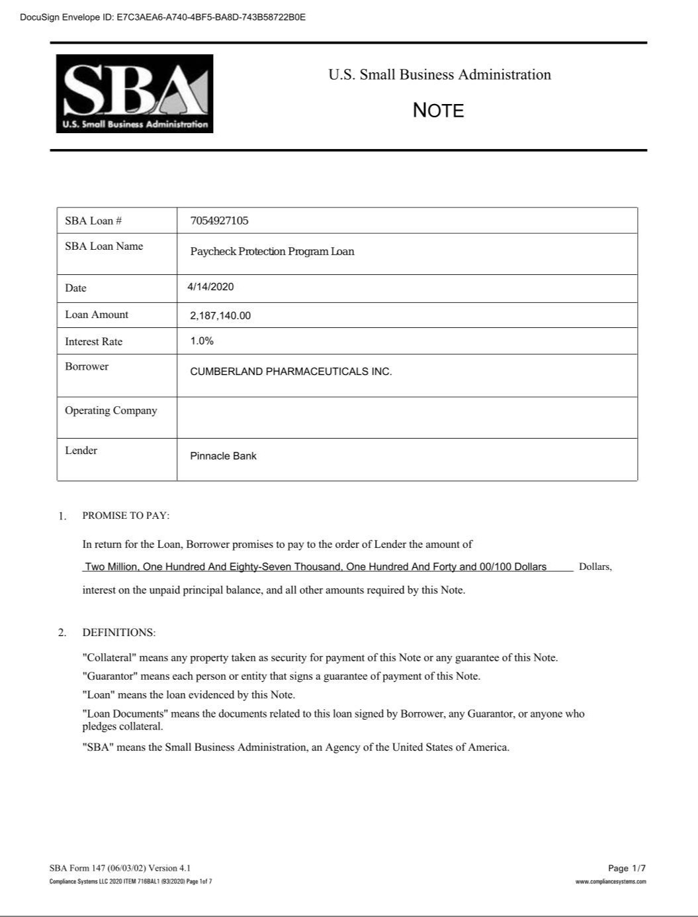

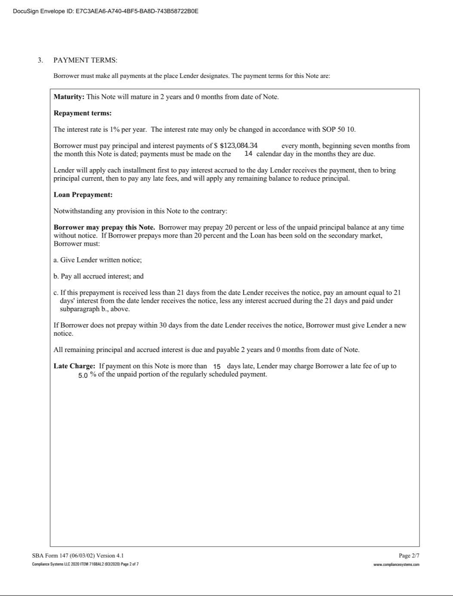

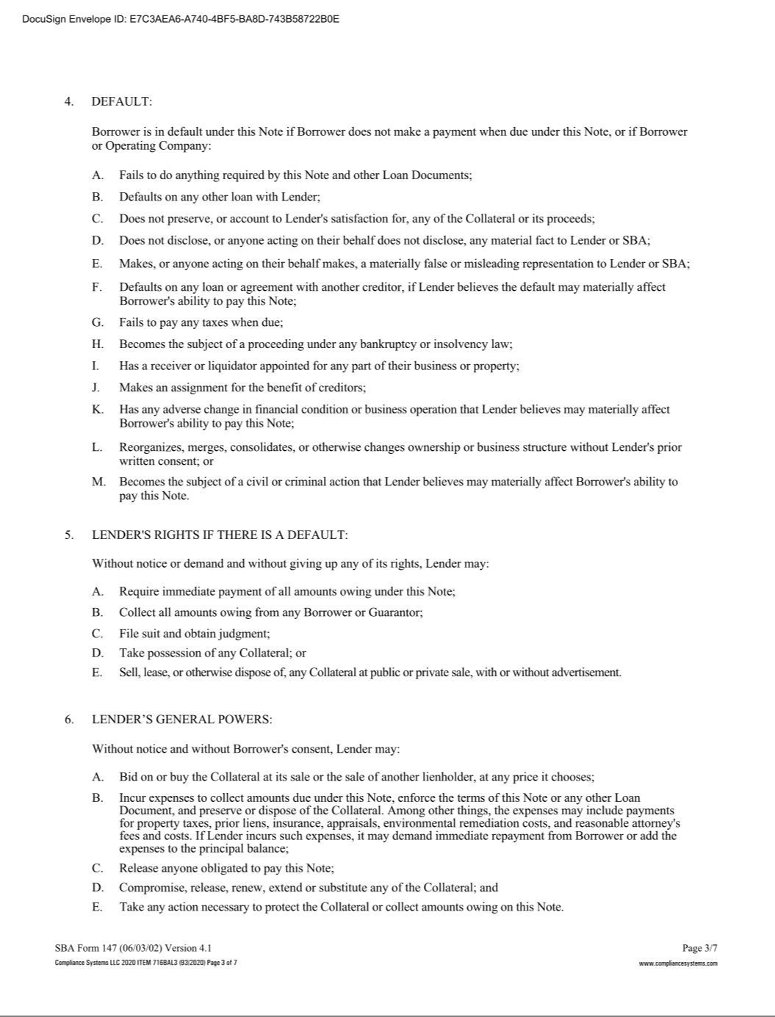

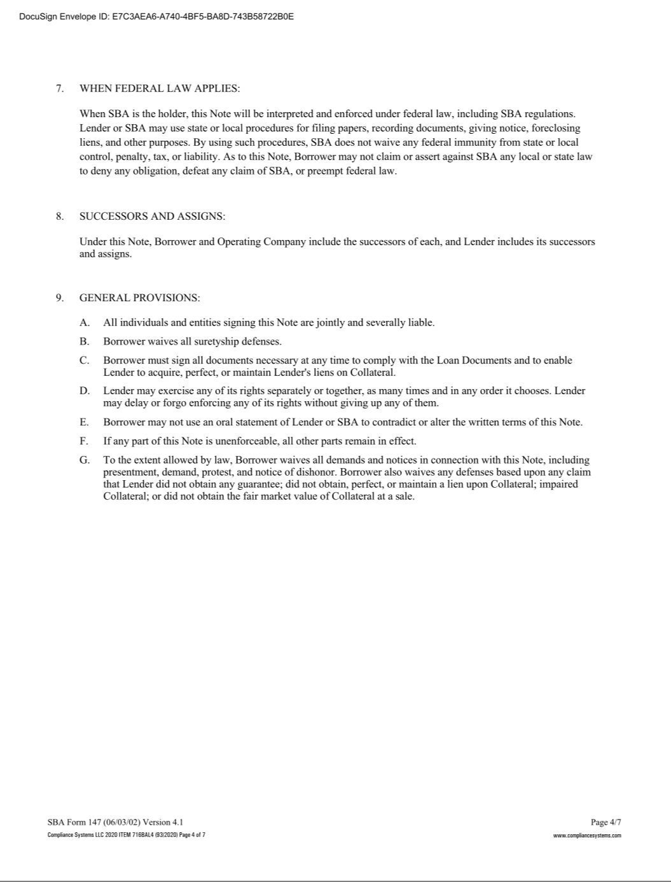

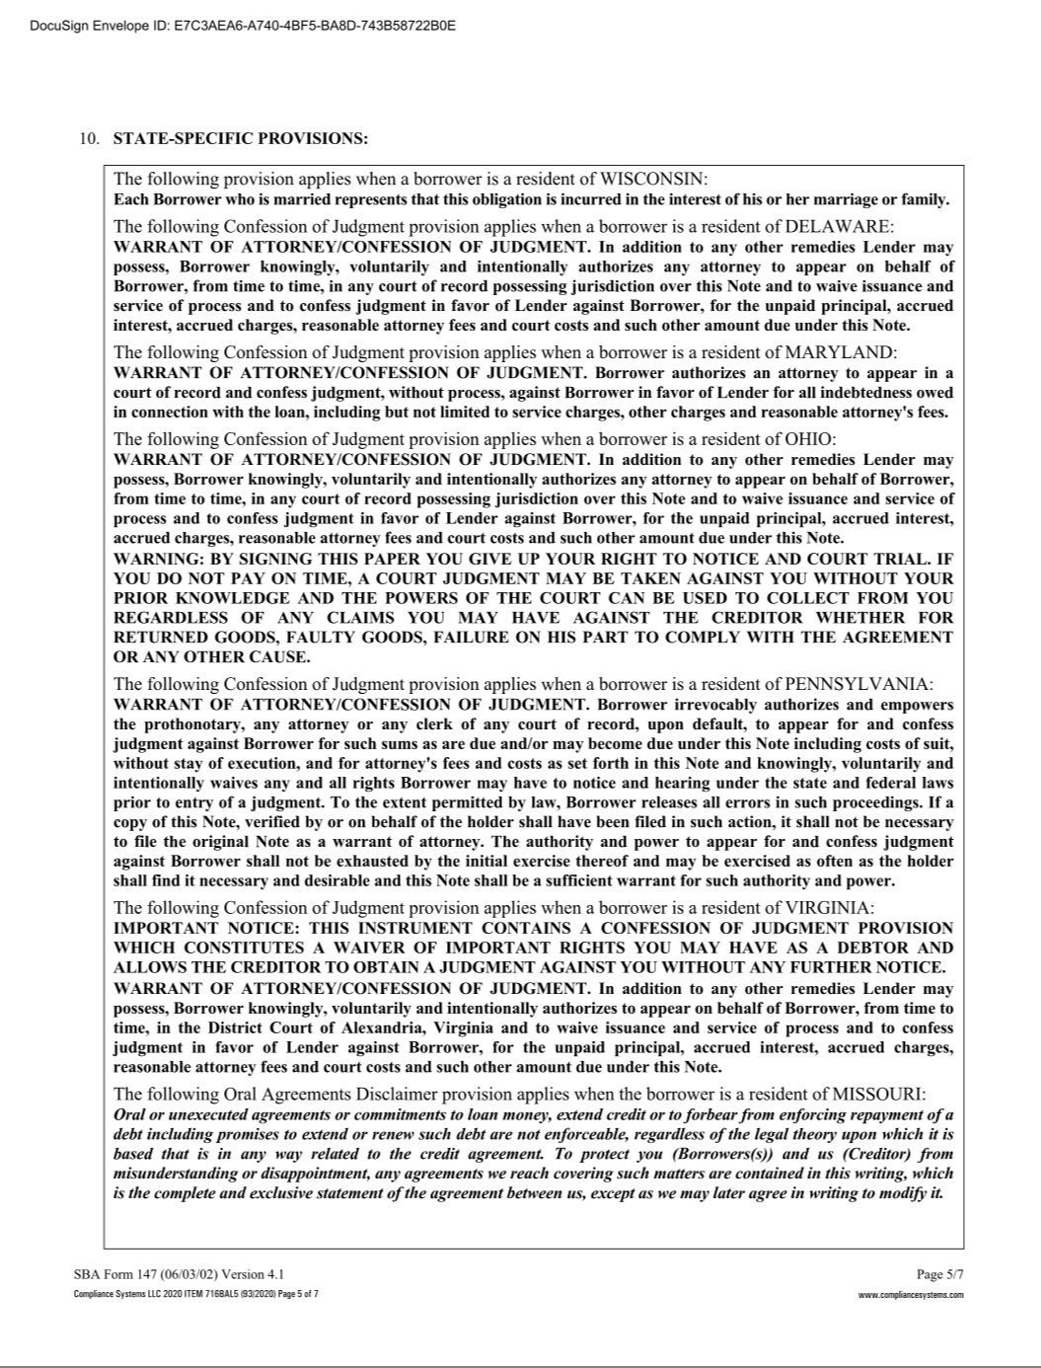

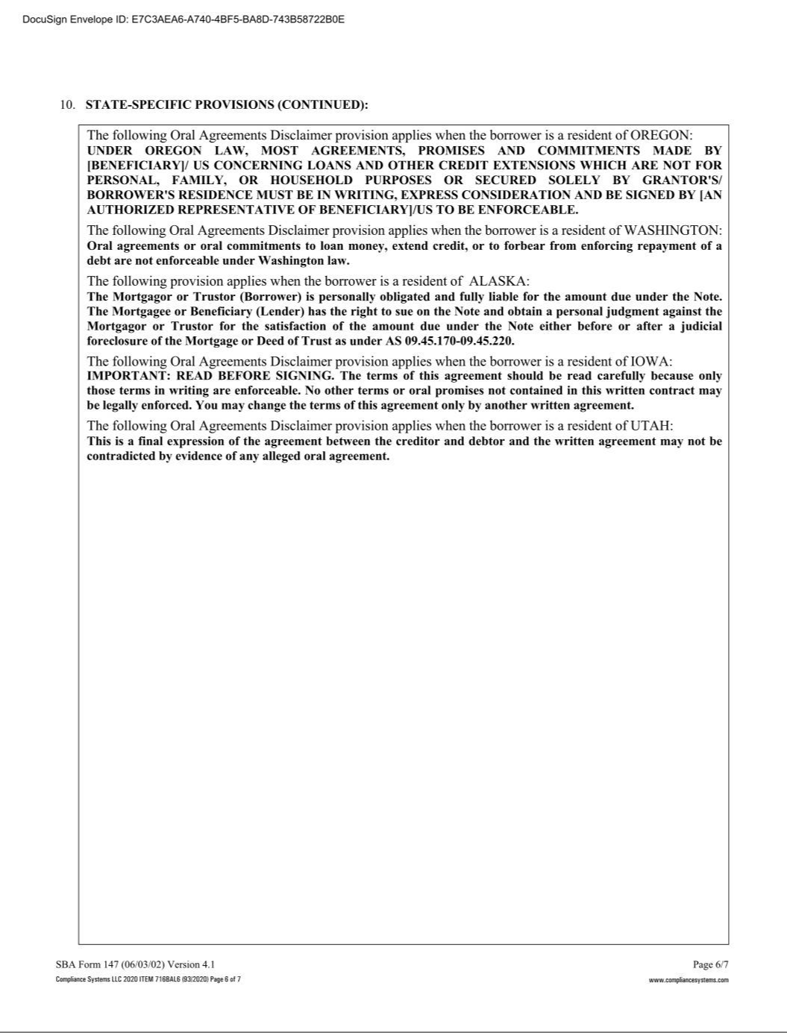

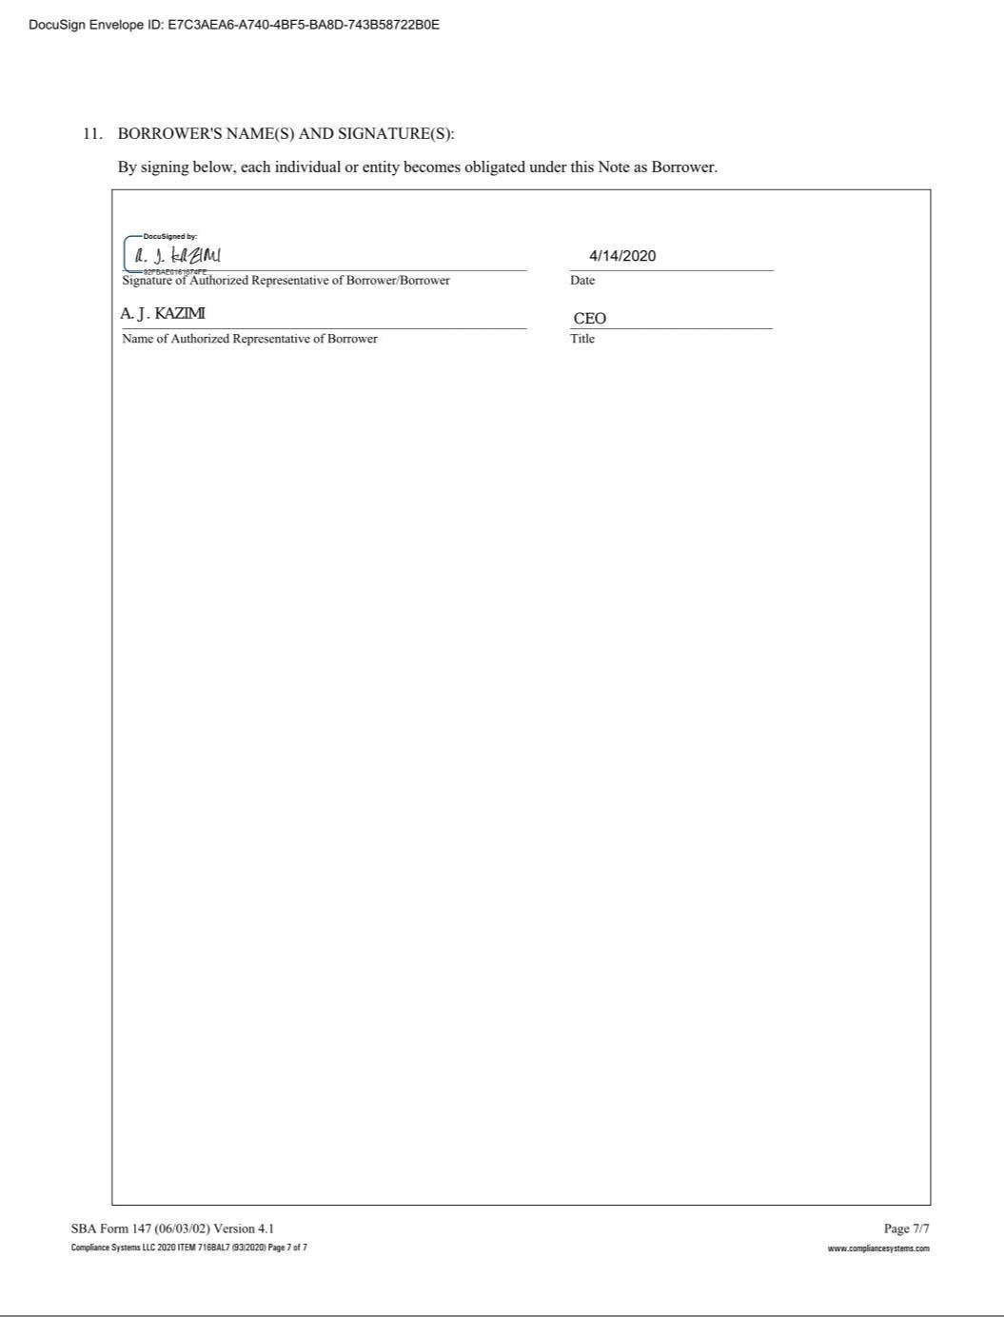

Exhibit 31.1

CERTIFICATION OF CHIEF EXECUTIVE OFFICER

PURSUANT TO SECTION 302 OF

THE SARBANES-OXLEY ACT OF 2002

I, A.J. Kazimi, certify that:

- I have reviewed this Form 10-Q of Cumberland Pharmaceuticals Inc.;

- Based on my knowledge, this report does not contain any untrue statement of a material fact or omit to state a material fact necessary to make the statements made, in light of the circumstances under which such statements were made, not misleading with respect to the period covered by this report;

- Based on my knowledge, the financial statements, and other financial information included in this report, fairly present in all material respects the financial condition, results of operations and cash flows of the registrant as of, and for, the periods presented in this report;

- The registrant’s other certifying officer and I are responsible for establishing and maintaining disclosure controls and procedures (as defined in Exchange Act Rules 13a-15(e) and 15d-15(e)) and internal control over financial reporting (as defined in Exchange Act Rules 13a-15(f) and 15d-15(f)) for the registrant and have:

  - Designed such disclosure controls and procedures, or caused such disclosure controls and procedures to be designed under our supervision, to ensure that material information relating to the registrant, including its consolidated subsidiaries, is made known to us by others within those entities, particularly during the period in which this report is being prepared;
  - Designed such internal control over financial reporting, or caused such internal control over financial reporting to be designed under our supervision, to provide reasonable assurance regarding the reliability of financial reporting and the preparation of financial statements for external purposes in accordance with generally accepted accounting principles;
  - Evaluated the effectiveness of the registrant’s disclosure controls and procedures and presented in this report our conclusions about the effectiveness of the disclosure controls and procedures, as of the end of the period covered by this report based on such evaluation; and
  - Disclosed in this report any change in the registrant’s internal control over financial reporting that occurred during the registrant’s most recent fiscal quarter (the registrant’s fourth fiscal quarter in the case of an annual report) that has materially affected, or is reasonably likely to materially affect, the registrant’s internal control over financial reporting; and

- The registrant’s other certifying officer and I have disclosed, based on our most recent evaluation of internal control over financial reporting, to the registrant’s auditors and the audit committee of the registrant’s board of directors (or persons performing the equivalent functions):

  - All significant deficiencies and material weaknesses in the design or operation of internal control over financial reporting which are reasonably likely to adversely affect the registrant’s ability to record, process, summarize and report financial information; and
  - Any fraud, whether or not material, that involves management or other employees who have a significant role in the registrant’s internal control over financial reporting.

August 14, 2020 By: /s/ A.J. Kazimi

A.J. Kazimi

Chief Executive Officer

Exhibit 31.2

CERTIFICATION OF CHIEF FINANCIAL OFFICER

PURSUANT TO SECTION 302 OF

THE SARBANES-OXLEY ACT OF 2002

I, Michael Bonner, certify that:

- I have reviewed this Form 10-Q of Cumberland Pharmaceuticals Inc.;

- Based on my knowledge, this report does not contain any untrue statement of a material fact or omit to state a material fact necessary to make the statements made, in light of the circumstances under which such statements were made, not misleading with respect to the period covered by this report;

- Based on my knowledge, the financial statements, and other financial information included in this report, fairly present in all material respects the financial condition, results of operations and cash flows of the registrant as of, and for, the periods presented in this report;

- The registrant’s other certifying officer and I are responsible for establishing and maintaining disclosure controls and procedures (as defined in Exchange Act Rules 13a-15(e) and 15d-15(e)) and internal control over financial reporting (as defined in Exchange Act Rules 13a-15(f) and 15d-15(f)) for the registrant and have:

  - Designed such disclosure controls and procedures, or caused such disclosure controls and procedures to be designed under our supervision, to ensure that material information relating to the registrant, including its consolidated subsidiaries, is made known to us by others within those entities, particularly during the period in which this report is being prepared;
  - Designed such internal control over financial reporting, or caused such internal control over financial reporting to be designed under our supervision, to provide reasonable assurance regarding the reliability of financial reporting and the preparation of financial statements for external purposes in accordance with generally accepted accounting principles;
  - Evaluated the effectiveness of the registrant’s disclosure controls and procedures and presented in this report our conclusions about the effectiveness of the disclosure controls and procedures, as of the end of the period covered by this report based on such evaluation; and
  - Disclosed in this report any change in the registrant’s internal control over financial reporting that occurred during the registrant’s most recent fiscal quarter (the registrant’s fourth fiscal quarter in the case of an annual report) that has materially affected, or is reasonably likely to materially affect, the registrant’s internal control over financial reporting; and

- The registrant’s other certifying officer and I have disclosed, based on our most recent evaluation of internal control over financial reporting, to the registrant’s auditors and the audit committee of the registrant’s board of directors (or persons performing the equivalent functions):

  - All significant deficiencies and material weaknesses in the design or operation of internal control over financial reporting which are reasonably likely to adversely affect the registrant’s ability to record, process, summarize and report financial information; and
  - Any fraud, whether or not material, that involves management or other employees who have a significant role in the registrant’s internal control over financial reporting.

August 14, 2020 By: /s/ Michael Bonner

Michael Bonner

Chief Financial Officer

Exhibit 32.1

CERTIFICATION OF CHIEF EXECUTIVE AND

CHIEF FINANCIAL OFFICER

PURSUANT TO 18 U.S.C. SECTION 1350,

AS ADOPTED PURSUANT TO SECTION 906

OF THE SARBANES-OXLEY ACT OF 2002

In connection with the Quarterly Report on Form 10-Q for the fiscal quarter ended June 30, 2020 of Cumberland Pharmaceuticals Inc. (the “Company”), as filed with the Securities and Exchange Commission on the date hereof (the “Report”), I, A.J. Kazimi, Chief Executive Officer and Michael Bonner, Chief Financial Officer of the Company, certify, pursuant to Section 906 of the Sarbanes-Oxley Act of 2002 (18 U.S.C. section 1350), that:

- The Report fully complies with the requirements of Section 13(a) or 15(d) of the Securities Exchange Act of 1934; and

- The information contained in the Report fairly presents, in all material respects, the financial condition and results of operations of the Company.

/s/ A. J. Kazimi

A.J. Kazimi

Chief Executive Officer

August 14, 2020

/s/ Michael Bonner

Michael Bonner

Chief Financial Officer

August 14, 2020

