

Working together to provide

unique products that improve patient care

2023 Annual Report



2023 Highlights

Delivering Our Products to New Patients

To Our Shareholders, Employees & Partners:

May | Caldolor® Newborn Indication & Study Publication

The FDA approved expanded labeling for our Caldolor product, an intravenously delivered formulation of ibuprofen, to include use in infants. The non-narcotic agent may now be administered for the treatment of pain and fever in patients 3 to 6 months of age. With this newly approved labeling, Caldolor is the only non-opioid product approved to treat pain in infants that is delivered through injection.

We also shared the positive results from a clinical study investigating the safety and pharmacokinetics of Caldolor in newborns, published in the journal Pediatric Drugs. The results of the study support the growing body of evidence that demonstrates Caldolor is a safe therapeutic option available to practitioners for the treatment of fever and pain in infants, children and adults.

June | Expanded Oncology Sales Division

We expanded our oncology sales division as we work to deliver our newest brand Sancuso® – to help cancer patients tolerate their chemotherapy treatments. Sancuso is the first and only FDA-approved prescription patch for the prevention of nausea and vomiting in patients receiving certain types of chemotherapy.

October | New Vibativ® Pediatric Study Publication

We announced a new publication in Antimicrobial Agents and Chemotherapy detailing the results of the first clinical study investigating the safety and pharmacokinetics of our Vibativ product in children 2 to 17 years of age. Vibativ is an intravenous antibiotic approved by the FDA for the treatment of hospital-acquired and ventilator-associated bacterial pneumonia, as well as complicated skin and skin structure infections caused by certain gram-positive bacteria. The results of the study suggest that a single dose of Vibativ is safe in children and they experience reduced exposure to Vibativ, compared with the same body weight-based dosing in adults.

In many ways 2023 was a building year for Cumberland, as we continued to integrate our newest products, while also delivering several significant achievements.

During the year we took a fresh look at our mission statement and refined it to better capture the spirit of what we do each day at Cumberland. Our mission is now: working together to provide unique products that improve the quality of patient care.

In designing this statement, we considered several factors.

First, we wanted our mission to address the constituencies we serve, which include patients in need of care, as well as health care providers, our employees, shareholders, partners and community.

We also sought to reflect Cumberland’s culture, where teamwork is prized, emphasized and expected – in order to achieve our goals.

Next, it needed to demonstrate our focus on developing, acquiring and distributing differentiated brands.

And finally, we wanted to emphasize that the patient is at the core of everything we do. Our collective efforts are directed at providing unique products that serve as better alternatives for poorly met medical needs.

Now, as we report on the progress we made throughout 2023, we are pleased to share a few exciting updates including the growth opportunities for our portfolio of branded medicines.

Following the FDA’s approval to expand the labeling for Caldolor, our non-narcotic agent may now be administered for the treatment of pain and fever in patients 3 to 6 months of age. This expanded use was further supported by the publication of positive results from a clinical study investigating the safety and pharmacokinetics of Caldolor in newborns. We are thrilled to extend Caldolor’s labeling for these youngest of patients.

Additionally, we shared the results of the first pediatric study investigating the safety and pharmacokinetics of our Vibativ product. The results suggest that a single dose of Vibativ can be safely administered to children to fight certain serious skin and lung infections.

Meanwhile, we completed the expansion of our oncology sales division as we work to deliver our newest brand, Sancuso, to cancer patients.

As we remain focused on delivering our products to patients within the U.S., we continue to work with our partners in their efforts to register and launch Vibativ in several international markets, which should provide significant future catalysts for the brand.

We also continue to progress our pipeline of innovative products designed to improve patient care and patients’ quality of life. Our ifetroban product candidate is being evaluated in a number of Phase II clinical trials for patients with a series of unmet medical needs.

It has now been dosed in nearly 1,400 subjects and has been found to be safe and well tolerated in those individuals. We look forward to sharing the results from these studies as they emerge and then deciding on the best development path for the product, which we believe has the potential to benefit many patients.

We remain committed to fulfilling our newly refined mission by building a portfolio of specialty pharmaceutical brands, which we do by maximizing the potential of our commercial brands, progressing our pipeline and also pursuing select acquisitions.

All the best,

A.J. Kazimi

Chairman and Chief Executive Officer

2 Cumberland Pharmaceuticals 2023 Annual Report 1

Products to
enhance patients’ lives

Addressing unmet medical needs through our product portfolio
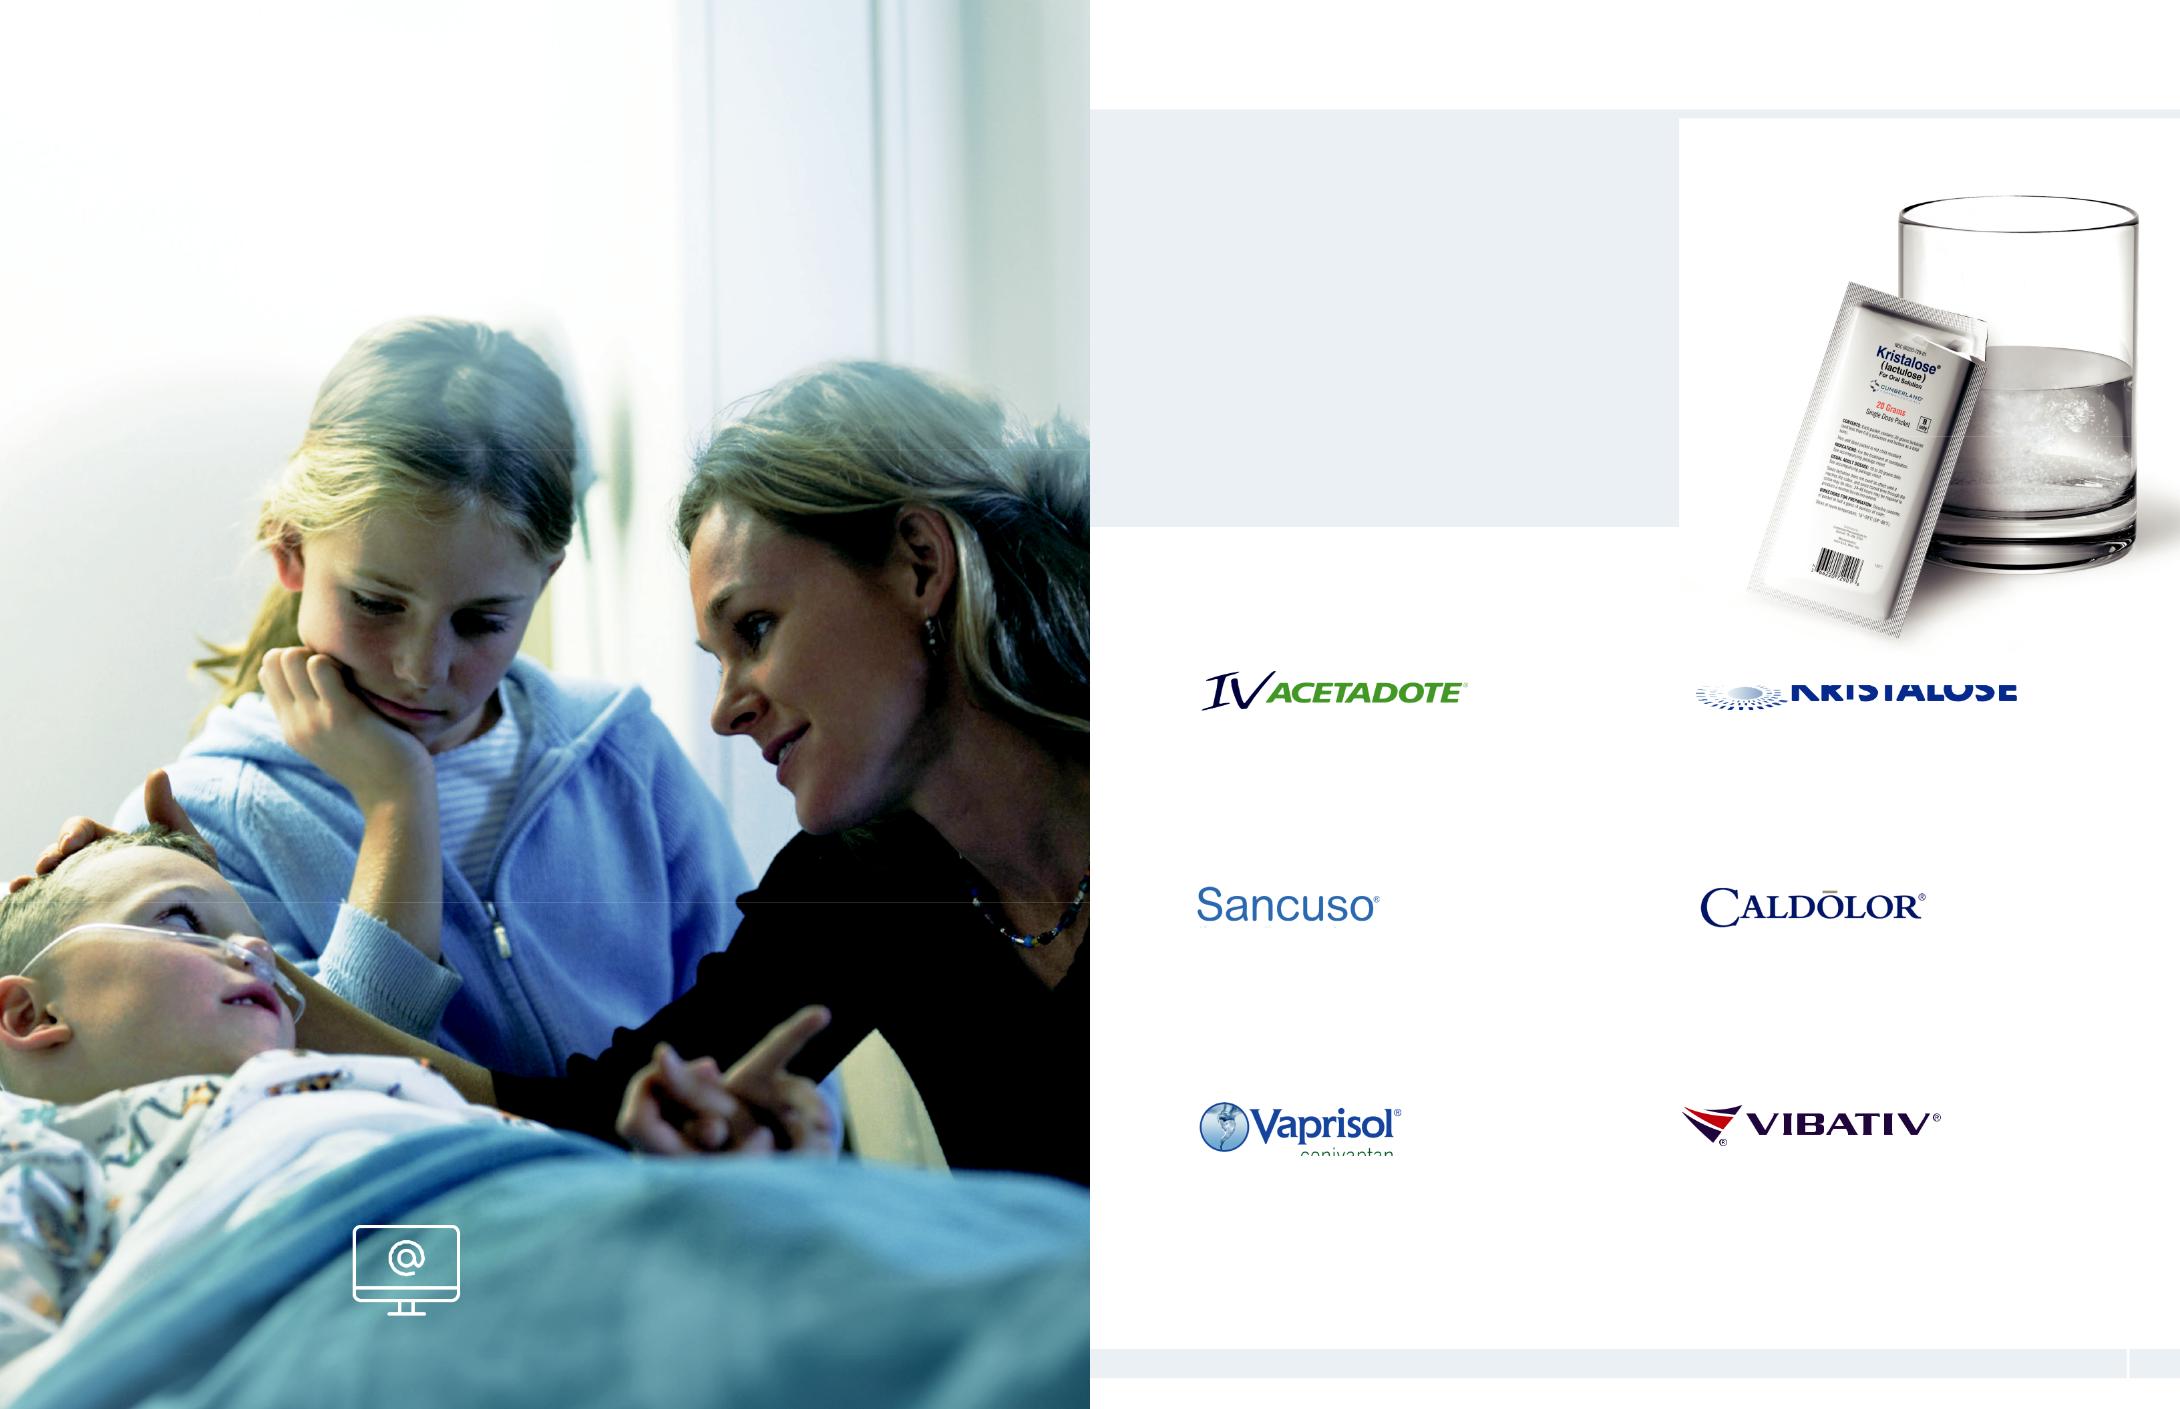

With a focus on underserved, specialty markets, including hospital acute care, gastroenterology and oncology, we develop and acquire medicines that are designed to offer distinct advantages over prior treatments.

Our portfolio of FDA-approved brands is supported through our hospital, field, and oncology sales divisions along with our national accounts and field-based medical teams across the United States.

Our commercial product line includes the brands shown below.

For more information on Cumberland’s approved products,

including safety and full prescribing information, please visit

links to the individual product websites, which can be found

on our corporate website, www.cumberlandpharma.com.

(acetylcysteine) An injection used for the treatment of acetaminophen poisoning, which is the leading cause of drug toxicity in the U.S.

(granisetron) The first and only FDA-approved prescription patch that prevents nausea and vomiting in patients receiving certain types of chemotherapy treatment

(conivaptan) The first and only intravenously administered vasopressin receptor antagonist, which is used

to raise serum sodium levels in hospitalized patients with euvolemic and hypervolemic hyponatremia

(lactulose) The only branded prescription laxative product that combines the established safety and efficacy of lactulose with the convenience and portability of a pre-measured dose

(ibuprofen) The first injectable therapy approved in the U.S. for the treatment of both pain and fever

(telavancin) An injection used for the treatment of certain serious bacterial infections, including hospital-acquired and ventilator-associated bacterial pneumonia, as well as complicated skin and skin structure infections

2 Cumberland Pharmaceuticals 2023 Annual Report 3


Building a Pipeline of
Differentiated Products

In addition to our portfolio of FDA-approved brands, we continue to advance our pipeline of new product candidates. All part of our ifetroban program, our development candidates have the potential to help multiple patient populations and are designed to treat conditions for which there is currently no FDA-approved pharmaceutical treatment.

Our Pipeline Includes:

Preclinical | IND | Phase I | Phase II | Phase III | NDA

Dyscorban®
An oral capsule to treat cardiomyopathy associated with duchenne muscular dystrophy (DMD), a fatal, genetic neuromuscular disease

Cumberland
Emerging Technologies

A collaboration to advance biomedical innovation

The FDA has cleared the Investigational New Drug (IND) application
for this program and a Phase II clinical trial in DMD patients has been

initiated, with enrollment advancing.

The FDA has also provided grant awards of over $1 million to
support this study.

Vasculan®
An oral capsule to treat systemic sclerosis (SSc), also known
as scleroderma, a rare, debilitating autoimmune disorder that
results in a thickening of the skin and internal organs

With FDA clearance of our IND, this Phase II study in SSc patients
is well underway.

We are also developing an oral capsule to treat
idiopathic pulmonary fibrosis (IPF), the most common

form of progressive fibrosing interstitial lung disease

Following FDA clearance of our IND, we are in the
process of initiating our Phase II study in IPF patients

in centers of excellence across the U.S.

The U.S. leads the world in biomedical innovation,

including the development of new medicines.

To create a long-term product pipeline and also

help build the local biomedical industry, we

formed Cumberland Emerging Technologies

(CET). As a majority owned subsidiary of

Cumberland Pharma, CET helps inventor

scientists and life science companies develop

health care solutions and provides needed

support to advance these solutions toward the

commercial marketplace.

CET represents a joint initiative between

Cumberland Pharmaceuticals, Vanderbilt

University, Launch Tennessee – a state-

supported network created to empower

Tennessee’s entrepreneurial ecosystem –

and WinHealth Pharmaceuticals – our

international partner.

At CET we team with academic research groups

and support the development process for

selected projects, providing critical expertise on

intellectual property, regulatory, manufacturing

and marketing issues essential to the successful

development of new biomedical products.

CET partners with several major academic research institutions, led by joint activities with Vanderbilt University and the Vanderbilt Medical Center. Together we work to identify early-stage biomedical research opportunities and develop the resulting new biopharmaceutical product candidates to improve patient care.

CET has also established and manages the Nashville Life Sciences Center, which serves as an incubator for Middle Tennessee’s emerging biomedical industry.

The Life Sciences Center provides offices, laboratory space, and equipment to early-stage companies looking to develop their technologies and products. We maintain the Cumberland Pharmaceuticals formulation and testing laboratory at the CET Life Sciences Center.

Nearly 30 life science companies exist today because of CET, including a vibrant group of current tenants at the Life Sciences Center as well as a growing number of successful graduates.

4 Cumberland Pharmaceuticals 2023 Annual Report 5

Providing Medicines to Patients Around the World

A look at our key international partnerships

Bringing our medicines topatients throughout the world through a growing networkof distinguished international partners

Tennessee

Cardinal Health Inc. provides

warehousing, shipping and

other distribution support for

our products in the U.S.

Mexico

PiSA Pharmaceutical is our

commercial partner for Caldolor.

Saudi Arabia and Jordan

Tabuk Pharmaceutical

Manufacturing Company is our

commercial partner for Vibativ.

To provide for the availability of our products, we have established a network of distribution partners. Our international partners are responsible for registering and commercializing select Cumberland products, allowing us to provide our unique medicines to better the quality of patient lives in their countries.


Russia and CIS

R-Pharm JSC is our commercial

partner for Vibativ.

South Korea

D.B. Pharm Korea Co. Ltd. is

our commercial partner for

Caldolor and Vibativ.

China

WinHealth Pharma Group is our

commercial partner for Caldolor

and Acetadote, and an investor in

Cumberland Emerging Technologies.

SciClone Pharmaceuticals is our

commercial partner for Vibativ.

Australia India

Phebra Pty Ltd. is our Sandor Medicaids Pvt.

commercial partner for Ltd. is our commercial

Acetadote and Caldolor. partner for Caldolor.

6 Cumberland Pharmaceuticals 2023 Annual Report 7

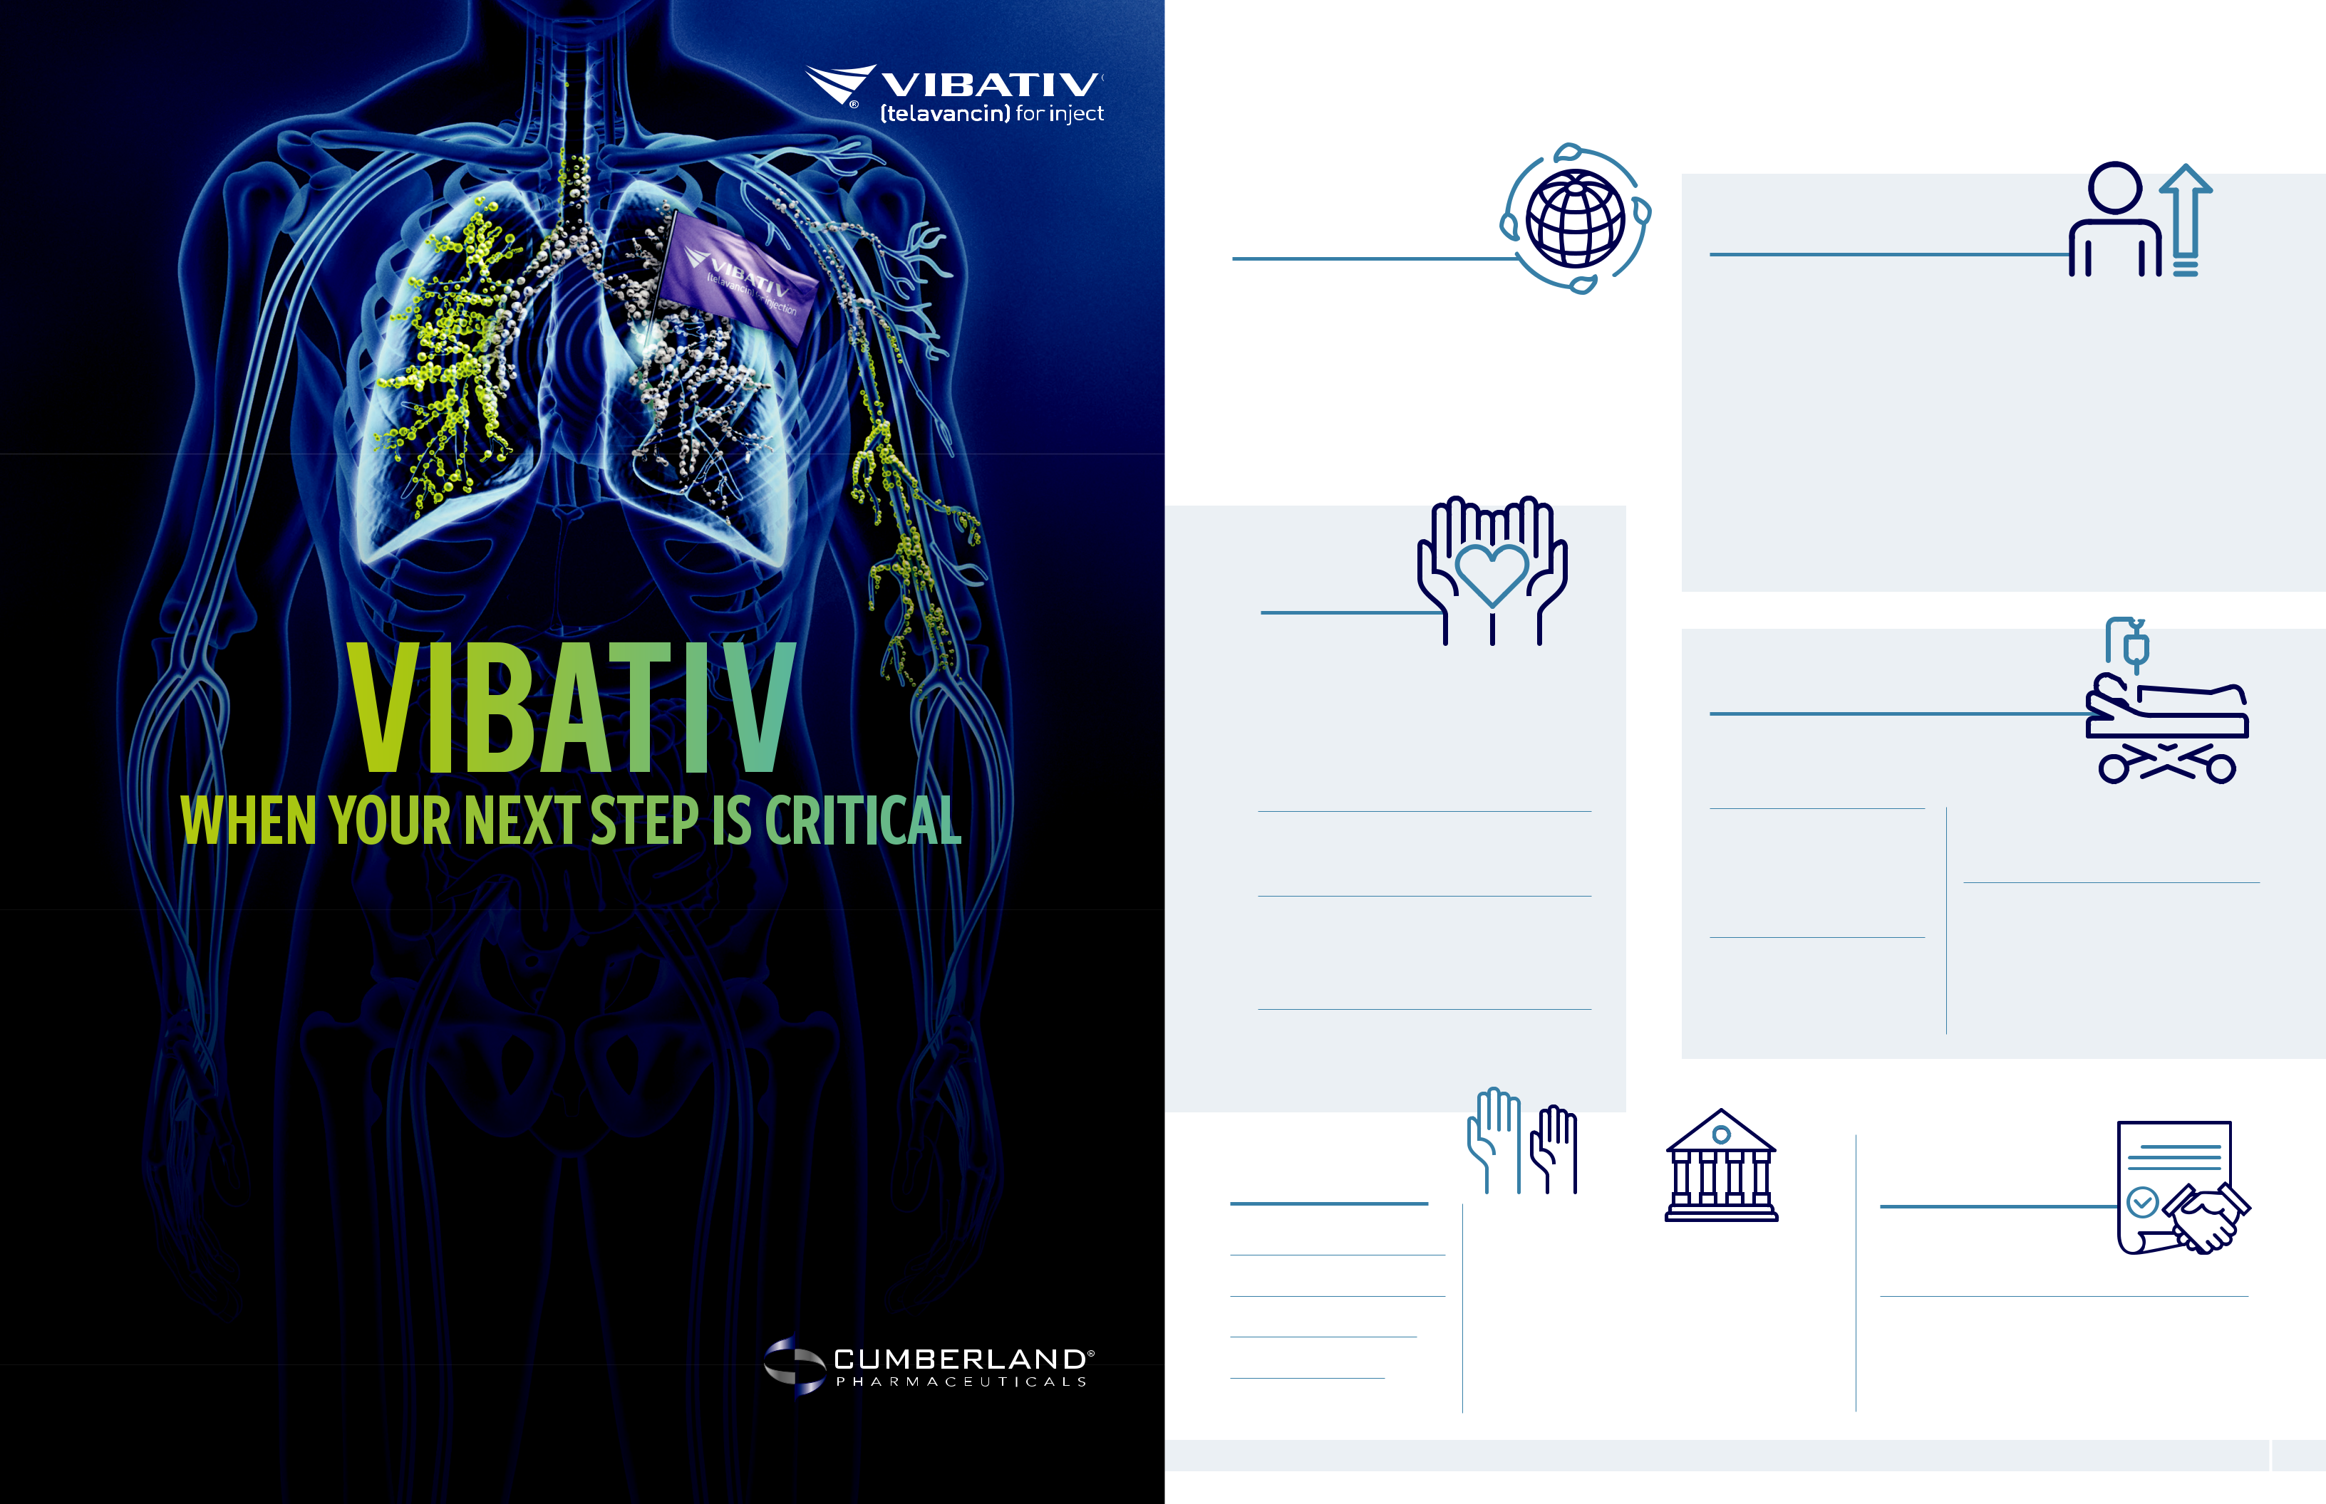
Sustainability 2023 At a Glance

ENVIRONMENT

Supplies |  | Waste
Contracted with third-party |  | Ensured strict
companies for the |  | guidelines and
manufacturing, packaging |  | processes for the safe,
and warehousing of |  | permanent disposal of
our products |  | all unused product
Returns |  | pounds of
Received and |  | damaged and
disposed of | 5,891 expired products
SOCIAL
Community

Involvement

Cumberland Pharma Foundation

Contributed to Denver Health, Loyola University, Tennessee State Museum, American Heart Association, Tennessee Historical Society, Belmont University & University of Mississippi

SOCIAL
Employees

Male – 56% |  |  |  | Turnover – 19.1%
Female – 44%
 |  |  |  | Additions – 20%
Minorities – 15%
 |  |  |  | Career Development Program
 |  |  | Available to all corporate employees
Ages
6.5% below 30 |  |  | Cumberland Academy
27.5% between 30 & 50 |  |  | Provides industry training for
66% over 50 |  |  | corporate employees
Tenures |  |  |  | Training |  | Work-related
35% @ 5 or more years |  |  |  | Average $4,000 |  | injuries
25% @ 10 or more years |  |  |  | per full-time |  | None
10% @ 15 or more years |  |  |  | employee

SOCIAL
Patients
Provided 3million doses

of our products to patients

The once-daily antibiotic infusion with a dual mechanism of action indicated for MRSA and MSSA

Sponsorships

Nashville Health Care Council’s Wall Street’s View of Healthcare Event

Associations

- Nashville Health Care Council

- Life Science Tennessee

- Nashville Chamber of Commerce

Life Sciences Center

Provide a lab and incubator to help build the biomedical industry in our area

Drug Safety Results

- No products listed in the FDA’ s MedWatch Safety Alerts

- No products recalled

Patient AffordAbility

We cover up to 71% of patient Rx costs through coupons for our GI brand

Clinical Trials Safety

No trials terminated due to failure to practice good clinical standards

Advocacy Groups Supported

- Muscular Dystrophy Association

- Parent Project Muscular Dystrophy

- Cumberland Pharmaceuticals

GOVERNANCE
Board

Independent – 7 of 8 Tenure – Average 9.8 years

Age – Average 66 years Male/ Female – 6/1 Turnover – None

Board
Meeting |  | GOVERNANCE
Attendance |  | GOVERNANCE
100% |  | Government Relations
100% |  | Cumberland Health
Standing |  | Cumberland Health
Standing |  | & Wellness PAC
Committee |  | & Wellness PAC
Committee |  | Supports candidates,
Attendance |  | Supports candidates,
100% |  | elected officials and
100% |  | relevant legislation

GOVERNANCE
Compliance

Code of Conduct
Establishes guidelines for all Board members and employees

Ethical Marketing |  | Health Care
No government |  | Professionals
judgments, decrees |  | All reports regarding
or fines |  | relations filed on time
 |  | 2023 Annual Report 9

Selected Financial Data

Our strategy involves maximizing the potential of our existing brands while continuing to build a portfolio of unique, differentiated products. The result of these efforts has strengthened our market presence, diversified our revenue stream and delivered positive cash flow from operations in 2023.


(dollars in thousands except per share data) | 2019 |  |  | 2020 |  | 2021 |  | 2022 |  | 2023
Net Revenues | $47,553 |  |  | $37,441 |  | $35,985 |  | $42,011 |  | $39,553
Less Total Expenses | 51,091 |  |  | 40,780 |  | 39,493 |  | 47,661 |  | 45,884
Net Income (Loss)
Net Income (Loss) | (3,538) |  |  | (3,339) |  | (3,508) |  | (5,650) |  | (6,331)
Cash Flow from Operating Activities | 3,056 |  |  | 5,415 |  | 6,342 |  | 8,453 |  | 6,094
Total Assets | 104,549 |  |  | 96,463 |  | 84,460 |  | 92,925 |  | 81,776
Total Liabilities | 53,464 |  |  | 49,590 |  | 41,858 |  | 56,951 |  | 52,516
Total Equity | 51,085 |  |  | 46,873 |  | 42,602 |  | 35,974 |  | 29,260

Reconciliation of Net Income (Loss) Attributable to Common Shareholders to Adjusted Earnings and Adjusted Diluted Earnings Per Share (1) (Unaudited)


(dollars in thousands except per share data) | 2019 |  |  | 2020 |  |  | 2021 |  | 2022 |  |  | 2023
Net Income (Loss) from Continuing
Operations | ($3,538) |  |  | ($6,625) |  |  | ($5,597) |  | ($5,650) |  |  | ($6,331)
Adjustments to Net Income (Loss)
Income Tax Expense (Benefit) | (79) |  |  | 56 |  |  | 35 |  | 69 |  |  | 46
Depreciation and Amortization | 4,404 |  |  | 4,749 |  |  | 4,606 |  | 5,328 |  |  | 8,280
Share-Based Compensation | 1,486 |  |  | 1,047 |  |  | 742 |  | 447 |  |  | 365
Other Adjustments to Net Income (1) |  | – |  | 440 |  |  | (1,051) |  | 1,368 |  |  | (347)
Interest Income | (243) |  |  | (75) |  |  | (26) |  | (98) |  |  | (287)
Interest Expense |  | 246 |  |  | 263 |  | 98 |  |  | 586 |  | 668
Adjusted Earnings
Adjusted Earnings | ($2,276) |  |  | ($146) |  |  | ($1,193) |  | $2,050 |  |  | $2,394
Adjusted Diluted Earnings per Share |  | ($0.32) |  |  | ($0.01) |  | ($0.08) |  |  | $0.14 |  | $0.17
Diluted Weighted-Average Common
Shares Outstanding: | 15,764 |  |  | 15,162 |  |  | 14,905 |  | 14,809 |  |  | 14,526

(1) The supplemental financial measures are Non-GAAP as defined, the reconciliation of these supplemental measures is above.

Board of Directors




A.J. Kazimi James R. Jones
Chairman Director

Chief Executive Officer Former Managing Partner

Cumberland Pharmaceuticals KPMG LLP-Nashville



Dr. Gordon R. Bernard Kenneth J. Krogulski
Director Lead Director

Professor of Medicine Managing Partner and

Division of Pulmonary & Critical Care Medicine Chief Investment Officer

Vanderbilt University Medical Center Berkshire Asset Management



Martin S. Brown Caroline R. Young
Director Director

Attorney of Counsel Vice President of Partnership Development

Adams and Reese LLP Frist Cressey Ventures

Former Board Director Former President

Brown-Forman Corporation Nashville Health Care Council


Joseph C. Galante
Director

Former Chairman

Sony Music Nashville

Former President

RCA Records

10 Cumberland Pharmaceuticals 2023 Annual Report 11

Corporate Information

Stock Listing

NASDAQ Global Select Market Ticker Symbol: CPIX

Annual Meeting

9:30 a.m. Central Time Wednesday, April 24, 2024 Cumberland Headquarters

1600 West End Avenue, Suite 1300 Nashville, TN 37203

Independent Registered Public Accounting Firm

Carr, Riggs & Ingram, LLC 3011 Armory Drive, Suite 300 Nashville, TN 37204 (615) 665-1811

Transfer Agent and Registrar

Continental Stock Transfer

& Trust Company

1 State Street, 30th Floor

New York, NY 10004

- 509-5586

- 509-4000 cstmail@continentalstock.com

Forward-Looking

Statements

This annual report includes forward-

looking statements regarding expected

future results of the company. A variety

of factors could cause actual results

to differ materially from expected

results. Please see the risk factors

more fully described in our Annual

Report on Form 10-K for the year ended

December 31, 2023, which is filed

with the U.S. Securities and Exchange

Commission.

Company Headquarters

Cumberland Pharmaceuticals Inc.

1600 West End Avenue, Suite 1300

Nashville, TN 37203

Phone: (615) 255-0068

Toll Free: (877) 484-2700

Fax: (615) 255-0094



