
Unique Medicines, Quality Care, Better Lives

2024 Annual Report

Advancing Our
Portfolio and Pipeline

2024 HIGHLIGHTS

December November November

New Study Compared Caldolor® to Ketorolac

A study published in Frontiers of Pain Research provided compelling evidence that our Caldolor product, an intravenously delivered formulation of ibuprofen, is associated with a significantly reduced incidence of adverse drug reactions when compared to its key competitor, ketorolac. Notably, patients experienced fewer gastrointestinal complications as well as reduced headaches, nausea and abdominal pain. Additionally, Caldolor demonstrated a positive impact on health care resource utilization when compared to ketorolac, with decreased emergency room and outpatient visits, as well as a shortened hospital length of stay for both adults and children..

FDA Granted Orphan Drug Designations for lfetroban

Our ifetroban product candidate received FDA Orphan Drug and Rare Pediatric Disease designations for the treatment of cardiomyopathy in Duchenne muscular dystrophy (DMD), a devastating genetic disorder affecting young boys. These designations recognize the urgent need for effective treatments and also provide vital support to accelerate research and development. They represent hope for families and a pathway to bring transformative medicines to a vulnerable patient population more quickly and efficiently.

FDA Approved New, Simplified Dosing Regimen for Acetadote®

The FDA approved a supplemental New Drug Application for our Acetadote product, an intravenous formulation of N-acetylcysteine indicated to prevent or lessen liver injury after ingestion of potentially toxic quantities of acetaminophen. A common over-the-counter pain reliever and fever reducer, acetaminophen is the leading cause of acute liver failure in the United States.

The new, streamlined approach is designed to reduce the frequency of medication errors and potentially serious non-allergic anaphylactoid reactions, without compromising the effectiveness of Acetadote. By simplifying the dosing regimen, health care providers can administer the life-saving treatment more efficiently, potentially improving patient outcomes.


To Our Shareholders, Employees & Partners:

Cumberland’s business strategy has been to establish two key core competencies – the development of new medicines and our own capabilities to commercialize them. We have also been building a network of international partners to bring our medicines to patients in their countries.

I am pleased to share a number of key developments during 2024 that enabled us to advance in our newly refined mission – working together to provide unique products that improve the quality of patient care.

We announced the publication of new real-world outcomes research in 150,000 patients comparing our Caldolor® product to its key competitor, ketorolac. The results provided compelling evidence that Caldolor offers a better safety profile, as a result of its significantly reduced incidence of adverse drug reactions. Caldolor also provides a potential significant cost savings to the health care facility, based on the findings that it improves their resource utilization.

Additionally, a Caldolor Special Report was published that presented the growing amount of data supporting the product’s use as a standard of care for the treatment of pain and fever. The report presented the studies demonstrating that Caldolor is a safe and effective treatment for pain and fever in adults, children and infants.

Meanwhile, we announced the FDA approval of expanded labeling for Acetadote®, our treatment for the liver injury associated with acetaminophen toxicity. The newly approved dosing regimen simplifies the administration of Acetadote by combining the first two bags of the standard regimen into a single, slower infusion. The new approach allows health care providers to administer the life-saving treatment more efficiently in order to improve patient outcomes.

We also made significant progress in advancing the Phase II clinical trials evaluating our ifetroban product candidate. We closed our study in patients with Duchenne muscular dystrophy (DMD), approached the conclusion of enrollment in our systemic sclerosis study and significantly progressed our study in patients suffering from pulmonary fibrosis. These programs are designed to address unmet medical needs in large potential markets.

We were delighted to receive both Orphan Drug Designation and Rare Pediatric Disease Designation from the FDA for the use of ifetroban for the treatment of DMD heart disease, reflecting its potential significance in treating this devastating condition.

At Cumberland Emerging Technologies (CET) we announced favorable top-line results from an investigator-led Phase II study evaluating our new treatment for delirium in critically ill patients. CET also entered into

a development agreement with a corporate partner to fund a new product designed to locate sites of internal bleeding. We are building a long-term pipeline of innovative biopharmaceutical products at CET in collaboration with academic research groups.

Turning to our commercial operations, we continued to be encouraged to see the positive impact on our business as more states provided favorable Medicaid coverage for Kristalose®, our prescription-strength laxative.

Manufacturing for our oncology support medication Sancuso® was transferred to a new facility that received FDA approval. We then introduced our newly Cumberland-packaged product, supported by an expanded oncology sales division.

On the international front, we began shipping Vibativ®, our potent antibiotic, to Saudi Arabia. Our partner for the product in China progressed approval in their country – the world’s second largest pharmaceutical market.

Looking ahead, we remain focused on our mission and will continue to build our specialty pharmaceutical business by maximizing the potential of our commercial brands, progressing our pipeline and pursuing select acquisitions.

We are entering an exciting time for our Company!

I’d like to extend a special thanks to the entire Cumberland team for their dedicated efforts and many contributions that enable us to build value and help many patients.

All the best,

A.J. Kazimi
Chairman and Chief Executive Officer

2024 Annual Report 1


Differentiated Brands, Unique Profiles, Patient-Focused

Advancing specialty care with innovative medicines

We are dedicated to our mission of working together to provide unique products that improve the quality of patient care. We develop, acquire and commercialize brands for select medical specialties, including hospital acute care, gastroenterology and oncology. Cumberland’s products are tailored for underserved, specialty markets and are designed to offer distinct advantages over prior treatments.

Our innovative product portfolio of FDA-approved brands is supported by our dedicated hospital, field and oncology sales divisions, as well as our national accounts and field-based medical teams across the country.

Our commercial product line includes the brands shown to the right.

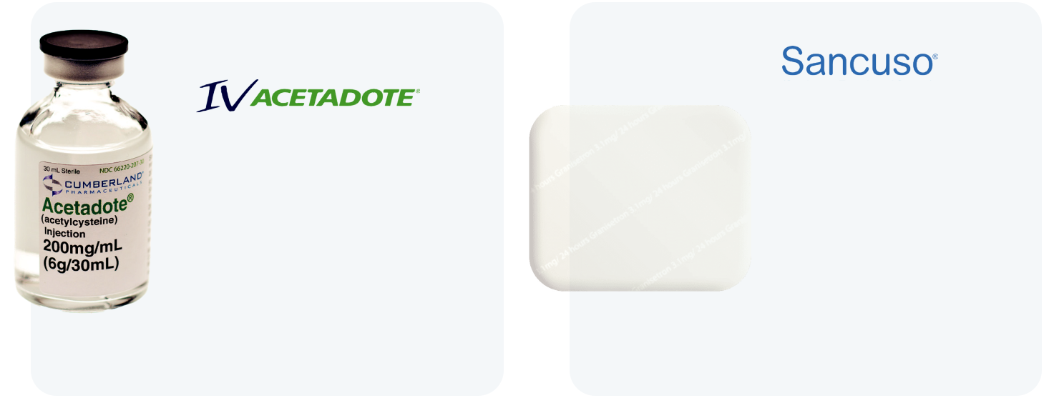
(acetylcysteine)

An injection used for the treatment of acetaminophen poisoning, which is the leading cause of drug toxicity in the U.S.
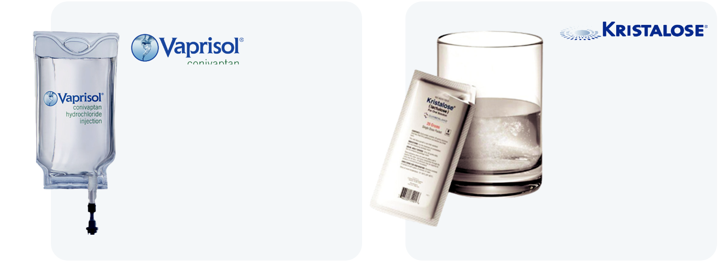

(conivaptan)

The only intravenously administered vasopressin receptor antagonist, which is used to raise serum sodium levels in hospitalized patients with euvolemic and hypervolemic hyponatremia (salt imbalances)
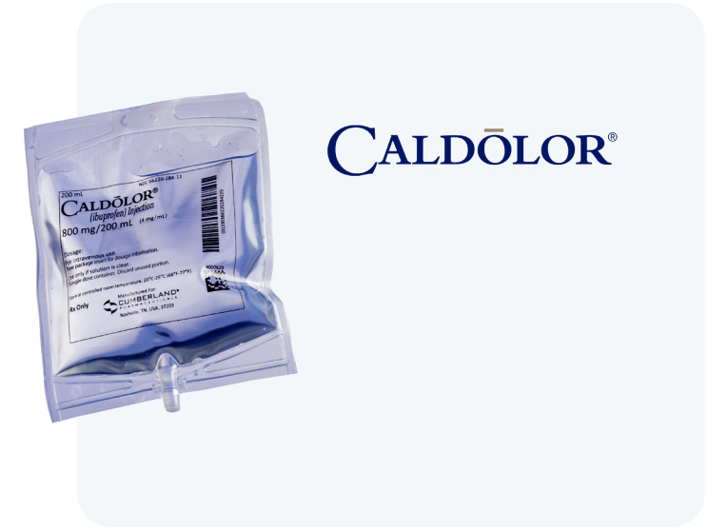

(granisetron)

An innovative

prescription patch

designed to prevent

nausea and vomiting

in patients receiving

certain types of

chemotherapy

treatment

(lactulose)

The only branded

prescription laxative

product that combines

the established

safety and efficacy

of lactulose with

the convenience

and portability of

- crystalline, pre-measured dose
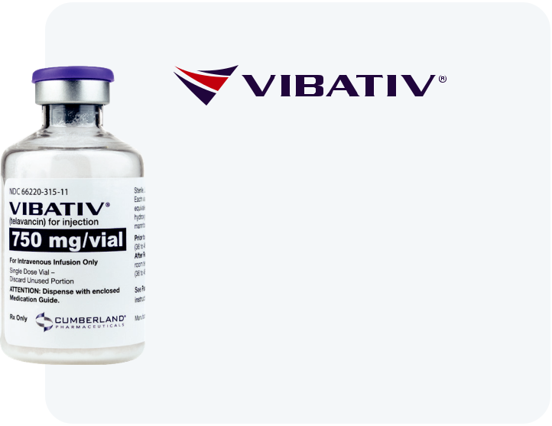

(ibuprofen)

An injectable therapy that reduces pain, fever and inflammation for patients, including those undergoing surgeries


(telavancin)

A potent antibiotic delivered through injection for the treatment of certain serious bacterial infections, including hospital-acquired and ventilator-associated bacterial pneumonia, as well as complicated skin and skin structure infections

For more information on Cumberland’s approved products, including safety and full prescribing information, please visit links to the individual product websites, which can be found on our corporate website, www.cumberlandpharma.com.

2024 Annual Report 3

Developing a Pipeline to Address Unmet Medical Needs

We are developing an innovative new chemical entity – ifetroban – with the potential to help patients with conditions for which there are no satisfactory approved treatments.

Our development programs include:
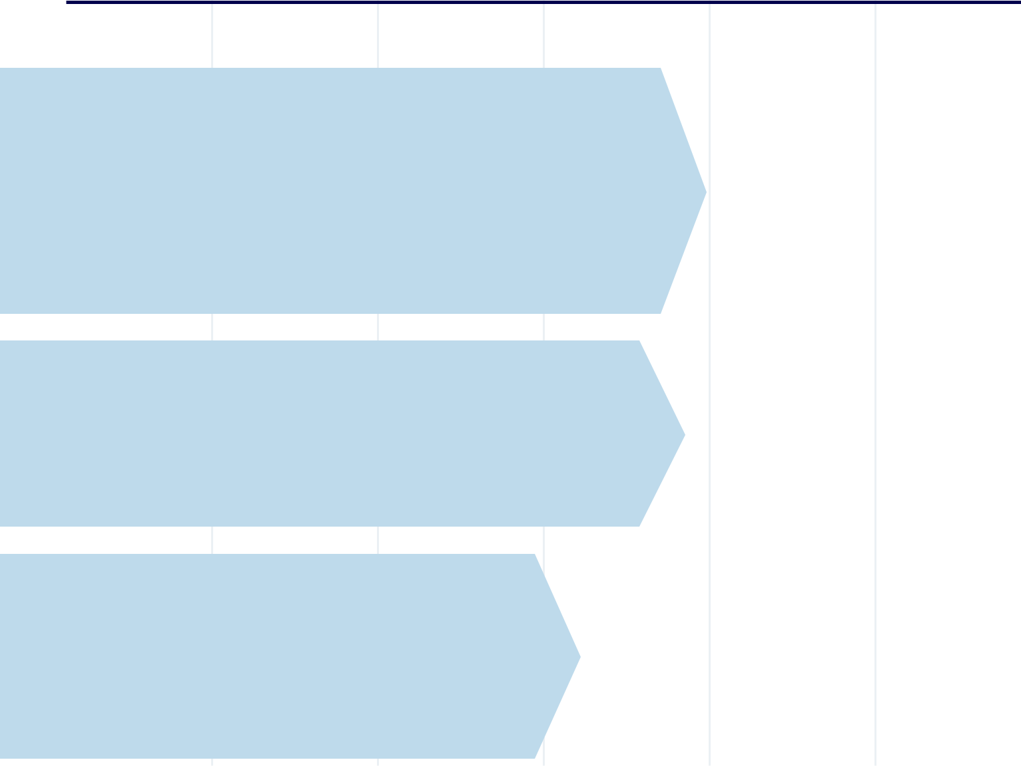

Preclinical | IND | Phase I | Phase II | Phase III | NDA

Dyscorban®
An oral capsule to treat cardiomyopathy associated with Duchenne muscular dystrophy, a fatal, genetic neuromuscular disease

Following a Phase II study, completion of data analysis and a full study report are underway in preparation for a meeting with the FDA to determine next steps for the product’s development and commercialization.

Vasculan®
An oral capsule to treat systemic sclerosis (SSc), also known as scleroderma, a rare, debilitating autoimmune disorder that results in a thickening of the skin and internal organs

With FDA clearance of our IND, this Phase II study in SSc patients is nearing completion.

Ifetroban
We are developing an oral capsule to treat idiopathic
pulmonary fibrosis (IPF), the most common form of
progressive fibrosing interstitial lung disease.

Following FDA clearance of our IND, a Phase II
clinical study is underway in IPF patients in centers of

excellence across the U.S.

- Cumberland Pharmaceuticals



Cumberland Emerging Technologies

Fostering collaboration, developing biomedical products, advancing innovation

The U.S. is a global leader in biomedical innovation, driving the discovery of new medicines. To foster our long-term product development and strengthen the local biomedical industry, we established Cumberland Emerging Technologies (CET). A majority-owned subsidiary of Cumberland Pharmaceuticals, CET supports inventor-scientists and life science companies in advancing health care solutions toward commercialization.

CET is a collaborative initiative between Cumberland Pharmaceuticals, Vanderbilt University, Launch Tennessee (a state-backed network supporting entrepreneurship) and WinHealth Pharmaceuticals, our international partner. We work closely with academic research groups, providing expertise in intellectual property, regulatory pathways, manufacturing and marketing to accelerate the development of promising biomedical products. We

also partner with major academic research institutions to identify and develop early-stage biopharmaceutical innovations that enhance patient care.

Additionally, CET has established and manages the Nashville Life Sciences Center (LSC), which houses Cumberland’s formulation laboratories and also serves as an incubator for Middle Tennessee’s emerging biopharmaceutical industry.

The LSC features flexible wet lab, dry lab and office space with opportunities for custom build outs. Additionally, it offers shared lab space and essential laboratory equipment to help tenants limit overhead costs and maximize resources. It was founded in response to a shortage of wet lab space in Middle Tennessee, which has historically inhibited the startup and progress of new biomedical companies and commercialization of new life science technologies.

With a vibrant group of current tenants and a growing number of successful graduates, the Life Sciences Center is a main driver behind building a strong commercial life sciences ecosystem in Middle Tennessee.

2024 Annual Report 5


Bringing Our Medicines to Patients Worldwide

An overview of our key international partnerships

To ensure the availability of our products, we have built a network of established international partners.

These companies are responsible for registering and commercializing select Cumberland products, and we support them in their efforts to bring our unique medicines to patients in their countries.

Tennessee

Cardinal Health Inc. provides

warehousing, shipping and

distribution support for our

products in the U.S.

Mexico

PiSA Pharmaceutical is our

commercial partner for Caldolor.

Saudi Arabia and Jordan

Tabuk Pharmaceutical

Manufacturing Company is our

commercial partner for Vibativ.

- Cumberland Pharmaceuticals



Russia and CIS

R-Pharm JSC is our commercial

partner for Vibativ.

South Korea

D.B. Pharm Korea Co. Ltd. is

our commercial partner for

Caldolor and Vibativ.

China

WinHealth Pharma Group is our

commercial partner for Caldolor

and Acetadote, and an investor in

Cumberland Emerging Technologies.

SciClone Pharmaceuticals is our

commercial partner for Vibativ.

Australia

Phebra Pty Ltd. is our

commercial partner for

Acetadote and Caldolor.

2024 Annual Report 7



An innovative FDA-approved patch designed to help prevent chemotherapy-associated nausea.

1 patch. 5-day
nausea relief.

Sustainability 2024 At a Glance
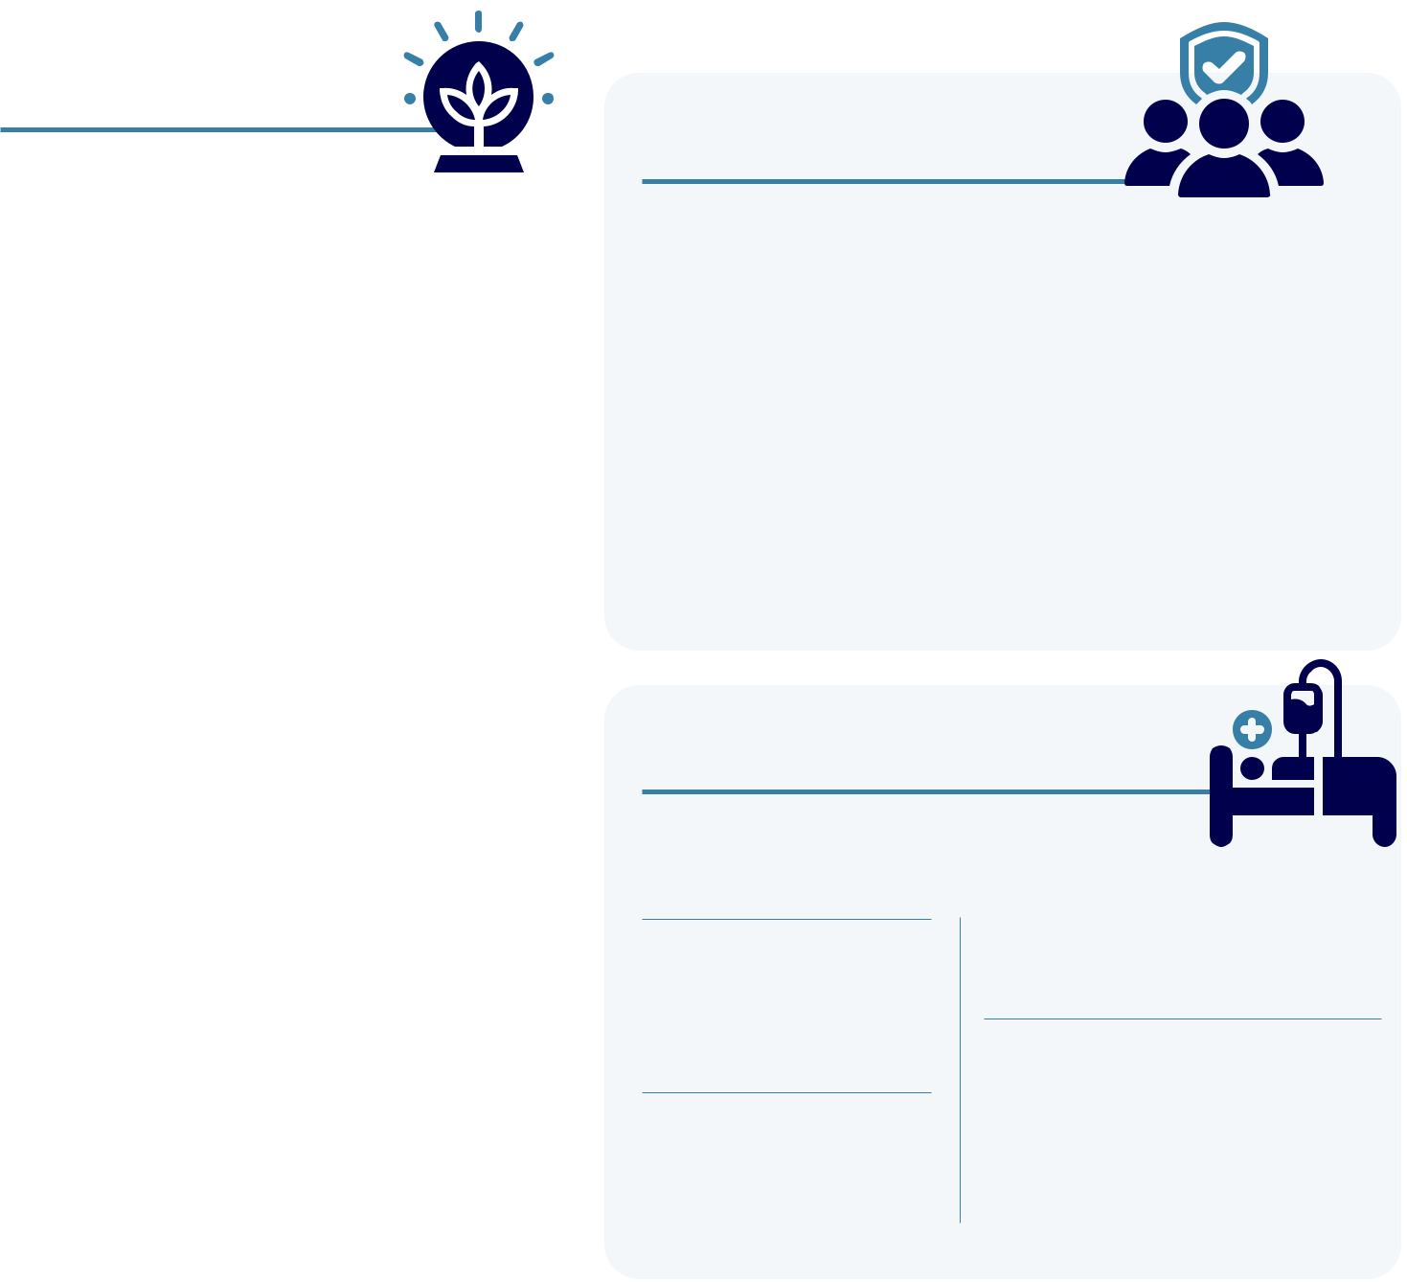

ENVIRONMENT

Supplies |  | Waste
Contracted with third- |  | Ensured strict
party companies for the |  | guidelines and
manufacturing, packaging |  | processes for the safe,
and warehousing of our |  | permanent disposal of
products |  | all unused product

Returns

Received and disposed of 12,480 pounds of damaged and expired products


SOCIAL
Community Involvement

Cumberland Pharma Foundation Contributed to the American Red Cross for Disaster Relief following Hurricane Helene, Denver Health, Vanderbilt University Medical Center, Gettysburg Foundation, Belmont University’s Healthcare Hall of Fame, Mary Parish Center, World Bible School, AACA Museum Endowment Fund & University of Mississippi

Sponsorships

• Nashville Health Care Council’s Wall
Street’s View of Healthcare Event

SOCIAL
Employees

Male – 51% |  |  |  | Turnover – 9.8% for corporate team
Female – 49% |  |  |  | 22.5% for sales team
 |  |  |  | Additions – 23%
Minorities – 27% |  |  |  | Additions – 23%
 |  |  |  | Career Development Program
Ages |  |  | Available to all corporate employees
7% below 30
 |  |  | Cumberland Academy
27% between 30 & 50
 |  |  | Provides industry training for
66% over 50
 |  |  | corporate employees
Tenures |  |  |  | Training |  | Work-related
38% @ 5 or more years |  |  |  | Average $600 |  | injuries
24% @ 10 or more years |  |  |  | per full-time |  | None
12% @ 15 or more years |  |  |  | employee

SOCIAL
Patients
Provided 3.9million doses

of our products to patients

• Alliance for an Affordable (Housing)

Nashville Summit

Associations

- Nashville Health Care Council

- Life Science Tennessee

- Nashville Chamber of Commerce

Life Sciences Center

An incubator to help build the biomedical industry in our area


Drug Safety Results

- No products listed in the FDA’ s MedWatch Safety Alerts

- No products recalled

Patient Affordability

We cover up to 80% of patient Rx costs through coupons for our GI and oncology support brands


Clinical Trials Safety

No trials terminated due to failure to practice good clinical standards

Advocacy Groups Supported

- Muscular Dystrophy Association

- Parent Project Muscular Dystrophy


GOVERNANCE
Board

Independent – 6 of 7 Tenure – Average 10.8 years Age – Average 67 years Male/ Female – 6/1 Turnover – None

Board
Meeting |  | GOVERNANCE
Attendance |  | GOVERNANCE
100% |  | Government Relations
Standing |  | Cumberland Health
Committee |  | & Wellness PAC
Attendance |  | Supports candidates,
100% |  | elected officials and
100% |  | relevant legislation

GOVERNANCE
Compliance

Code of Conduct
Establishes guidelines for all Board members and employees

Ethical Marketing |  | Health Care
No government |  | Professionals
judgments, decrees |  | All reports regarding
or fines |  | relations filed on time
 |  | 2024 Annual Report | 9



Intravenous Ibuprofen

Now Approved for Treating Pain and Fever in Adults, Children & Newborns

Your Non-Opioid Pain Management Solution

The non-narcotic agent may now be administered for the treatment of pain and fever in patients 3 to 6 months of age. With this newly approved labeling, Caldolor is the only non-opioid product approved to treat pain in infants that is delivered through injection.



Board of Directors


A.J. Kazimi
Chairman

Chief Executive Officer

Cumberland Pharmaceuticals



Kenneth J. Krogulski | James R. Jones
Lead Director | James R. Jones
Lead Director | Director
Managing Partner and | Director
Managing Partner and | Former Managing Partner
Chief Investment Officer | Former Managing Partner
Chief Investment Officer | KPMG LLP-Nashville
Berkshire Asset Management | KPMG LLP-Nashville
Dr. Gordon R. Bernard | Joseph C. Galante
Dr. Gordon R. Bernard | Director
Director | Director
Director | Former Chairman
Professor of Medicine | Former Chairman
Professor of Medicine | Sony Music Nashville
Division of Pulmonary & Critical Care Medicine | Sony Music Nashville
Division of Pulmonary & Critical Care Medicine | Former President
Vanderbilt University Medical Center | Former President
Vanderbilt University Medical Center | RCA Records
Caroline R. Young | Martin S. Brown
Director | Martin S. Brown
Director | Director
Vice President of Partnership | Director
Vice President of Partnership | Attorney of Counsel
Development | Attorney of Counsel
Development | Adams and Reese LLP
Frist Cressey Ventures | Adams and Reese LLP
Frist Cressey Ventures | Former Board Director
Former President | Former Board Director
Former President | Brown-Forman Corporation
Nashville Health Care Council | Brown-Forman Corporation


2024 Annual Report 11


Selected Financial Data

Our strategy involves maximizing the potential of our existing brands while continuing to build a portfolio of unique, differentiated products. The result of these efforts has strengthened our market presence and diversified our revenue stream in 2024.

(dollars in thousands except per share data) | 2020 |  |  | 2021 |  |  | 2022 |  | 2023 |  |  | 2024
Net Revenues | $37,441 |  |  | $35,985 |  |  | $42,011 |  | $39,553 |  |  | $37,868
Less Total Expenses | 40,780 |  |  | 39,493 |  |  | 47,661 |  | 45,884 |  |  | 44,312
Net Income (Loss)
Net Income (Loss) | (3,339) |  |  | (3,508) |  |  | (5,650) |  | (6,331) |  |  | (6,444)
Cash Flow from Operating Activities | 5,415 |  |  | 6,342 |  |  | 8,453 |  | 6,094 |  |  | (612)
Total Assets | 96,463 |  |  | 84,460 |  |  | 92,925 |  | 81,776 |  |  | 75,583
Total Liabilities | 49,590 |  |  | 41,858 |  |  | 56,951 |  | 52,516 |  |  | 53,037
Total Equity | 46,873 |  |  | 42,602 |  |  | 35,974 |  | 29,260 |  |  | 22,546

Reconciliation of Net Income (Loss) Attributable to Common Shareholders to Adjusted Earnings and Adjusted Diluted Earnings Per Share (1) (Unaudited)

(dollars in thousands except per share data) | 2020 |  |  | 2021 |  | 2022 |  |  | 2023 |  | 2024
Net Income (Loss) from Continuing
Operations | ($6,625) |  |  | ($5,597) |  | ($5,650) |  |  | ($6,331) |  | ($6,444)
Adjustments to Net Income (Loss)
Income Tax Expense (Benefit) | 56 |  |  | 35 |  | 69 |  |  | 46 |  | (23)
Depreciation and Amortization | 4,749 |  |  | 4,606 |  | 5,328 |  |  | 8,280 |  | 4,902
Share-Based Compensation | 1,047 |  |  | 742 |  | 447 |  |  | 365 |  | 302
Other Adjustments to Net Income (1) | 440 |  |  | (1,051) |  | 1,368 |  |  | - |  | -
Interest Income | (75) |  |  | (26) |  | (98) |  |  | (287) |  | (334)
Interest Expense |  | 263 |  | 98 |  |  | 586 |  | 668 |  | 606
Adjusted Earnings
Adjusted Earnings |  | ($146) |  | ($1,193) |  |  | $2,050 |  | $2,741 |  | ($991)
Adjusted Diluted Earnings per Share |  | ($0.01) |  | ($0.08) |  |  | $0.14 |  | $0.20 |  | ($0.07)
Diluted Weighted-Average Common
Shares Outstanding: | 15,162 |  |  | 14,905 |  | 14,809 |  |  | 14,526 |  | 14,060

(1) The supplemental financial measures are Non-GAAP as defined, the reconciliation of these supplemental measures is above.

- Cumberland Pharmaceuticals



Corporate Information

Stock Listing

Nasdaq Global Select

Market Ticker Symbol: CPIX

Annual Meeting

9:30 a.m. Central Time

Tuesday, April 22, 2025

Cumberland Headquarters

1600 West End Avenue, Suite 1300 Nashville, TN 37203

Independent Registered Public Accounting Firm

Carr, Riggs & Ingram, LLC

3011 Armory Drive, Suite 300

Nashville, TN 37204

(615) 665-1811

Transfer Agent and

Registrar

Continental Stock Transfer

& Trust Company

1 State Street, 30th Floor

New York, NY 10004

- 509-5586

- 509-4000 cstmail@continentalstock.com

Forward-Looking

Statements

This annual report includes forward-

looking statements regarding expected

future results of the Company. A variety

of factors could cause actual results

to differ materially from expected

results. Please see the risk factors

more fully described in our Annual

Report on Form 10-K for the year ended

December 31, 2024, which is filed

with the U.S. Securities and Exchange

Commission.

Company Headquarters

Cumberland Pharmaceuticals Inc.

1600 West End Avenue, Suite 1300

Nashville, TN 37203

Phone: (615) 255-0068

Toll Free: (877) 484-2700

Fax: (615) 255-0094

2024 Annual Report 13



