

Quality Medicines to Enhance Patients’ Quality of Life

2022 Annual Report

2022 Highlights


A New Brand, New Partnerships, New Horizons

- Acquired & Launched New Oncology Medicine – January


2 | Entered into
 | New Agreement
 | for Vibativ in the
 | Middle East – March


To Our

Shareholders, Employees & Partners:

We acquired the U.S. rights, from Japan-based Kyowa Kirin, to Sancuso, the first and only FDA-approved prescription patch for the prevention of nausea and vomiting in patients receiving certain types of chemotherapy treatment. To support Sancuso, we established a dedicated oncology sales division, Cumberland Oncology, which will feature the newest addition to our portfolio.

- Formed New Partnership

for Mexico – October


We announced an agreement with PiSA Pharmaceutical for the registration and commercialization in Mexico of Caldolor – Cumberland’s non-narcotic pain relief product. When administered immediately before surgery, Caldolor enables patients to wake up after their procedure in significantly less pain and then continue to experience significantly less pain during their recovery. It can also considerably reduce the need for post-operative opioids and improve patients’ quality of life by reducing opioid-related side effects and the potential for addiction.

We established distribution for our Vibativ product in the Middle East, through a partnership with Tabuk Pharmaceutical Manufacturing Company. Vibativ is a potentially life-saving treatment for patients with hospital-acquired and ventilator-associated pneumonia resulting from

- range of Gram-positive bacterial pathogens, including those that are considered difficult-to-treat and are multidrug-resistant. Through our partnership, Tabuk will introduce the product in Saudi Arabia, Jordan and potentially other countries in the Middle East.

- Opened New Headquarters – November


We opened our new headquarter offices at the Broadwest campus in the Vanderbilt/West End corridor of Nashville. Our move allows the company to accommodate our growth, support our team, and better serve our international base of customers and partners.

We welcomed a return to a more typical operating environment as 2022 progressed, following the economic and societal effects of the pandemic. We were excited to see enrollment in our clinical trials resume, patient procedures return to more customary levels and access for our sales representatives improve as they gained more face-to-face meetings with medical professionals.

What the pandemic did not change was our mission to deliver high-quality medicines to improve patient care.

We remained focused on further expanding our product portfolio, starting the year with the exciting and significant announcement of our Sancuso® acquisition from the U.S. affiliate of Japan-based Kyowa Kirin. During the year, we successfully transitioned Sancuso from Kyowa Kirin and we’re supporting the brand through our new sales division

– Cumberland Oncology. Sancuso is designed to support cancer patients and we are honored to provide this unique product to patients throughout the U.S. who can benefit from it.

While Cumberland remains focused on featuring our Caldolor® and Vibativ® brands in the United States, we’re excited and eager to bring the products to patients in other countries.

In the fourth quarter of 2022, we entered into an agreement with PiSA Pharmaceutical for the exclusive supply and distribution of our Caldolor product in Mexico. We believe Caldolor will serve an important role in the careful management of pain there, and we’re pleased to work with PiSA to establish a successful partnership.

Earlier in 2022, we announced a new partnership with Saudi-based Tabuk Pharmaceutical to introduce Vibativ into the Middle East. The arrangement provides Tabuk exclusive rights to distribute Vibativ in Saudi Arabia and Jordan, with the option to expand into other countries in the region.

Meanwhile, our Vibativ partner for the Chinese market, SciClone Pharmaceuticals, had their approval application in China accepted for review in September 2021. We’ve since been supporting SciClone and their requests associated with review of that submission. They are working toward the approval and believe that there is significant potential for Vibativ in their country.

In addition to expanding our international partnerships, we’re working to build a pipeline of innovative products that address unmet medical needs. These product candidates are designed to improve patient care and patients’ quality of life. In 2022, we continued efforts to progress our series of Phase II clinical trials. We look forward to sharing the results from these studies as they emerge and then advancing these development programs, which we believe have the potential to help many patients.

Toward the end of the year, we moved into our new headquarter offices on the Broadwest campus in the Vanderbilt/West End corridor of Nashville. We are delighted to continue our presence and participation in the Nashville health care community, which represents the largest concentration of health care companies in the U.S. Our new headquarters also keeps us close to the Vanderbilt Medical Center, where we continue our collaboration to develop innovative new medicines. The new, state-of-the-art facility allows us to accommodate our growth, support our team and better serve our patients, customers and partners.

While we’re pleased to share so many exciting developments contributing to our growth, we also understand the importance of recognizing and addressing our impact on the environment, our employees and the community. Last year, we shared our 2021 Sustainability Report, outlining our activities pertaining to environmental, social and governance issues. This year, we have added a table to this annual report sharing an update on our key sustainability metrics for 2022.

With a new product to promote in Sancuso, an improving operating environment and a robust pipeline, we’re very optimistic about our future and look forward to delivering quality medicines to enhance patients’ quality of life.

All the best,


AJ Kazimi
Chairman and Chief Executive Officer

Cumberland Pharmaceuticals — Quality Medicines to Enhance Patients’ Quality of Life

2022 Annual Report 1

Better Medicines for Better Lives

Our Portfolio Continues to Expand in Order to Improve Patient Care

In developing and acquiring medicines, we focus on medical conditions that do not currently have a satisfactory treatment, targeting specialty markets including hospital acute care, gastroenterology and oncology.

Our portfolio of FDA-approved brands continues to fulfill our mission of providing medicines that enhance patients’ quality of life. These products are promoted through our hospital, field and oncology sales divisions throughout the United States, and internationally through select partnerships.
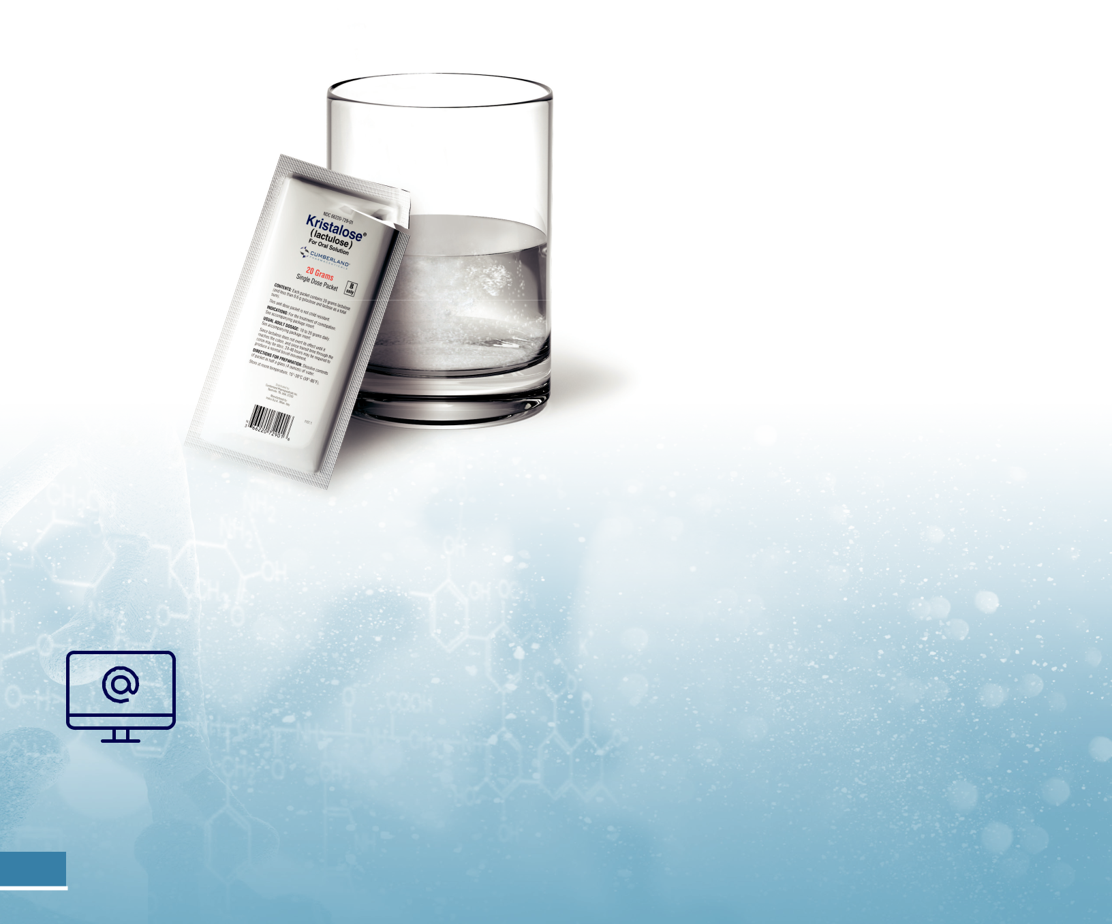

Our commercial product line includes the brands shown to the right.

For more information on Cumberland’s approved products,

including full prescribing information, please visit links to

the individual product websites, which can be found on the

company’s website, www.cumberlandpharma.com.

(acetylcysteine)
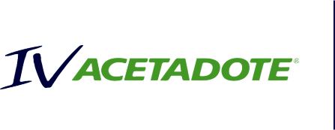

An injection used for the treatment of acetaminophen poisoning, the leading cause of drug toxicity in the U.S.

(ibuprofen)


The first injectable therapy approved in the U.S. for the treatment of both pain and fever

(lactulose)


The only branded prescription laxative product that combines the established safety and efficacy of lactulose with the convenience and portability of a pre-measured dose

(granisetron)


The first and only FDA-approved prescription patch that prevents nausea and vomiting in patients receiving certain types of chemotherapy treatment

(conivaptan)

The first and only intravenously administered vasopressin receptor antagonist, which is used to raise serum sodium levels in hospitalized patients with euvolemic and hypervolemic hyponatremia


(telavancin)

An injection used for the treatment of certain serious bacterial infections including hospital-acquired and ventilator-associated bacterial pneumonia, as well as complicated skin and skin structure infections


2 Cumberland Pharmaceuticals — Quality Medicines to Enhance Patients’ Quality of Life 2022 Annual Report 3

New to the Product Line: Sancuso

Helping Patients Find Relief From Chemotherapy Side Effects
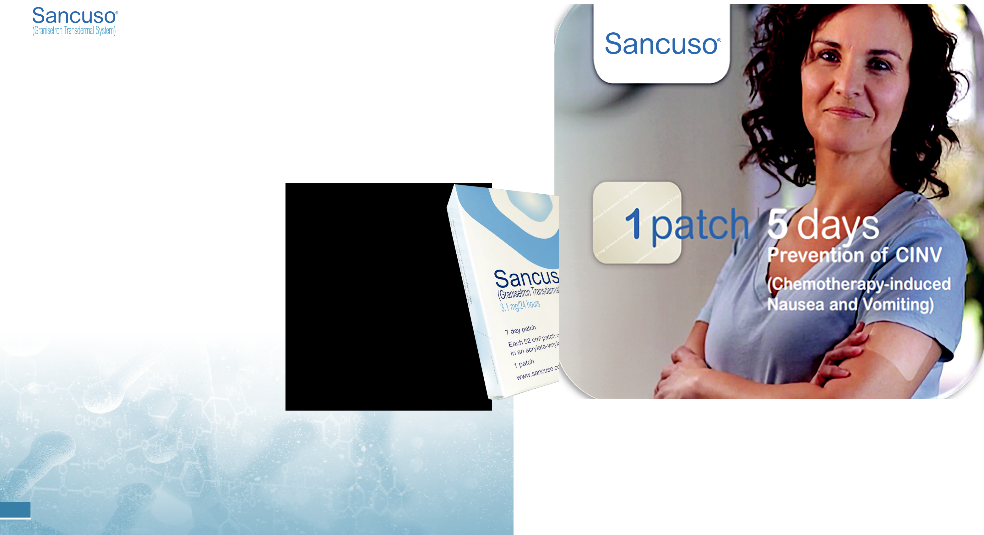

The newest addition to our portfolio, Sancuso is a unique patented oncology support product – the first and only FDA-approved prescription patch for the prevention of nausea

and vomiting in cancer patients receiving certain types of chemotherapy treatment.

The active drug in Sancuso, granisetron, slowly dissolves through a thin layer that adheres to the patient’s skin and is released into their bloodstream over several days, working continuously to prevent chemotherapy-induced nausea and vomiting. It is applied 24 to 48 hours before receiving chemotherapy and can prevent nausea and vomiting for up to five consecutive days. Alternative oral treatments must be taken several times (day and night) to deliver the same therapeutic doses.

There were an estimated 1.9 million new cases of cancer in the U.S. in 20221 and each year more than 1 million Americans undergo chemotherapy2, with many suffering from the side effects of their treatment.

With Sancuso, patients are given a simple, easy-to-apply preventative solution that does not require swallowing pills

– which can be difficult for patients experiencing nausea. We are honored to introduce this brand through our commercial organization, ensuring that it is delivered to the patients across the country who can benefit from it.

- https://www.cancer.org/latest-news/facts-and-figures-2022.html

- https://www.cdc.gov/cancer/preventinfections/providers.htm

4 Cumberland Pharmaceuticals — Quality Medicines to Enhance Patients’ Quality of Life 2022 Annual Report 5

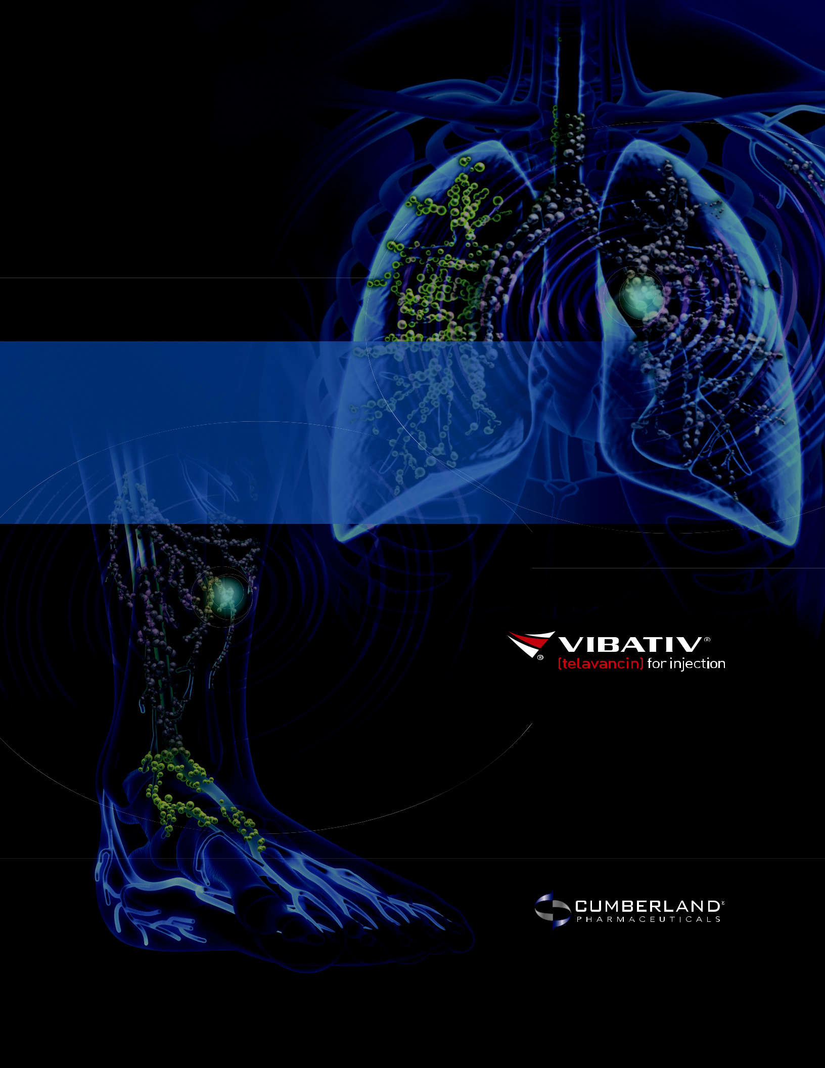

WHEN YOUR FIRST ANTIBIOTIC FAILS
Serious bacterial infections

need serious antibiotics.

For more information, including full prescribing

and safety information, visit www.vibativ.com.

The Impact of Our Science
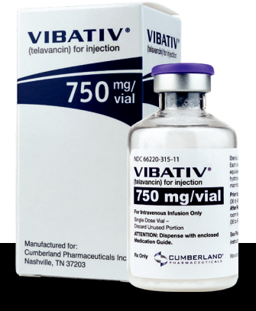

Patients Who Have Benefited
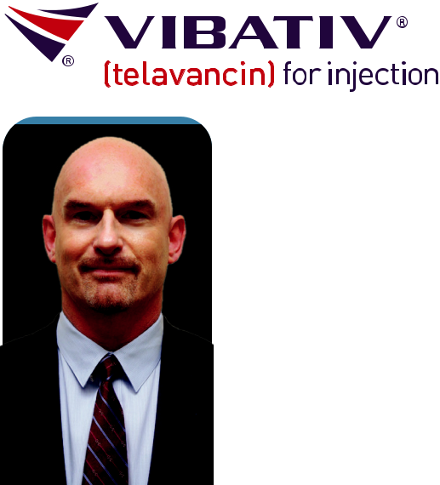

“A 51-year-old patient with diabetes, heart disease and other underlying health conditions was admitted to the hospital for COVID-19. He developed MSSA hospital-acquired bacterial pneumonia, and initial treatment with vancomycin resulted in no notable improvement in the patient’s condition. His antibiotic was then switched to Vibativ (telavancin), and within 48 hours he experienced clinical improvement with blood cultures clear of bacteria. He was cured of pneumonia, had no reported adverse events to Vibativ and was discharged to home.”



Dr. Joseph Reilly, PharmD

Clinical Pharmacist Specialist

Infectious Disease Residency Program Director
Atlanticare Regional Medical Center | Pomona, NJ

Cumberland’s Vibativ has been used across the country to help patients who develop secondary bacterial infections in their lungs. This case study illustrates that once-daily dosing of telavancin can effectively and safely treat pneumonia due to Gram-positive infection among COVID-19 and other patients.

“He was cured of pneumonia, had no reported adverse events to Vibativ and was discharged to home.”

2022 Annual Report 7

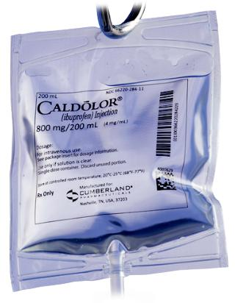


The Impact of Our Science

Patients Who Have Benefited



“I was admitted to the emergency room after a biking accident that caused a tibial plateau fracture on my left leg and a split laceration down to the muscle on my forearm. Rather than getting generic ketorolac or any opioids to manage the pain as my lacerations were sewn up, I received 800 milligrams of Caldolor (intravenous ibuprofen) through a rapid infusion. Caldolor has a 10-milligram morphine equivalency with none of the opioid side effects, so Caldolor is all I needed for pain control for those few hours I was at the hospital.”

Dr. Stephen Southworth, M.D.

Orthopaedic Surgeon

Orthopaedic Institute of North Mississippi | Tupelo, MS

In addition to receiving Cumberland’s Caldolor as a patient himself, Dr. Southworth has conducted his own research on the drug and has used it in over 2,000 surgical procedures at one of the largest regional medical centers in the country. Patients who receive Caldolor have been shown to wake up from their procedure in significantly less pain, then remain in significantly less pain, while also needing significantly fewer opioids.



“so Caldolor is all I needed for pain control those few hours I was at the hospital”

2022 Annual Report 9


Developing New Medicines for Better Quality of Life

We enjoy a robust pipeline of new medicines designed to address a variety of unmet medical needs and improve patients’ quality of life.

Our Pipeline of Product Candidates Includes:

Preclinical IND Phase I Phase II Phase III NDA

Boxaban®

Sustainability


2022 at a Glance

Environment

Supplies |  | Waste
Contract with third party |  | Ensure strict
companies for the |  | guidelines and
manufacturing, packaging |  | processes for the safe,
and warehousing of our |  | permanent disposal of
products |  | all unused product
Returns |  | pounds of
Received and |  | damaged and
disposed of | 2,756expired products.

Social
Community
Involvement

Social

Employees

Male – 55.3% |  |  |  | Turnover – 17%
Female – 44.7%
 |  |  |  | Additions – 11%
Minorities – 15.3%
 |  |  |  | Career Development Program
 |  |  | Available to all corporate employees
Ages
7% below 30 |  |  | Cumberland Academy
26% between 30 & 50, |  |  | Provides industry training for
67% over 50 |  |  | corporate employees
Tenures |  |  |  | Training |  |  | Work-related
36% @ 5 or more years, |  |  |  | Average $4,000 |  |  | injuries
27% @ 10 or more years, |  |  |  | per full-time |  |  | None
8% @ 15 or more years |  |  |  | employee


Dyscorban®

Vasculan®

Cumberland Pharma Foundation

Contributed to Denver Health,

MSU Foundation, TN State Museum,

American Heart Association,

TN Historical Society &

University of Mississippi

Sponsorships

- Nashville Healthcare Awards

- Wall Street’s View of Healthcare

- Women to Watch in Healthcare Event

Associations

- Nashville Health Care Council

- Life Science Tennessee

- Nashville Chamber of Commerce

Life Sciences Center

Helping to build the biomedical industry in middle Tennessee


Social
Patients
Product 2.2

Provided _{million patient doses}

Drug Safety Results

- No products listed in the FDA’ s MedWatch Safety Alerts

- No products identified in the FDA Adverse Event Reporting System

- No products recalled

Patient AffordAbility — We cover up to 80% of patient Rx costs through coupons for our GI brands


Clinical Trials Safety No trials terminated due to failure to practice good clinical standards

Advocacy Groups

Supported

- Muscular Dystrophy Association and

- Parent Project Muscular Dystrophy


Governance
Board

Independent – 7 of 8 Tenure – Average 9.1 years

Age – Average 65 years Male/ Female – 5/1 Turnover – None

 |  |  |  | Governance
 |  |  |  | Compliance
 | Governance |  |  |  | Code of Conduct
 |  |  |  |  | Establishes guidelines for all
 | Government |  |  |  | Board members and employees
Board | Relations
Meeting |  |  |  |  | Ethical Marketing |  |  | Health Care
Attendance | Cumberland Health & |  |  |  |  |  |  | Health Care
100% |  |  |  |  | No government |  |  | Professionals
100% | Wellness PAC |  |  |  | judgments, decrees |  |  | All reports regarding
100% | Supports candidates, |  |  |  | or fines |  |  | relations filed on time
 | elected officials, and
 | relevant legislation

10 Cumberland Pharmaceuticals — Quality Medicines to Enhance Patients’ Quality of Life 2022 Annual Report 11

Selected Financial Data

Our growth strategy involves maximizing the potential of our existing brands while continuing to build a portfolio of differentiated products. The result of these efforts has strengthened our market presence, diversified our revenue stream, and delivered positive cash flow from operations in 2022.


(dollars in thousands except per share data) | 2018 |  | 2019 |  | 2020 |  | 2021 |  | 2022
Net Revenues | $ 40,742 |  | $ 34,388 |  | $ 37,441 |  | $ 35,985 |  | $ 42,011
Less Total Expenses | 47,705 |  | 37,926 |  | 40,780 |  | 39,493 |  | 47,581
Net Income (Loss)
Net Income (Loss) | (6,963) |  | (3,538) |  | (3,339) |  | (3,508) |  | (5,570)
Cash Flow from Operating Activities | 3,112 |  | 3,056 |  | 5,415 |  | 6,342 |  | 8,453
Total Assets | 112,694 |  | 104,549 |  | 96,463 |  | 84,460 |  | 92,925
Total Liabilities | 57,123 |  | 53,464 |  | 49,590 |  | 41,858 |  | 56,951
Total Equity | 55,571 |  | 51,085 |  | 46,873 |  | 42,602 |  | 35,974

Reconciliation of Net Income (Loss) Attributable to Common Shareholders to Adjusted Earnings and Adjusted Diluted Earnings Per Share (1) (Unaudited)


(dollars in thousands except per share data) |  | 2018 |  | 2019 |  | 2020 |  |  | 2021 |  |  | 2022
Net Income (Loss) from Continuing
Operations | $ | (7,039) | $ | (9,212) | $ | (6,569) |  | $ | (5,597) |  | $ | (5,650)
Adjustments to Net Income (Loss)
Income Tax Expense (Benefit) |  | 17 |  | (79) |  | 56 |  |  | 35 |  |  | 69
Depreciation and Amortization |  | 2,983 |  | 4,404 |  | 4,749 |  |  | 4,606 |  |  | 5,328
Share-Based Compensation |  | 1,365 |  | 1,486 |  | 1,047 |  |  | 742 |  |  | 447
Other Adjustments to Net Income (1) |  | – |  | – |  | 440 |  |  | (1,051) |  |  | 1,368
Interest Income |  | (564) |  | (243) |  | (75) |  |  | (26) |  |  | (98)
Interest Expense |  | 196 |  | 246 |  | 264 |  |  | 98 |  |  | 586
Adjusted Earnings
Adjusted Earnings | $ | (3,043) | $ | (3,398) | $ | (146) |  | $ | (1,193) |  | $ | 2,050
Adjusted Diluted Earnings per Share | $ | (0.19) | $ | (0.22) | $ | (0.01) |  | $ | (0.08) |  | $ | 0.14
Diluted Weighted-Average Common
Shares Outstanding: |  | 15,614 |  | 15,396 |  | 15,162 |  |  | 14,905 |  |  | 14,809

(1) The supplemental financial measures are Non-GAAP as defined, the reconciliation of these supplemental measures is above.

Board of Directors



A.J. Kazimi James R. Jones
Chairman Director

Chief Executive Officer Former Managing Partner

Cumberland Pharmaceuticals KPMG LLP-Nashville



Dr. Gordon R. Bernard Kenneth J. Krogulski
Director Lead Director

Executive Vice President for Research President and Chief Investment Officer

Vanderbilt University Medical Center Berkshire Asset Management


Martin S. Brown Caroline R. Young
Director Director

Attorney of Counsel Vice President of Partnership Development

Adams and Reese LLP First Cressey Ventures

Former Board Director Former President

Brown-Forman Corporation Nashville Health Care Council



Joseph C. Galante
Director

Former Chairman

Sony Music Nashville

Former President

RCA Records

In Memoriam

We were deeply saddened to lose two of our dedicated board members over the last year – Marty Cearnal and Joey Jacobs. Each was an outstanding leader, valued colleague and dear friend to many.


MARTIN E. CEARNAL | JOEY JACOBS
MARTIN E. CEARNAL | Former Chairman and Chief
Former Chief Commercial Officer | Executive Officer
Cumberland Pharmaceuticals | Acadia Healthcare Co. Inc.
Former President | Former Chairman and
Cumberland Sales Corporation | Chief Executive Officer
 | Psychiatric Solutions, Inc.

12 Cumberland Pharmaceuticals — Quality Medicines to Enhance Patients’ Quality of Life 2022 Annual Report 



Corporate Information

Stock Listing

NASDAQ Global Select

Market Ticker Symbol: CPIX

Annual Meeting

9:30 a.m. Central Time

Tuesday, April 25, 2023

Cumberland Headquarters

1600 West End Avenue, Suite 1300 Nashville, TN 37203

Independent Registered Public Accounting Firm

FORVIS, LLP

1222 Demonbreun Street, Suite 950 Nashville, TN 37203
(615) 454-9800

Transfer Agent and

Registrar

Continental Stock Transfer

& Trust Company

1 State Street, 30th Floor

New York, NY 10004

- 509-5586

- 509-4000 cstmail@continentalstock.com

Forward-Looking Statements

This annual report includes forward-looking statements regarding expected future results of the company. A variety of factors could cause actual results to differ materially from expected results. Please see the risk factors more fully described in our Annual Report on Form 10-K for the year ended December 31, 2022, which is filed with the U.S.

Securities and Exchange Commission.

Company Headquarters

Cumberland Pharmaceuticals Inc.

1600 West End Avenue,

Suite 1300

Nashville, TN 37203

Phone: (615) 255-0068

Toll Free: (877) 484-2700

Fax: (615) 255-0094

