UNITED STATES

SECURITIES AND EXCHANGE COMMISSION

WASHINGTON, DC 20549

FORM 10-Q

(Mark One)

- QUARTERLY REPORT PURSUANT TO SECTION 13 OR 15(d) OF THE SECURITIES EXCHANGE ACT OF 1934

For the quarterly period ended September 30, 2021

OR

- TRANSITION REPORT PURSUANT TO SECTION 13 OR 15(d) OF THE SECURITIES EXCHANGE ACT OF 1934

 |  | For the transition period from |  |  |  | to | .
 |  |  | Commission file number: 001-33637
Cumberland Pharmaceuticals Inc.
 | (Exact Name of Registrant as Specified In Its Charter)
Tennessee |  |  |  |  |  |  | 62-1765329
(State or Other Jurisdiction of |  |  |  |  |  |  | (I.R.S. Employer
Incorporation or Organization) |  |  |  |  |  |  | Identification No.)
2525 West End Avenue, Suite 950, |  |  |  |  |  |  | 37203
Nashville, Tennessee |  |  |  |  |  |  | 37203
(Address of Principal Executive Offices) |  |  |  |  |  |  | (Zip Code)
 | (615) 255-0068
 |  |  | (Registrant’s Telephone Number, Including Area Code)
 | Securities registered pursuant to Section 12(b) of the Act:
Class |  |  | Trading Symbol |  |  |  | Name of exchange on which registered
Common stock, no par value |  |  | CPIX |  |  |  | Nasdaq Global Select Market

Indicate by check mark whether the registrant (1) has filed all reports required to be filed by Section 13 or 15(d) of the Securities Exchange Act of 1934 during the preceding 12 months (or for such shorter period that the registrant was required to file such reports), and (2) has been subject to such filing requirements for the past 90 days. Yes ☒ No ☐

Indicate by check mark whether the registrant has submitted electronically every Interactive Data File required to be submitted pursuant to Rule 405 of Regulation S-T (§232.405 of this chapter) during the preceding 12 months (or for such shorter period that the registrant was required to submit such files.) Yes ☒ No ☐

Indicate by check mark whether the registrant is a large accelerated filer, an accelerated filer, a non-accelerated filer, a smaller reporting company, or an emerging growth company. See the definitions of “large

accelerated | filer,” | “accelerated | filer,” | “smaller | reporting | company,” | and | “emerging | growth | company” | in | Rule | 12b-2 | of | the | Exchange | Act.
Large accelerated filer |  |  |  | ☐ |  |  |  |  |  |  | Accelerated filer |  |  |  |  |  | ☐
Non-accelerated filer |  |  |  | ☒ |  |  |  |  |  |  | Smaller reporting company |  |  |  |  |  | ☒
Emerging growth company |  |  |  | ☐

If an emerging growth company, indicate by check mark if the registrant has elected not to use the extended transition period for complying with any new or revised financial accounting standards provided pursuant to Section 13(a) of the Exchange Act. ☐

Indicate by check mark whether the registrant is a shell company (as defined in Rule 12b-2 of the Exchange Act). Yes ☐ No ☒

Indicate the number of shares outstanding of each of the issuer’s classes of common stock, as of the latest practicable date: 14,809,628 shares of common stock as of November 8, 2021.

CUMBERLAND PHARMACEUTICALS INC.

INDEX

 | PART I – FINANCIAL INFORMATION |  |  |  |  |  |  |  |  |  |  |  |  |  |  |  |  |  |  | 1
 |  | Item 1. Financial Statements (Unaudited) |  |  |  |  |  |  |  |  |  |  |  |  |  |  |  |  |  | 1
 |  |  | Condensed Consolidated Balance Sheets |  |  |  |  |  |  |  |  |  |  |  |  |  |  |  |  | 1
 |  |  | Condensed Consolidated Statements of Operations |  |  |  |  |  |  |  |  |  |  |  |  |  |  |  |  | 2
 |  |  | Condensed Consolidated Statements of Cash Flows |  |  |  |  |  |  |  |  |  |  |  |  |  |  |  |  | 3
 |  |  | Condensed Consolidated Statements of Equity |  |  |  |  |  |  |  |  |  |  |  |  |  |  |  |  | 4
 |  |  | Notes to the Unaudited Condensed Consolidated Financial Statements |  |  |  |  |  |  |  |  |  |  |  |  |  |  |  |  | 5
 |  | Item 2. Management’s Discussion and Analysis of Financial Condition and Results of Operations |  |  |  |  |  |  |  |  |  |  |  |  |  |  |  |  |  | 15
 |  | Item 3. Quantitative and Qualitative Disclosures About Market Risk |  |  |  |  |  |  |  |  |  |  |  |  |  |  |  |  |  | 28
 |  | Item 4. |  | Controls and Procedures |  |  |  |  |  |  |  |  |  |  |  |  |  |  |  | 28
 | PART II – OTHER INFORMATION |  |  |  |  |  |  |  |  |  |  |  |  |  |  |  |  |  |  | 29
 |  | Item 1. |  | Legal Proceedings |  |  |  |  |  |  |  |  |  |  |  |  |  |  |  | 29
 |  | Item 1A. Risk Factors |  |  |  |  |  |  |  |  |  |  |  |  |  |  |  |  |  | 29
 |  | Item 2. |  | Unregistered Sales of Equity Securities and Use of Proceeds |  |  |  |  |  |  |  |  |  |  |  |  |  |  |  | 29
 |  | Item 6. |  | Exhibits |  |  |  |  |  |  |  |  |  |  |  |  |  |  |  | 30
 | SIGNATURES |  |  |  |  |  |  |  |  |  |  |  |  |  |  |  |  |  |  | 31

 |  | PART I – FINANCIAL INFORMATION
Item 1. Financial Statements (Unaudited)
 |  | CUMBERLAND PHARMACEUTICALS INC. AND SUBSIDIARIES
 |  | Condensed Consolidated Balance Sheets
 |  | (Unaudited)
 |  |  |  | September 30, 2021 |  |  | December 31, 2020
 | ASSETS
 | Current assets:
 | Cash and cash equivalents | $ |  | 25,843,231 |  | $ | 24,753,796
 | Accounts receivable, net |  |  | 9,850,530 |  |  | 12,377,713
 | Inventories |  |  | 10,262,769 |  |  | 10,638,157
 | Prepaid and other current assets |  |  | 1,259,098 |  |  | 2,199,926
 | Total current assets |  |  | 47,215,628 |  |  | 49,969,592
 | Non-current inventories |  |  | 9,476,737 |  |  | 11,656,742
 | Property and equipment, net |  |  | 493,488 |  |  | 574,169
 | Intangible assets, net |  |  | 24,918,830 |  |  | 28,118,316
 | Goodwill |  |  | 882,000 |  |  | 882,000
 | Operating lease right-of-use assets |  |  | 1,282,275 |  |  | 2,028,148
 | Other assets |  |  | 3,301,816 |  |  | 3,234,338
 | Total assets |  | $ | 87,570,774 |  | $ | 96,463,305
 | LIABILITIES AND EQUITY
 | Current liabilities:
 | Accounts payable | $ |  | 9,233,383 |  | $ | 13,396,286
 | Operating lease current liabilities |  |  | 1,094,187 |  |  | 1,016,779
 | Other current liabilities |  |  | 7,617,913 |  |  | 11,254,381
 | Total current liabilities |  |  | 17,945,483 |  |  | 25,667,446
 | Revolving line of credit |  |  | 15,000,000 |  |  | 15,000,000
 | Operating lease noncurrent liabilities |  |  | 229,605 |  |  | 1,059,693
 | Other long-term liabilities |  |  | 7,749,421 |  |  | 7,862,772
 | Total liabilities |  |  | 40,924,509 |  |  | 49,589,911
 | Commitments and contingencies
 | Equity:
 | Shareholders’ equity:
 | Common stock—no par value; 100,000,000 shares authorized; 14,850,526 and 14,988,429 shares issued and |  |  | 48,612,935 |  |  | 49,121,523
 | outstanding as of September 30, 2021 and December 31, 2020, respectively |  |  | 48,612,935 |  |  | 49,121,523
 | Retained earnings (deficit) |  |  | (1,790,903) |  |  | (2,131,013)
 | Total shareholders’ equity |  |  | 46,822,032 |  |  | 46,990,510
 | Noncontrolling interests |  |  | (175,767) |  |  | (117,116)
 | Total equity |  |  | 46,646,265 |  |  | 46,873,394
 | Total liabilities and equity |  | $ | 87,570,774 |  | $ | 96,463,305

See accompanying Notes to Unaudited Condensed Consolidated Financial Statements.

1

CUMBERLAND PHARMACEUTICALS INC. AND SUBSIDIARIES

Condensed Consolidated Statements of Operations

(Unaudited)

 |  | Three months ended September 30, |  |  |  |  |  | Nine months ended September 30,
 |  | 2021 |  |  | 2020 |  |  | 2021 |  |  | 2020
Net revenues | $ | 8,072,540 |  | $ | 9,250,689 |  | $ | 27,665,182 |  | $ | 27,179,600
Costs and expenses:
Cost of products sold |  | 1,328,027 |  |  | 2,142,839 |  |  | 5,486,005 |  |  | 6,387,002
Selling and marketing |  | 3,800,288 |  |  | 3,587,842 |  |  | 11,709,445 |  |  | 11,160,924
Research and development |  | 1,453,873 |  |  | 1,230,335 |  |  | 4,071,638 |  |  | 4,374,392
General and administrative |  | 2,039,799 |  |  | 2,381,273 |  |  | 6,367,438 |  |  | 6,608,321
Amortization |  | 1,013,948 |  |  | 1,117,086 |  |  | 3,354,080 |  |  | 3,284,610
Total costs and expenses |  | 9,635,935 |  |  | 10,459,375 |  |  | 30,988,606 |  |  | 31,815,249
Operating income (loss) |  | (1,563,395) |  |  | (1,208,686) |  |  | (3,323,424) |  |  | (4,635,649)
Interest income |  | 7,394 |  |  | 12,004 |  |  | 19,411 |  |  | 70,553
Other income |  | — |  |  | — |  |  | 2,187,140 |  |  | —
Interest expense |  | (20,021) |  |  | (75,210) |  |  | (70,297) |  |  | (227,730)
Income (loss) from continuing operations before income taxes |  | (1,576,022) |  |  | (1,271,892) |  |  | (1,187,170) |  |  | (4,792,826)
Income tax (expense) benefit |  | (7,458) |  |  | (3,728) |  |  | (22,375) |  |  | (45,423)
Net income (loss) from continuing operations |  | (1,583,480) |  |  | (1,275,620) |  |  | (1,209,545) |  |  | (4,838,249)
Discontinued operations |  | 496,787 |  |  | 777,916 |  |  | 1,491,004 |  |  | 2,334,811
Net income (loss) |  | (1,086,693) |  |  | (497,704) |  |  | 281,459 |  |  | (2,503,438)
Net (income) loss at subsidiary attributable to noncontrolling interests |  | 31,415 |  |  | 15,967 |  |  | 58,651 |  |  | 47,806
Net income (loss) attributable to common shareholders | $ | (1,055,278) |  | $ | (481,737) |  | $ | 340,110 |  | $ | (2,455,632)
Earnings (loss) per share attributable to common shareholders
- Continuing operations - basic | $ | (0.10) |  | $ | (0.08) |  | $ | (0.08) |  | $ | (0.31)
- Discontinued operations - basic |  | 0.03 |  |  | 0.05 |  |  | 0.10 |  |  | 0.15
 | $ | (0.07) |  | $ | (0.03) |  | $ | 0.02 |  | $ | (0.16)
- Continuing operations - diluted | $ | (0.10) |  | $ | (0.08) |  | $ | (0.08) |  | $ | (0.31)
- Discontinued operations - diluted |  | 0.03 |  |  | 0.05 |  |  | 0.10 |  |  | 0.15
 | $ | (0.07) |  | $ | (0.03) |  | $ | 0.02 |  | $ | (0.16)
Weighted-average shares outstanding
- basic |  | 14,880,887 |  |  | 15,134,583 |  |  | 14,939,919 |  |  | 15,206,179
- diluted |  | 14,880,887 |  |  | 15,134,583 |  |  | 15,139,904 |  |  | 15,206,179

See accompanying Notes to Unaudited Condensed Consolidated Financial Statements.

2

CUMBERLAND PHARMACEUTICALS INC. AND SUBSIDIARIES

Condensed Consolidated Statements of Cash Flows

(Unaudited)

Nine months ended September 30,

 | 2021 |  |  |  | 2020
Cash flows from operating activities:
Net income (loss) | $ | 281,459 |  | $ | (2,503,438)
Discontinued operations |  | 1,491,004 |  |  | 2,334,811
Net income (loss) from continuing operations |  | (1,209,545) |  |  | (4,838,249)
Adjustments to reconcile net income (loss) from continuing operations to net cash provided by operating activities:
Depreciation and amortization expense |  | 3,529,245 |  |  | 3,524,684
Share-based compensation |  | 517,081 |  |  | 805,338
Decrease in non-cash contingent consideration |  | (632,646) |  |  | (806,390)
Decrease (increase) in cash surrender value of life insurance policies over premiums paid |  | (52,070) |  |  | 169,406
Noncash interest expense |  | 33,943 |  |  | 36,197
Gain on forgiveness of debt |  | (2,187,140) |  |  | —
Net changes in assets and liabilities affecting operating activities:
Accounts receivable |  | 2,527,183 |  |  | (1,817,490)
Inventories |  | 2,555,393 |  |  | 1,696,668
Other current assets and other assets |  | 1,627,350 |  |  | 1,962,024
Accounts payable and other current liabilities |  | (2,873,596) |  |  | 3,248,450
Other long-term liabilities |  | (943,439) |  |  | (1,585,584)
Net cash provided by operating activities from continuing operations |  | 2,891,759 |  |  | 2,395,054
Discontinued operations |  | 1,491,004 |  |  | 2,166,086
Net cash provided by operating activities |  | 4,382,763 |  |  | 4,561,140
Cash flows from investing activities:
Additions to property and equipment |  | (94,485) |  |  | (95,189)
Proceeds from surrender of life insurance policies |  | — |  |  | 460,888
Note receivable investment funding |  | (200,000) |  |  | —
Additions to intangible assets |  | (180,613) |  |  | (1,807,467)
Net cash used in investing activities |  | (475,098) |  |  | (1,441,768)
Cash flows from financing activities:
Borrowings on line of credit |  | 45,000,000 |  |  | 44,000,000
Repayments on line of credit |  | (45,000,000) |  |  | (45,500,000)
Cash payment of contingent consideration |  | (1,792,573) |  |  | (834,014)
Repurchase of subsidiary shares from noncontrolling interest |  | — |  |  | (800,000)
Repurchase of common shares |  | (1,025,657) |  |  | (1,551,463)
Net cash used in financing activities |  | (2,818,230) |  |  | (4,685,477)
Net increase (decrease) in cash and cash equivalents |  | 1,089,435 |  |  | (1,566,105)
Cash and cash equivalents at beginning of period | $ | 24,753,796 |  | $ | 28,212,635
Cash and cash equivalents at end of period | $ | 25,843,231 |  | $ | 26,646,530

See accompanying Notes to Unaudited Condensed Consolidated Financial Statements.

3

CUMBERLAND PHARMACEUTICALS INC. AND SUBSIDIARIES

Condensed Consolidated Statements of Equity

(Unaudited)

 |  | Common stock |  |  |  |  |  |  |  | Retained earnings
 |  | Shares |  |  |  |  | Amount |  |  |  |  |  |  | Noncontrolling interests |  |  |  |  |  |  |  | Total equity
 |  |  |  |  |  |  | Amount |  |  |  |  | (deficit) |  |  |  |  |  |  |  |  |  | Total equity
Balance, December 31, 2019 |  | 15,263,555 |  |  | $ |  | 49,914,478 |  | $ |  |  | 1,208,395 |  | $ |  |  | (37,620) |  |  | $ |  | 51,085,253
Share-based compensation |  | 219,850 |  |  |  |  | 264,574 |  |  |  |  | — |  |  |  |  | — |  |  |  |  | 264,574
Repurchase of common shares |  | (164,866) |  |  |  |  | (441,624) |  |  |  |  | — |  |  |  |  | — |  |  |  |  | (441,624)
Net loss |  |  | — |  |  |  | — |  |  |  |  | (1,055,620) |  |  |  |  | (9,525) |  |  |  |  | (1,065,145)
Balance, March 31, 2020 |  | 15,318,539 |  |  | $ |  | 49,737,428 |  | $ |  |  | 152,775 |  | $ |  |  | (47,145) |  |  | $ |  | 49,843,058
Balance, March 31, 2020 |  | 15,318,539 |  |  | $ |  | 49,737,428 | $ |  |  |  | 152,775 |  | $ |  |  | (47,145) |  |  | $ |  | 49,843,058
Share-based compensation |  | 4,200 |  |  |  |  | 278,349 |  |  |  |  | — |  |  |  |  | — |  |  |  |  | 278,349
Repurchase of common shares |  | (141,463) |  |  |  |  | (769,648) |  |  |  |  | — |  |  |  |  | — |  |  |  |  | (769,648)
Net loss |  |  | — |  |  |  | — |  |  |  |  | (918,275) |  |  |  |  | (22,314) |  |  |  |  | (940,589)
Balance, June 30, 2020 |  | 15,181,276 |  |  | $ |  | 49,246,129 |  | $ |  |  | (765,500) |  | $ |  |  | (69,459) |  |  | $ |  | 48,411,170
Balance, June 30, 2020 |  | 15,181,276 |  |  |  | $ | 49,246,129 |  |  | $ |  | (765,500) |  |  |  | $ | (69,459) |  |  | $ |  | 48,411,170
Share-based compensation |  | 4,450 |  |  |  |  | 262,415 |  |  |  |  | — |  |  |  |  | — |  |  |  |  | 262,415
Repurchase of common shares |  | (101,354) |  |  |  |  | (332,504) |  |  |  |  | — |  |  |  |  | — |  |  |  |  | (332,504)
Net loss |  | — |  |  |  |  |  | — |  |  |  | (481,737) |  |  |  |  | (15,967) |  |  |  |  | (497,704)
Balance, September 30, 2020 |  | 15,084,372 | 15,084,372 |  |  | $ | 49,176,040 |  |  |  | $ | (1,247,237) |  |  |  | $ | (85,426) |  |  |  | $ | 47,843,377

 | Common stock |  |  |  |  |  | Retained earnings
 | Shares |  |  | Amount |  |  |  |  | Noncontrolling interests |  |  |  | Total equity
 |  |  |  |  |  |  | (deficit) |  |  |  |  |  | Total equity
Balance, December 31, 2020 | 14,988,429 |  | $ | 49,121,523 |  | $ | (2,131,013) |  | $ | (117,116) |  | $ | 46,873,394
Share-based compensation | 187,759 |  |  | 162,960 |  |  | — |  |  | — |  |  | 162,960
Repurchase of common shares | (91,724) |  |  | (303,088) |  |  | — |  |  | — |  |  | (303,088)
Net income (loss) | — |  |  | — |  |  | 166,828 |  |  | (22,167) |  |  | 144,661
Balance, March 31, 2021 | 15,084,464 |  | $ | 48,981,395 |  | $ | (1,964,185) |  | $ | (139,283) |  | $ | 46,877,927
Balance, March 31, 2021 | 15,084,464 |  | $ | 48,981,395 |  | $ | (1,964,185) |  | $ | (139,283) |  | $ | 46,877,927
Share-based compensation |  |  |  | 191,954 |  |  |  |  |  |  |  |  | 191,954
Repurchase of common shares | (158,405) |  |  | (484,965) |  |  |  |  |  |  |  |  | (484,965)
Net income (loss) |  |  |  |  |  |  | 1,228,560 |  |  | (5,069) |  |  | 1,223,491
Balance, June 30, 2021 | 14,926,059 |  | $ | 48,688,384 |  | $ | (735,625) |  | $ | (144,352) |  | $ | 47,808,407
Balance, June 30, 2021 | 14,926,059 |  | $ | 48,688,384 |  | $ | (735,625) |  | $ | (144,352) |  | $ | 47,808,407
Share-based compensation | 875 |  |  | 162,167 |  |  | — |  |  | — |  |  | 162,167
Repurchase of common shares | (76,408) |  |  | (237,616) |  |  | — |  |  | — |  |  | (237,616)
Net loss | — |  |  | — |  |  | (1,055,278) |  |  | (31,415) |  |  | (1,086,693)
Balance, September 30, 2021 | 14,850,526 |  | $ | 48,612,935 |  | $ | (1,790,903) |  | $ | (175,767) |  | $ | 46,646,265

See accompanying Notes to Unaudited Condensed Consolidated Financial Statements.

4

CUMBERLAND PHARMACEUTICALS INC. AND SUBSIDIARIES

Notes to Condensed Consolidated Financial Statements

(Unaudited)

(1) ORGANIZATION AND BASIS OF PRESENTATION

Cumberland Pharmaceuticals Inc. (“Cumberland,” the “Company,” or as used in the context of “we,” “us,” or “our”) is a specialty pharmaceutical company focused on the acquisition, development and commercialization of branded prescription products. The Company's primary target markets are hospital acute care, gastroenterology and rheumatology. These medical specialties are characterized by relatively concentrated prescriber bases that the Company believes can be penetrated effectively by small, targeted sales forces. Cumberland is dedicated to providing innovative products that improve quality of care for patients and address unmet or poorly met medical needs. The Company promotes its approved products through its hospital and field sales forces in the United States and is establishing a network of international partners to bring its medicines to patients in their countries.

Cumberland focuses its resources on maximizing the commercial potential of its products, as well as developing new product candidates, and has both internal development and commercial capabilities. The Company’s products are manufactured by third parties, which are overseen by Cumberland’s quality control and manufacturing professionals. The Company works closely with its third-party distribution partners to make its products available in the United States.

In the opinion of management, the accompanying unaudited condensed consolidated financial statements of the Company have been prepared on a basis consistent with the December 31, 2020, audited consolidated financial statements and include all adjustments, consisting of only normal recurring adjustments, necessary to fairly present the information set forth herein. All significant intercompany accounts and transactions have been eliminated in consolidation. The unaudited condensed consolidated financial statements have been prepared in accordance with the regulations of the Securities and Exchange Commission (the “SEC”), and certain information and disclosures have been condensed or omitted as permitted by the SEC for interim period presentation. These unaudited condensed consolidated financial statements should be read in conjunction with the audited consolidated financial statements and notes included in our Annual Report on Form 10-K for the year ended December 31, 2020 (the “2020 Annual Report on Form 10-K”). The results of operations for the three and nine months ended September 30, 2021, are not necessarily indicative of the results to be expected for the entire fiscal year or any future period.

Discontinued Operations

As discussed further in Note 9, during May 2019, Cumberland entered into a Dissolution Agreement ("Dissolution Agreement") with Clinigen Healthcare Limited ("Clinigen") in which the Company returned the exclusive rights to commercialize Ethyol® and Totect® in the United States to Clinigen. Under the terms of the Dissolution Agreement, Cumberland is no longer involved directly or indirectly with the distribution, marketing and promotion of either Ethyol or Totect or any competing products following December 31, 2019. The Company's exit from Ethyol and Totect meets the accounting criteria to be reported as discontinued operations and the discontinued operating results have been presented in the financial statements and footnotes to reflect the discontinued status of Ethyol and Totect. Refer to Note 9, for additional information.

Revision of prior period condensed consolidated statement of cash flows presentation

The Company has made a revision to prior period amounts to conform to the current year presentation of the cash surrender value of life insurance policies over premiums paid on the condensed consolidated statement of cash flows. The revised amounts were previously included as net changes in assets affecting operating activities. These revisions have no net effect on the reported net cash provided by operating activities nor any impact on the reported operating results or balance sheet for the 2020 period presented.

COVID-19 Pandemic

In March 2020, the U.S. declared a health care emergency following the outbreak of the SARS-CoV-2, a novel strain of coronavirus that causes COVID-19, a respiratory illness.

Cumberland has remained open for business, as the Company is considered to be essential by the United States Department of Homeland Security. The Company has implemented measures to address the impact of the novel coronavirus on the business and taken appropriate action to protect its employees, secure the supply chain, and support the patients who can benefit from its medicines. All of the Company's employees have been given the opportunity to work remotely, and those that wish to work from Cumberland's office and laboratories are encouraged to practice the behaviors outlined by the Centers for Disease Control.

5

Throughout the pandemic, Cumberland has faced the same headwinds affecting other companies that rely on hospital admissions and patient visits to drive revenue. Our business and our clinical studies were impacted as less patients sought elective surgeries and our access to medical facilities was substantially limited. During 2020 and 2021, we carefully monitored our supply chain during the pandemic including the flow of raw materials into the plants that manufacture our products as well as the batches of finished product emerging from those facilities. Several of our brands were negatively impacted by the lockdowns and postponement of physician office visits and elective procedures. However, we are fortunate to have a diversified product portfolio, with other brands delivering a strong performance.

Cumberland relies on third-party organizations around the world to supply components, manufacture and distribute its products. The Company is aware that it may experience revenue loss, supply interruptions, time delays and incur unplanned expenses as a result of the impact of the ongoing COVID-19 pandemic. The Company continues to monitor the COVID-19 pandemic situation both in the U.S. and internationally in order to maintain its employees’ safety and well-being, while also keeping its business operating. Given the uncertainty, magnitude and impact of such changes, the Company is unable to quantify the impact on the future results as of the date of this filing.

Recent Accounting Guidance

Recent Accounting Pronouncements - Not Yet Adopted

In June 2016, the Financial Accounting Standards Board ("FASB") issued ASU No. 2016-13, “Financial Instruments-Credit Losses,” which changes the impairment model for most financial assets and certain other instruments. For trade and other receivables, held-to-maturity debt securities, loans and other instruments, companies will be required to use a new forward-looking “expected loss” model that generally will result in the earlier recognition of allowances for losses. For available-for-sale debt securities with unrealized losses, companies will measure credit losses in a manner similar to what they do today, except that the losses will be recognized as allowances rather than as reductions in the amortized cost of the securities. Companies will have to disclose additional information, including information they use to track credit quality by year of origination for most financing receivables. Companies will apply the ASU’s provisions as a cumulative-effect adjustment, if any, to retained earnings as of the beginning of the first reporting period in which the guidance is adopted.

Related to ASU No. 2016-13 discussed above, in May 2019, the FASB issued ASU 2019-05, "Financial Instruments-Credit Losses (Topic 326): Targeted Transition Relief" which provides transition relief for ASU 2016-13 by providing entities with an alternative to irrevocably elect the fair value option for eligible financial assets measured at amortized cost upon adoption of the new credit losses standard. Certain eligibility requirements must be met and the election must be applied on an instrument-by-instrument basis. The election is not available for either available-for-sale or held-to-maturity debt securities. The Company will adopt both ASU 2016-13 and ASU 2019-05 on January 1, 2023. The adoption of ASU 2016-13 and ASU 2019-05 are not expected to have a material impact on the Company’s consolidated financial statements.

Accounting Policies:

Use of Estimates

The preparation of the condensed consolidated financial statements in conformity with U.S. generally accepted accounting principles requires management of the Company to make estimates and assumptions that affect the reported amounts of assets and liabilities and disclosure of contingent liabilities at the date of the consolidated financial statements and the reported amounts of revenues and expenses during the period. Actual results could differ from those estimates under different assumptions and conditions. The Company's most significant estimates include: (1) its allowances for chargebacks and accruals for rebates and product returns, (2) the allowances for obsolescent or unmarketable inventory and (3) valuation of a contingent consideration liability associated with a business combination.

Operating Segments

The Company has one operating segment which is specialty pharmaceutical products. Management has chosen to organize the Company based on the type of products sold. Operating segments are identified as components of an enterprise about which separate discrete financial information is evaluated by the chief operating decision maker, or decision-making group, in making decisions regarding resource allocation and assessing performance. The Company, which uses consolidated financial information in determining how to allocate resources and assess performance, has concluded that our specialty pharmaceutical products compete in similar economic markets and similar circumstances. Substantially all of the Company’s assets are located in the United States and total revenues are primarily attributable to U.S. customers.

6

(2) EARNINGS (LOSS) PER SHARE

The following table reconciles the numerator and denominator used to calculate diluted earnings (loss) per share for the three and nine months ended September 30, 2021 and 2020:

 | Three months ended September 30,
 | 2021 |  |  | 2020
Numerator:
Net income (loss) from continuing operations | $ | (1,583,480) |  | $ | (1,275,620)
Discontinued operations |  | 496,787 |  |  | 777,916
Net income (loss) |  | (1,086,693) |  |  | (497,704)
Net (income) loss at subsidiary attributable to noncontrolling interest |  | 31,415 |  |  | 15,967
Net income (loss) attributable to common shareholders | $ | (1,055,278) |  | $ | (481,737)
Denominator:
Weighted-average shares outstanding – basic |  | 14,880,887 |  |  | 15,134,583
Dilutive effect of other securities |  | — |  |  | —
Weighted-average shares outstanding – diluted |  | 14,880,887 |  |  | 15,134,583

 | Nine months ended September 30,
 | 2021 |  |  | 2020
Numerator:
Net income (loss) from continuing operations | $ | (1,209,545) |  | $ | (4,838,249)
Discontinued operations |  | 1,491,004 |  |  | 2,334,811
Net income (loss) |  | 281,459 |  |  | (2,503,438)
Net income (loss) at subsidiary attributable to noncontrolling interest |  | 58,651 |  |  | 47,806
Net income (loss) attributable to common shareholders | $ | 340,110 |  | $ | (2,455,632)
Denominator:
Weighted-average shares outstanding – basic |  | 14,939,919 |  |  | 15,206,179
Dilutive effect of other securities |  | 199,985 |  |  | —
Weighted-average shares outstanding – diluted |  | 15,139,904 |  |  | 15,206,179

As of September 30, 2021 and 2020, restricted stock awards and options to purchase 158,900 and 197,210 shares of common stock, respectively, were outstanding but were not included in the computation of diluted earnings per share because the effect would be antidilutive.

7

(3) REVENUES
Product Revenues
The Company accounts for revenues from contracts with customers under ASC 606, which became effective January 1, 2018.
The | Company’s | net | revenues | consisted | of | the | following |  | for | the | three |  | and | nine | months |  | ended | September | 30, |  |  |  | 2021 | and | 2020:
 |  |  |  |  |  |  |  |  | Three months ended September 30, |  |  |  |  |  |  |  |  | Nine months ended September 30,
 |  |  |  |  |  |  |  |  |  | 2021 |  |  |  | 2020 |  |  |  | 2021 |  |  |  |  |  | 2020
Products:
 | Kristalose |  |  |  |  |  | $ |  |  | 4,012,746 |  |  | $ |  | 3,615,557 |  | $ | 12,286,729 |  |  |  | $ |  | 10,387,046
 | Vibativ |  |  |  |  |  |  |  |  | 1,896,584 |  |  |  |  | 2,813,249 |  |  | 8,799,891 |  |  |  |  |  | 8,551,125
 | Caldolor |  |  |  |  |  |  |  |  | 1,255,669 |  |  |  |  | 1,416,146 |  |  | 3,734,273 |  |  |  |  |  | 3,677,434
 | Vaprisol |  |  |  |  |  |  |  |  |  | 325,774 |  |  |  | 406,162 |  |  | 1,861,130 |  |  |  |  |  |  | 790,817
 | Acetadote |  |  |  |  |  |  |  |  |  | 368,733 |  |  |  | 218,462 |  |  | 638,704 |  |  |  |  |  | 1,527,173
 | Omeclamox-Pak |  |  |  |  |  |  |  |  |  | 22,689 |  |  |  | 516,066 |  |  | (451,683) |  |  |  |  |  |  | 640,435
 | RediTrex |  |  |  |  |  |  |  |  |  | 11,459 |  |  |  | — |  |  | (13,291) |  |  |  |  |  |  | —
Other revenue |  |  |  |  |  |  |  |  |  |  | 178,886 |  |  |  | 265,047 |  |  | 809,429 |  |  |  |  |  | 1,605,570
Total net revenues |  |  |  |  |  |  |  | $ |  | 8,072,540 |  |  | $ |  | 9,250,689 |  | $ | 27,665,182 |  |  |  | $ |  | 27,179,600

The Omeclamox-Pak revenue for the first, second and third quarter of 2021 was the result of Cumberland currently being out of commercial inventory of this product. The packager for our Omeclamox-Pak product encountered financial difficulties due to the impact of COVID-19. They are under new management and are in the process of a reorganization. Discussions with the packager are ongoing. In the third quarter of 2021, the amounts noted were normal adjustments by channel partners. Net revenue was negatively impacted by product returns during the periods.

Other Revenues

The Company has agreements with international partners for commercialization of the Company's products with associated payments included in other revenues. Those agreements provide that each of the partners are responsible for seeking regulatory approvals for the product, and following approval, each partner will be responsible for the ongoing distribution and sales in the respective international territories. The Company provides a dossier for product registration and maintains responsibility for the relevant intellectual property. Cumberland is typically entitled to receive a non-refundable, up-front payment at the time each agreement is executed as consideration for the product dossier and for the rights to the distinct intellectual property rights in the respective international territory. These agreements also typically provide for additional payments upon a partner’s achievement of a defined regulatory approval and sales milestones. The Company may also be entitled to

receive royalties on future sales of the products and a transfer price on supplies. The contractual payments associated with the partner’s achievement of regulatory approvals, sales milestones and royalties on future sales are recognized as revenue upon occurrence, or at such time that the Company has a high degree of confidence that the revenue would not be reversed in a subsequent period.

Other revenues also include funding from federal grant programs including those secured by CET through the Small Business Administration as well as lease income generated by CET’s Life Sciences Center. The Life Sciences Center is a research center that provides scientists with access to flexible lab space and other resources to develop biomedical products. Grant revenue from these programs totaled approximately $0.02 million and $0.1 million for the three months ended September 30, 2021 and 2020, and $0.3 million and $0.7 million for the nine months ended September 30, 2021 and 2020, respectively.

(4) INVENTORIES

The Company works closely with third parties to manufacture and package finished goods for sale. Based on the arrangements with the manufacturer or packager, the Company will either take title to

the finished goods at the time of shipment or at the time of arrival at the Company’s warehouses. The Company then holds such goods in inventory until distribution and sale. These finished goods inventories are stated at the lower of cost or net realizable value with cost determined using the first-in, first-out method.

8

The Company continually evaluates inventory for potential losses due to excess, obsolete or slow-moving goods by comparing sales history and projections to the inventory on hand. When evidence indicates that the carrying value may not be recoverable, a charge is taken to reduce the inventory to its current net realizable value. At September 30, 2021 and December 31, 2020, the Company had recognized and maintained cumulative net realizable value charges for potential obsolescence and discontinuance losses of approximately $0.3 million and $0.2 million, respectively.

The Company is responsible for the purchase of the active pharmaceutical ingredient (“API”) for Kristalose and maintains the inventory at third-party packagers. As that API is consumed in production, the value of the API is transferred from raw materials to finished goods. API for the Company's Vaprisol brand is also included in the raw materials inventory at September 30, 2021 and
December 31, 2020. Consigned inventory represents Authorized Generic inventory stored with Perrigo until shipment.

As part of the Vibativ acquisition, Cumberland acquired API and work in process inventories of $15.6 million that were all initially classified as non-current inventories at the date of acquisition. At September 30, 2021 and December 31, 2020, total non-current inventory, including Vibativ and ifetroban, was $9.5 million and $11.7 million, respectively. The Company had $0.2 million and $2.1 million of Vibativ finished goods included in non-current inventory at September 30, 2021 and December 31, 2020, respectively. The Company also has obtained $0.4 million of finished goods in non-current inventory for API related to its ifetroban clinical initiatives at September 30, 2021 and December 31, 2020.

At September 30, 2021 and December 31, 2020 the Company's net inventories consisted of the following:
 |  | September 30, 2021 |  |  | December 31, 2020
Raw materials and work in process | $ | 13,782,630 |  | $ | 16,223,162
Consigned inventory |  | 144,583 |  |  | 128,005
Finished goods |  | 5,812,293 |  |  | 5,943,732
Total inventories |  | 19,739,506 |  |  | 22,294,899
less non-current inventories |  | (9,476,737) |  |  | (11,656,742)
Total inventories classified as current | $ | 10,262,769 |  | $ | 10,638,157

9

(5) LEASES

Cumberland’s significant operating leases include the lease of approximately 25,500 square feet of office space in Nashville, Tennessee for its corporate headquarters. This lease currently expires in October 2022. The Company's operating leases also include the lease of approximately 14,200 square feet of wet laboratory and office space in Nashville, Tennessee by CET, our majority-owned subsidiary, where it operates the CET Life Sciences Center. This lease currently expires in April 2023.

Operating lease liabilities are recorded as the present value of remaining lease payments not yet paid for the lease term discounted using the incremental borrowing rate associated with each lease. Operating lease right-of-use assets represent operating lease liabilities adjusted for lease incentives and initial direct costs. As Cumberland’s leases do not contain implicit borrowing rates, the incremental borrowing rates were calculated based on information available at January 1, 2019. Incremental borrowing rates reflect the Company’s estimated interest rates for collateralized borrowings over similar lease terms. The weighted-average incremental borrowing rate used to discount the present value of the remaining lease payments is 7.42%. The weighted-average remaining lease term at September 30, 2021 is 1.2 years.

Lease Position
At September 30, 2021 and December 31, 2020 , the Company's lease assets and liabilities were as follows:
Right-of-Use Assets |  |  | September 30, 2021 |  |  | December 31, 2020
Operating lease right-of-use assets |  | $ | 1,282,275 |  | $ | 2,028,148
Lease Liabilities |  |  | September 30, 2021 |  |  | December 31, 2020
Operating lease current liabilities |  | $ | 1,094,187 |  | $ | 1,016,779
Operating lease noncurrent liabilities |  |  | 229,605 |  |  | 1,059,693
Total |  | $ | 1,323,792 |  | $ | 2,076,472

Cumulative future minimum sublease income under non-cancelable operating subleases totals approximately $0.1 million and will be paid through the leases ending in October 2022 and April 2023.

Future minimum lease payments under non-cancelable operating leases (with initial or remaining lease terms in excess of one year) are as follows:

Maturity of Lease Liabilities at September 30, 2021 |  |  | Operating Leases
2021 |  | $ | 295,038
2022 |  |  | 1,019,313
2023 |  |  | 92,478
After 2023 |  |  | —
Total lease payments |  |  | 1,406,829
Less: Interest |  |  | 83,037
Present value of lease liabilities |  | $ | 1,323,792

Rent expense is recognized over the expected term of the lease, including renewal option periods, if applicable, on a straight-line basis as a component of general and administrative expense. Rent expense and sublease income were as follows:

 |  | Nine months ended September 30,
 | 2021 |  |  |  | 2020
Rent expense | $ | 910,975 |  | $ | 871,441
Sublease income | $ | 526,868 |  | $ | 491,391

10

(6) SHAREHOLDERS’ EQUITY AND DEBT

Share repurchases

Cumberland currently has a share repurchase program to repurchase up to $10 million of its common stock pursuant to Rule 10b-18 of the Securities Exchange Act of 1934. In January 2019, the Company's Board of Directors established the current $10 million repurchase program to replace the prior authorizations. During the nine months ended September 30, 2021 and September 30, 2020, the Company repurchased 326,537 shares and 407,683 shares, respectively, of common stock for approximately $1.0 million and $1.5 million, respectively. At September 30, 2021, approximately $5.2 million of common shares was left to repurchase under this program.

Share purchases and sales

During the Company's March 2021 trading window, several members of Cumberland's Board of Directors entered into share purchase agreements of the Company's stock pursuant to Rule 10b-18 of the Securities Exchange Act of 1934. These purchases are designed to increase ownership in the Company by the members of the Board.

Share Sales

In November 2017, Cumberland filed a Shelf Registration on Form S-3 with the SEC associated with the sale of up to $100 million in corporate securities. The Shelf Registration was declared effective in January 2018. It also included an At the Market ("ATM") feature that allowed the Company to sell common shares at market prices, along with an agreement with B. Riley FBR Inc. to support such a placement of shares. The Company filed an updated Form S-3 with the SEC in December 2020, which was declared effective in January 2021. The Company does not currently have an ATM feature in place. Cumberland plans to continue to evaluate the market for its common shares, and if favorable, will further evaluate whether or not to enter into an ATM feature through B. Riley FBR, Inc. that would allow the Company to issue shares of its common stock. The Company did not issue any shares under an ATM during the nine months ended September 30, 2021 or September 30, 2020.

Restricted Share Grants and Incentive Stock Options

During the nine months ended September 30, 2021 and September 30, 2020, the Company issued 36,850 shares and 230,491 shares of restricted stock to employees and directors, respectively. Restricted stock issued to employees generally cliff-vests on the fourth anniversary of the date of grant and for directors on the one-year anniversary of the date of grant. During the nine months ended September 30, 2021, the Company also issued 174,800 incentive stock options to employees that cliff-vest on the fourth anniversary of the date of grant, that are set to expire in March and May 2031. Stock compensation expense is presented as a component of general and administrative expense in the condensed consolidated statements of operations.

Debt Agreement

On October 28, 2021, the Company and Pinnacle Bank entered into a Fourth Amendment to the Revolving Credit Note and Fifth Amendment ("Fifth Amendment") to the Revolving Credit Loan Agreement to renew the Revolving Credit Loan.

The original Pinnacle Agreement was dated July 2017. Beginning on August 14, 2018, and continuing until October 7, 2020, the Company and Pinnacle Bank entered into a series of amendments to extend and update the Revolving Credit Note and Revolving Credit Agreement. The most recent amendment dated October 28, 2021, extends the maturity date three years through October 1, 2024.

Consistent with prior Amendments, the Fifth Amendment provides for a principal balance available for borrowing of up to $15 million. The Company has the right to request an increase of up to an additional $5 million providing a maximum principal available of up to $20 million upon the satisfaction of certain conditions and with the approval of Pinnacle Bank. Also consistent with prior Amendments, the Company is required to maintain either a Funded Debt Ratio covenant or a Tangible Capital Ratio covenant.

The interest rate on the Pinnacle Agreement is based on LIBOR plus an interest rate spread. The pricing under the Fourth Amendment provides for an interest rate spread of 1.75% to 2.75% above LIBOR with a minimum LIBOR of 0.90%. The applicable interest rate under the Pinnacle Agreement was 3.65% at September 30, 2021. In addition, a fee of 0.25% per year is charged on the unused line of credit. Interest and the unused line fee are payable quarterly.

As of September 30, 2021 and December 31, 2020, the Company had $15.0 million in borrowings outstanding under its revolving credit facility. The Company was in compliance with the Tangible Capital Ratio financial covenant as of September 30, 2021.

Borrowings under the line of credit are collateralized by substantially all of our assets.

11

Paycheck Protection Program Loan

On April 20, 2020, Cumberland received the funding of a loan from Pinnacle Bank in the amount of $2,187,140 pursuant to the Paycheck Protection Program (the “PPP”) under the Federal Coronavirus Aid, Relief, and Economic Security Act ("CARES Act"), which was enacted March 27, 2020. The PPP is administered by the U.S. Small Business Administration ("SBA").

Pursuant to the PPP requirements, loan funds were used to maintain payroll, continue group health care benefits, and pay for rent and utilities during the pandemic. We applied for this loan after carefully considering, with our bank, the eligibility criteria to participate in this program, and determining that Cumberland met those criteria. We evaluated and provided information on our payroll and other qualifying expenses to determine the amount of PPP funds to apply for.

Under the terms of the PPP, certain amounts of the loan may be forgiven if they are used for qualifying expenses as described in the CARES Act. Cumberland used the PPP loan funds for such qualifying expenses. Due to assistance from our PPP loan, the Company did not lay off or furlough any employees as a result of the COVID-19 pandemic.

Cumberland elected to account for the proceeds of the loan as a government grant under International Accounting Standard 20 ("IAS 20"), Accounting for Government Grants and Disclosure of Government Assistance. The permitted analogous use of IAS 20 outlines a model for the accounting for government assistance, including forgivable loans. As a result, the Company recorded the $2,187,140 as a deferred income liability, which was included as a component of other current liabilities on the condensed consolidated balance sheet at December 31, 2020.

In October 2020, Cumberland submitted a request for the loan’s forgiveness. On June 11, 2021, the Company received a formal notice from the SBA that the full amount of the loan was forgiven. The Company accounted for the forgiveness of the PPP loan under IAS 20 and recorded the $2,187,140 as other income.

Joint Venture Agreement

In August 2020, Cumberland entered into an agreement with WinHealth Investment (Singapore) Ltd creating WHC Biopharmaceuticals, Pte. Ltd. The joint venture, as a limited liability company, will focus on acquiring, developing, registering, and commercializing development stage and commercial stage biopharmaceuticals for China, Hong Kong and other Asian markets. The agreement provides for initial investment from WinHealth in the form of a $0.2 million equity contribution and an initial investment from Cumberland in the form of a $0.2 million convertible note, which was funded during the first quarter 2021. The joint venture will seek additional future capital from additional investors and has entered into exclusive option agreements to license intellectual property from both Cumberland Pharmaceuticals Inc. and Cumberland Emerging Technologies.

(7) INCOME TAXES

As of September 30, 2021, the Company has approximately $56.5 million in federal net operating loss carryforwards including approximately $44.1 million of net operating loss carryforwards resulting from the exercise of nonqualified stock options. These have historically been used to significantly offset income tax obligations. The Company expects it will continue to pay minimal income taxes during 2021 and beyond, through the continued utilization of these net operating loss carryforwards, on any taxable income generated from our operations. The Company does not allocate any portion of its income tax expense (benefit) to discontinued operations.

(8) COLLABORATIVE AGREEMENTS

Cumberland is a party to several collaborative arrangements with research institutions to identify and pursue promising pharmaceutical product candidates. The funding for these programs is primarily provided through Federal Small Business Administration (SBIR/STTR) and other grant awards. The Company has determined that these collaborative agreements, with the exception of the collaborative payment received related to RediTrex, do not meet the criteria for accounting under ASC Topic 808, Collaborative Agreements. The agreements do not specifically designate each party’s rights and obligations to each other under the collaborative arrangements. Except for patent defense costs, expenses incurred by one party are not required to be reimbursed by the other party. Expenses incurred under these collaborative agreements are included in research and development expenses and funding received from grants are recorded as net revenues in the condensed consolidated statements of operations.

12

(9) ADDITIONS AND RETURN OF PRODUCT RIGHTS

Vibativ

During November 2018, the Company closed on an agreement with Theravance Biopharma ("Theravance") to acquire the global responsibility for Vibativ including the marketing, distribution, manufacturing and regulatory activities associated with the brand. Vibativ is a patented, Food and Drug Administration ("FDA") approved injectable anti-infective for the treatment of certain serious bacterial infections including hospital-acquired and ventilator-associated bacterial pneumonia and complicated skin and skin structure infections. It addresses a range of Gram-positive bacterial pathogens, including those that are considered difficult-to-treat and multidrug-resistant.

Cumberland has accounted for the transaction as a business combination in accordance with ASC 805 and the product sales are included in the results of operations subsequent to the acquisition date. The Company made an upfront payment of $20.0 million at the closing of the transaction and a $5.0 million milestone payment in early April 2019. In addition, Cumberland has agreed to pay a royalty of up to 20% of on-going net sales of the product. The future royalty payments were required to be recognized at their acquisition-date fair value as a contingent consideration liability, as part of the contingent consideration transferred in the business combination. Cumberland prepared the valuations of the contingent consideration liability utilizing significant unobservable inputs. As a result, the valuation is classified as Level 3 fair value measurement.

The following table presents the changes in the fair value of the contingent consideration liability that is remeasured on a recurring basis. The contingent consideration earned and accrued in operating

expenses | is | paid | to | Theravance |  | quarterly.
Balance at December 31, 2020 |  |  |  | $ |  | 8,200,552
Cash payment of royalty during the period |  |  |  |  |  | (1,792,573)
Change in fair value of contingent consideration included in operating expenses |  |  |  |  |  | (632,646)
Contingent consideration earned and accrued in operating expenses |  |  |  |  |  | 1,134,333
Balance at September 30, 2021 |  |  |  |  | $ | 6,909,666

The contingent consideration liability of $6.9 million was classified as other current liabilities of $2.6 million and other long-term liabilities of $4.3 million on the condensed consolidated balance sheet as of September 30, 2021.

13

RediTrex

In November 2016, the Company announced an agreement with the Nordic Group B.V. ("Nordic") to acquire the exclusive U.S. rights to Nordic’s injectable methotrexate product line designed for the treatment of active rheumatoid arthritis, juvenile idiopathic arthritis, severe psoriatic arthritis, and severe disabling psoriasis.

As consideration for the license Cumberland paid a deposit of $100,000 at closing. The Company provided $0.9 million in consideration through a grant of 180,000 restricted shares of Cumberland common stock to be vested upon the FDA approval of the first Nordic product. Cumberland also agreed to provide Nordic a series of payments tied to the products’ FDA approval, launch and achievement of certain sales milestones. Under the terms of the agreement, Cumberland is responsible for the product registration and commercialization in the U.S. Nordic is responsible for product manufacturing and supply.

On November 27, 2019, Cumberland received FDA approval for the first Nordic injectable product and authorization to market them under the RediTrex brand name. The 180,000 shares of restricted Cumberland common stock previously provided to Nordic vested upon approval and were valued at $0.9 million on the vesting date. The FDA approval also resulted in a $1.0 million milestone payment due to Nordic. During December 2020, Cumberland introduced RediTrex and the launch that will take place in late 2021 will result in a $1.0 million milestone payment due to Nordic. This milestone payment will be paid during 2022 and is included as a current liability at September 30, 2021.

Cumberland has approximately $2.7 million in net intangible assets related to RediTrex at September 30, 2021.

Ethyol and Totect

In 2016, Cumberland entered into an agreement with Clinigen for the rights and responsibilities associated with the commercialization of Ethyol in the United States. In 2017, the Company entered into another agreement with Clinigen for the rights and responsibilities associated with the commercialization of Totect in the United States.

Early in 2019, Cumberland announced a strategic review of the Company's brands, capabilities, and international partners. This review followed an accelerated business development initiative, which resulted in a series of transactions. During May 2019, Cumberland entered into the Dissolution Agreement with Clinigen in which the Company returned the exclusive rights to commercialize Ethyol and Totect in the United States to Clinigen. Under the final terms of the Dissolution Agreement, Cumberland was no longer responsible for the distribution, marketing and promotion of either Ethyol or Totect or any competing products after December 31, 2019. In exchange for the return of these product license rights and the non-compete provisions of the Dissolution Agreement, Cumberland is receiving $5 million in financial consideration paid in quarterly installments over the two-years following the transition date. Cumberland recorded the first four quarterly installments totaling $3.0 million during 2020 and the next three installments totaling $1.5 million during the nine months ended September 30, 2021, as discontinued operations. The Company will record the last remaining quarterly installment in the fourth quarter of 2021.

The exit from Ethyol and Totect meets the accounting criteria to be reported as discontinued operations. December 31, 2019, as the transition date, was the final day Cumberland was responsible for the products. Cumberland was responsible for the products through December 31, 2019 and beginning on January 1, 2020, the products' rights transitioned back to Clinigen. As a result, January 1, 2020, was the first day of discontinued operations for the Ethyol and Totect products.

The dissolution payments from Clinigen are reflected as revenue from discontinued operations. The Company does not incur expenses associated with these payments from Clinigen.

 | Three months ended September 30, |  |  |  |  |  | Nine months ended September 30,
 | 2021 |  |  | 2020 |  |  | 2021 |  |  | 2020
Revenues | $ | 496,787 |  | $ | 777,916 | $ | 1,491,004 |  | $ | 2,334,811
Costs of products sold |  | — |  |  | — |  | — |  |  | —
Selling, Marketing and other |  | — |  |  | — |  | — |  |  | —
Income from discontinued operations | $ | 496,787 |  | $ | 777,916 | $ | 1,491,004 |  | $ | 2,334,811
 | 14

Item 2. Management’s Discussion and Analysis of Financial Condition and Results of Operations Disclosure regarding forward-looking statements

The following discussion contains certain forward-looking statements which reflect management’s current views of future events and operations. These statements involve certain risks and uncertainties, and actual results may differ materially from them. Forward-looking statements are made pursuant to the safe harbor provisions of the Private Securities Litigation Reform Act of 1995. Actual results may differ significantly from the results discussed in these forward-looking statements. Some important factors which may cause results to differ from expectations include: availability of additional debt and equity capital; market conditions at the time additional capital is required; our ability to continue to acquire branded products; product sales; management of our growth and integration of our acquisitions and impacts on our business as well as national and international markets and economies resulting from the COVID-19 pandemic. While forward-looking statements reflect our beliefs and best judgment based upon current information, they are not guarantees of future performance. Other important factors that may cause actual results to differ materially from forward-looking statements are discussed in the sections entitled “Risk Factors” and “Special Note Regarding Forward-Looking Statements” of our Annual Report on Form 10-K for the year ended

December 31, 2020, and our other filings with the SEC. We do not undertake to publicly update or revise any of our forward-looking statements, even in the event that experience or future changes indicate that the anticipated results will not be realized. The following presentation of management’s discussion and analysis of financial condition and results of operations should be read in conjunction with our unaudited condensed consolidated financial statements and related notes included in this report on Form 10-Q.

15

OVERVIEW

Our Business

Cumberland Pharmaceuticals Inc. (“Cumberland,” the “Company,” or as used in the context of “we,” “us,” or “our”), is a specialty pharmaceutical company focused on the acquisition, development and commercialization of branded prescription products. We are dedicated to providing innovative products that improve the quality of care for patients and address poorly met medical needs.

Our primary target markets are hospital acute care, gastroenterology and rheumatology. These medical specialties are characterized by relatively concentrated prescriber bases that we believe can be served effectively by small, targeted sales forces. We promote our approved products through our hospital and field sales forces in the United States and are establishing a network of international partners to register and provide our medicines to patients in their countries.

Our portfolio of FDA approved brands include:

- Acetadote® (acetylcysteine) Injection, for the treatment of acetaminophen poisoning;

- Caldolor® (ibuprofen) Injection, for the treatment of pain and fever;

- Kristalose® (lactulose) for Oral Solution, a prescription laxative, for the treatment of constipation;

- Omeclamox®-Pak, (omeprazole, clarithromycin, and amoxicillin) for the treatment of Helicobacter pylori (H. pylori) infection and related duodenal ulcer disease;

- RediTrex® (methotrexate) Injection, for the treatment of active rheumatoid, juvenile idiopathic and severe psoriatic arthritis, as well as disabling psoriasis;

- Vaprisol® (conivaptan) Injection, to raise serum sodium levels in hospitalized patients with euvolemic and hypervolemic hyponatremia; and

- Vibativ® (telavancin) Injection, for the treatment of certain serious bacterial infections including hospital-acquired and ventilator-associated bacterial pneumonia, as well as complicated skin and skin structure infections.

In addition to these commercial brands, we have Phase II clinical programs underway evaluating our ifetroban product candidates being used by patients with cardiomyopathy associated with Duchenne Muscular Dystrophy (“DMD”), a degenerative disease, Systemic Sclerosis (“SSc”), a deadly autoimmune condition, and Aspirin-Exacerbated Respiratory Disease (“AERD”), a severe form of asthma.

Cumberland has built core competencies in both the development and commercialization of pharmaceutical products. We have established the capabilities needed to acquire, develop and commercialize branded pharmaceuticals in the U.S. and believe we can leverage this existing infrastructure to support our expected growth. Our management team consists of pharmaceutical industry veterans experienced in business development, product development, regulatory, manufacturing, sales, marketing and finance.

Our business development team identifies, evaluates, and negotiates product acquisition, licensing and co-promotion agreements. Our product development team creates proprietary product formulations, manages our clinical studies, prepares all regulatory submissions and staffs our medical call center. Our quality and manufacturing professionals oversee the manufacturing, release and shipment of our products. Our marketing and sales team is responsible for our commercial activities, and we work closely with our distribution partners to ensure availability and delivery of our products.

16

Growth Strategy

Cumberland's growth strategy involves maximizing the potential of our existing brands while continuing to build a portfolio of differentiated products. We currently feature seven FDA products

approved for sale in the United States. Through our international partners, we are working to bring our medicines to patients in their countries. We also look for opportunities to expand our products into additional patient populations through clinical trials, new presentations and our support for select, investigator-initiated studies. We actively pursue opportunities to acquire additional marketed products, as well as late-stage development product candidates in our target medical specialties. Our clinical team is developing a pipeline of new product candidates largely to address poorly met medical needs.

We are supplementing these activities with the earlier stage drug development at Cumberland Emerging Technologies (“CET”), our majority-owned subsidiary. CET partners with academic research institutions to identify and support the progress of promising new product candidates, which Cumberland has the opportunity to further develop and commercialize.

Specifically, we are seeking long-term sustainable growth by:

Supporting and expanding the use of our marketed products - We continue to evaluate our products following their FDA approval to determine if additional clinical data could expand their market and use. We will continue to explore opportunities for label expansion to bring our products to new patient populations. As examples, we have secured pediatric approval, expanding the labeling for both our Acetadote and Caldolor brands.

Selectively adding complementary brands - In addition to our product development activities, we are also seeking to acquire products or late-stage development product candidates to continue building a portfolio of complementary brands. We focus on under-promoted, FDA-approved drugs as well as late-stage development products that address poorly met medical needs. We will continue to target product acquisition candidates that are competitively differentiated, have valuable intellectual property or other protective features, and allow us to leverage our existing infrastructure. Our acquisition of Vibativ is an example of this strategy.

Progressing our clinical pipeline and incubating future product opportunities at CET - We believe it is important to build a pipeline of innovative new product opportunities, such as we are doing through our ifetroban Phase II development programs. We are also supplementing our acquisition and late-stage development activities with early-stage drug development activities at CET. CET partners with universities and other research organizations to develop promising, early-stage product candidates, which Cumberland has the opportunity to further develop and commercialize.

Leveraging our infrastructure through co-promotion partnerships - We believe that our commercial infrastructure can help drive prescription volume and product sales. We look for strategic partners that can complement our capabilities and enhance opportunities for our brands. For example, our co-promotion partnerships have allowed us to expand support for Kristalose across the United States.

Building an international market - We have established our own commercial capabilities, including two sales divisions, to cover the U.S. market for our products. We are also building a network of select international partners to register our products and make them available to patients in their countries. We will continue to develop and expand our network of international partners while supporting our partners’ registration and commercialization efforts in their respective territories. The acquisition of Vibativ resulted in several new international partners and market opportunities.

Managing our operations with financial discipline - We continually work to manage our expenses in line with our revenues in order to deliver positive cash flow from operations. We remain in a strong financial position, with favorable gross margins and a strong balance sheet.

We were incorporated in 1999 and have been headquartered in Nashville, Tennessee since inception. During 2009, we completed an initial public offering of our common shares and listing on the Nasdaq stock exchange. Our website address is www.cumberlandpharma.com.

We make available through our website our Annual Reports on Form 10-K, Quarterly Reports on Form 10-Q, Current Reports on Form 8-K and all material press releases and other reports as soon as reasonably practicable after their filing with the U.S. Securities and Exchange Commission, (“SEC”). These filings are also available to the public at www.sec.gov.

17

RECENT DEVELOPMENTS

COVID-19 Pandemic

In early 2020, the U.S. declared a health care emergency following the outbreak of SARS-CoV-2, a novel strain of coronavirus that causes COVID-19, a respiratory illness. The Company has managed through the resulting COVID-19 pandemic, continuing to operate our business – keeping facilities open and our organization intact. We moved quickly to ensure the health and safety of our team. We also maintained our ongoing compliance with the many laws and regulations that apply to us as a publicly traded pharmaceutical company.

Throughout the pandemic, Cumberland faced the same challenges affecting other companies that rely on hospital admissions and patient visits to drive revenue. Our business and our clinical studies were impacted, as fewer patients sought elective surgeries and our access to medical facilities was substantially limited. We carefully monitored our supply chain, including the flow of raw materials and the batches of finished products emerging from the facilities that manufacture our products.

Several of our brands were negatively impacted by the lockdowns and postponement of physician office visits and elective procedures. However, we are fortunate to have a diversified product portfolio that includes other brands that have delivered a strong performance during the pandemic.

Overall, we have been able to continue the delivery of our products while addressing the interests of our shareholders, employees, partners and community.

RediTrex Launch

In late 2019, we received approval from the U.S. Food and Drug Administration (“FDA”) for our New Drug Application for RediTrex, our methotrexate product line. RediTrex is a new line of pre-filled syringes specifically designed for ease of handling and dosing accuracy for the subcutaneous administration of methotrexate in patients with arthritis and psoriasis.

In late 2020, we received initial product supplies and then provided shipments of RediTrex to select accounts. Due to the pandemic, we delayed the national launch of the product, which was implemented during the third quarter of 2021.

RediTrex treats patients with severe, active rheumatoid arthritis, and polyarticular juvenile idiopathic arthritis who have difficulty tolerating or responding to orally delivered methotrexate. It is also approved for symptomatic control of severe, recalcitrant, disabling psoriasis in adults who are not adequately responsive to other forms of therapy.

With more than 54 million Americans living with some form of arthritis, the disease is among the most common causes of work disability in the U.S., according to the CDC. The oral form of methotrexate is typically the first line of treatment for rheumatoid arthritis. As the disease progresses, the dose must be increased to stay effective, often causing intolerable gastrointestinal side effects. Injectable methotrexate has been proven to be more effective than oral delivery, with fewer gastrointestinal reactions. Because of the increased efficacy and tolerability, injectable methotrexate can delay the need to move to costly biologics, lowering overall patient treatment costs. Once disease progression requires the use of biologics, continuing the treatment of injectable methotrexate along with the biologic has been shown to increase overall efficacy.

Other injectable methotrexate options available may not optimally meet the needs of arthritis patients who are offered either a vial and syringe for self-injection, or the use of an expensive autoinjector. The vial and syringe method can be difficult for a patient to handle due to limited dexterity in their hands. Additionally, obtaining the exact dose needed while preventing skin exposure to the caustic methotrexate can be quite challenging for many patients. The autoinjectors provide a better alternative to the vial and syringe, but they remove injection control from the patient and can be painful to administer. They are also the most expensive methotrexate delivery.

18

ESG Report

In July 2021, we released our second annual Sustainability Report (the "2020 Sustainability Report"), which details Cumberland’s activities pertaining to our environmental, social and governance (“ESG”) matters. After issuing our inaugural ESG report last year (the "2019 Sustainability Report"), we remain committed to sustainability and to maintaining transparency of our corporate operations. As the largest biopharmaceutical company founded and headquartered in the Mid-South, we hold ourselves to the highest standards of ethical practices and understand the importance of recognizing and addressing our impact on our constituents, the community and the environment.

The 2020 Sustainability Report notes that in 2020 we provided nearly 2.5 million patient doses of our products, safely disposed of over 4,000 pounds of expired and damaged products and had no product recalls. We also had no Company brands listed on the FDA’s MedWatch Safety Alerts for Human Medical Products, no Company product issues identified by FDA from their Adverse Event Reporting System and no clinical trials terminated due to failure to practice good clinical standards.

The 2020 Sustainability Report also highlights several initiatives we implemented as part of our commitment to delivering high-quality pharmaceutical products to improve patient care. For example, we continued a program to serialize all commercial products sold in the United States, allowing us to track every unit distributed, which helps to prevent counterfeit drugs from entering the market under the Cumberland brand. In addition, through our coupon program, Cumberland can cover up to 90% of patient prescription costs for our gastrointestinal products.

The 2020 Sustainability Report also highlights our investment in our employees through our continuing education programs, employee development initiatives and employee recognition awards.

Cumberland’s workforce is 46% women – and 18% of our employees are minorities.

Ifetroban Clinical Studies

We have been evaluating our ifetroban product candidate in a series of clinical studies. We are sponsoring Phase II clinical programs to evaluate our ifetroban product candidates in 1) patients with cardiomyopathy associated with Duchenne Muscular Dystrophy, a rare, fatal, genetic neuromuscular disease that results in deterioration of the skeletal, heart and lung muscles, 2) Systemic Sclerosis or scleroderma, a debilitating autoimmune disorder characterized by diffuse fibrosis of the skin and internal organs and 3) Aspirin-Exacerbated Respiratory Disease, a severe form of asthma.

Enrollment in these clinical studies was interrupted due to the COVID-19 pandemic. However, many of our clinical study sites have reopened and resumed screening of patients for potential participation into our studies. We are awaiting results from the studies underway before deciding on the best development path for the registration of ifetroban, our first new chemical entity.

In September 2021, our Board of Directors approved a new clinical program for the use of ifetroban to treat Progressive Fibrosing Interstitial Lung Diseases (“PF-ILDs”). Nonclinical studies are complete, and the resulting manuscript has been prepared and submitted for publication. A Phase II clinical study is planned and an application to the FDA is in preparation to support this new clinical program.

Additional pilot preclinical and clinical studies of ifetroban are underway, including several investigator-initiated trials.

Omeclamox-Pak Supply Update

Cumberland has partnered with a select group of FDA-approved facilities to manufacture its line of branded pharmaceutical products and has been carefully monitoring its supply chain during the pandemic. The packager for our Omeclamox-Pak product encountered financial difficulties due to the impact of COVID-19, and their operations are currently suspended. We are awaiting the resumption of those operations, while also exploring other alternatives to restart the product’s packaging. Meanwhile, we informed the FDA of a shortage of the Omeclamox-Pak effective October 14, 2020 and have not provided a date for the availability of new inventory.

Renal Colic Study

A clinical trial studying the comparison of intravenous ibuprofen with injectable ketorolac in renal colic pain management demonstrated that ibuprofen is the more rapid-acting drug in controlling pain caused by kidney stones. The study also indicated that the complete relief from pain with ibuprofen was twice as much as that of ketorolac. The findings build upon a body of medical evidence supporting the use of our Caldolor product for the treatment of patient pain.

19

Hyponatremia Publication

The Health Outcome Predictive Evaluation (HOPE) COVID-19 Registry Analysis, an international study of over 4,000 patients published in November 2020, found that patients hospitalized with COVID-19 had a high risk of developing hyponatremia. These COVID-19 patients also had a higher incidence of mortality due to their hyponatremia. The study results support the use of an intravenous vaptan to treat hyponatremia in critically ill patients afflicted with COVID-19.

Hyponatremia, an imbalance of serum sodium to body water, is the most common electrolyte disorder among hospitalized patients. Our Vaprisol product is one of two branded prescription products indicated for the treatment of hyponatremia, and the only intravenously administered branded treatment. Vaprisol has a proven day-1 response rate to normalize serum sodium levels in hyponatremic patients and move them out of the Intensive Care Unit as efficiently as possible.

New Line of Credit

On October 28, 2021, we entered into an amendment to renew our Revolving Credit Loan Agreement with Pinnacle Bank. The amendment extended the term of the loan agreement for a three-year period ending in October 2024. The facility provides for a principal balance available for borrowing up to $15 million and an opportunity to request an increase in availability to $20 million. The interest rate on funds borrowed under the facility ranges from 30-day LIBOR plus 175 to 275 basis points depending on the funded debt ratio.

Vibativ International Agreements

- On August 25, 2021, we signed an agreement with Verity Pharmaceuticals International Limited to license and commercialize Vibativ in Puerto Rico. Verity is a specialty pharmaceutical company with commercial operations in the U.S. and Canada.

Vibativ is a patented, FDA-approved injectable anti-infective for the treatment of certain serious bacterial infections, including hospital-acquired and ventilator-associated bacterial pneumonia, and complicated skin and skin structure infections. It addresses a range of Gram-positive bacterial pathogens, including those that are considered difficult-to-treat and multidrug-resistant. In November 2018, Cumberland reached an agreement to acquire Vibativ from Theravance Biopharma and assume global responsibility for the product.

- SciClone Pharmaceuticals (Holdings) Limited has licensed our Vibativ product for sale and distribution in China. In February 2021, SciClone completed an initial public offering and listing of their shares on the Hong Kong stock exchange. In June 2021, SciClone submitted an application to the Chinese regulatory authority for the approval of Vibativ in that country. In October 2021, we were informed by SciClone that the filing was accepted by the regulatory agency for review. SciClone expects a review period of up to twelve months for their application and believes that the potential for Vibativ in China may be significant.

Summary

Despite the challenges of operating during a pandemic, Cumberland remains committed to our mission of providing innovative products that improve the quality of care for patients and address poorly met medical needs. We are working to fulfill this mission by building a portfolio of innovative and differentiated products through a multifaceted strategy that includes development of new candidates and acquisition of established brands. Our resulting, diversified product line has enabled us to weather external challenges, while our team has remained responsive to the evolving medical market. We are prepared for and look forward to future opportunities to carry out our mission.

20

CRITICAL ACCOUNTING POLICIES AND SIGNIFICANT JUDGMENTS AND ESTIMATES

Please see a discussion of our critical accounting policies and significant judgments and estimates in Note 1 to the Company's Condensed Consolidated Financial Statements accompanying this report and the section entitled “Management’s Discussion and Analysis of Financial Condition and Results of Operations” in our 2020 Annual Report on Form 10-K.

Accounting Estimates and Judgments

The preparation of condensed consolidated financial statements in conformity with U.S. generally accepted accounting principles requires management to make estimates, judgments and assumptions that affect the reported amounts of assets and liabilities and disclosure of contingent liabilities at the date of the financial statements and the reported amounts of revenues and expenses during the period. We base our estimates on past experience and on other factors we deem reasonable given the circumstances. Past results help form the basis of our judgments about the carrying value of assets and liabilities that cannot be determined from other sources. Actual results could differ from these estimates. These estimates, judgments and assumptions are most critical with respect to our accounting for revenue recognition, inventories, fair value of contingent consideration liability associated with a business combination, share-based compensation and intangible assets.

21

RESULTS OF OPERATIONS
Three months ended September 30, 2021 compared to the three months ended September 30, 2020
The following table presents the unaudited interim statements of operations for continuing operations for the three months ended September 30, 2021 and 2020:
 |  | Three months ended September 30,
 | 2021 |  |  |  | 2020 |  |  | Change
Net revenues | $ | 8,072,540 |  | $ | 9,250,689 |  | $ | (1,178,149)
Costs and expenses:
Cost of products sold |  | 1,328,027 |  |  | 2,142,839 |  |  | (814,812)
Selling and marketing |  | 3,800,288 |  |  | 3,587,842 |  |  | 212,446
Research and development |  | 1,453,873 |  |  | 1,230,335 |  |  | 223,538
General and administrative |  | 2,039,799 |  |  | 2,381,273 |  |  | (341,474)
Amortization |  | 1,013,948 |  |  | 1,117,086 |  |  | (103,138)
Total costs and expenses |  | 9,635,935 |  |  | 10,459,375 |  |  | (823,440)
Operating income (loss) |  | (1,563,395) |  |  | (1,208,686) |  |  | (354,709)
Interest income |  | 7,394 |  |  | 12,004 |  |  | (4,610)
Interest expense |  | (20,021) |  |  | (75,210) |  |  | 55,189
Income (loss) from continuing operations before income taxes |  | (1,576,022) |  |  | (1,271,892) |  |  | (304,130)
Income tax (expense) benefit |  | (7,458) |  |  | (3,728) |  |  | (3,730)
Net income (loss) from continuing operations | $ | (1,583,480) |  | $ | (1,275,620) |  | $ | (307,860)
The following table summarizes net revenues by product for the periods presented:
 |  | Three months ended September 30,
 | 2021 |  |  |  | 2020 |  |  | Change
Products:
Kristalose | $ | 4,012,746 |  | $ | 3,615,557 |  | $ | 397,189
Vibativ |  | 1,896,584 |  |  | 2,813,249 |  |  | (916,665)
Caldolor |  | 1,255,669 |  |  | 1,416,146 |  |  | (160,477)
Vaprisol |  | 325,774 |  |  | 406,162 |  |  | (80,388)
Acetadote |  | 368,733 |  |  | 218,462 |  |  | 150,271
Omeclamox-Pak |  | 22,689 |  |  | 516,066 |  |  | (493,377)
RediTrex |  | 11,459 |  |  | — |  |  | 11,459
Other revenue |  | 178,886 |  |  | 265,047 |  |  | (86,161)
Total net revenues | $ | 8,072,540 |  | $ | 9,250,689 |  | $ | (1,178,149)

Net revenues. Net revenues for the three months ended September 30, 2021, were $8.1 million compared to $9.3 million for the three months ended September 30, 2020. As detailed in the table above, net revenue increased for two of our marketed products: Kristalose and Acetadote during the quarter.

Kristalose revenue increased by 11.0% during the third quarter of 2021 to $4.0 million, when compared to the prior year period. The increase was primarily the result of growth in shipments of the product to our wholesale customers.

Acetadote revenue includes net sales of our Acetadote brand and our share of net sales from our Authorized Generic. During the quarter, there was an increase of $0.2 million in the product's revenue when compared to the prior year period as a result of higher sales volumes for the Authorized Generic.

Vaprisol revenue was $0.3 million for the third quarter of 2021, a decrease of $0.1 million. This decrease of net sales compared to the third quarter of 2020 is primarily due to cyclical buying trends.

Caldolor revenue was $1.3 million for the third quarter of 2021, a decrease of $0.2 million compared to the same period last year. The decrease was the result of lower international shipments of the product, due to order timing.

22

Vibativ revenue was $1.9 million for the three months ended September 30, 2021, compared to $2.8 million the same period last year. The decrease was a result of customer buying patterns during the year.

Omeclamox-Pak had no sales for the third quarter of 2021, as Cumberland is currently out of commercial inventory of this product. The packager for our Omeclamox-Pak product encountered financial difficulties, and currently is under new management and a reorganization. We are in discussions about the resumption of packaging the product. Net revenue for the third quarter of 2021 was positively impacted by various revenue adjustments.

Cost of products sold. Cost of products sold for the third quarter of 2021 and 2020 were $1.3 million and $2.1 million, respectively. Cost of products sold, as a percentage of net revenues, were 16.5% during the three months ended September 30, 2021, compared to 23.2% during the three months ended September 30, 2020. This change in costs of products sold as a percentage of revenue was attributable to a change in the product sales mix, particularly the increase of Kristalose product sales.

Selling and marketing. Selling and marketing expense for the third quarter of 2021 increased $0.2 million compared to the prior year period. This increase is primarily attributable to an increase in marketing spending for Kristalose and Vibativ. Lower royalty costs were partially offset by an increase in direct promotional spending, meeting costs and travel expenses during the third quarter of 2021.

Research and development. Research and development costs for the third quarter of 2021 and 2020 were $1.5 million and $1.2 million, respectively. A portion of our research and development costs is variable based on the number of trials, study sites, number of patients and the cost per patient in each of our clinical programs. We continue to fund our ongoing clinical initiatives associated with our pipeline products.

General and administrative. General and administrative expense for the third quarter of 2021 were $2.0 million, which were $0.3 million lower than the third quarter of 2020. There were declines in salaries and stock-based compensation expense.

The components of the statements of operations discussed above reflect the following impacts from Vibativ:
Financial Impact of Vibativ |  | Three months ended September 30,
 |  | 2021 |  |  | 2020
Net revenue | $ | 1,896,584 |  | $ | 2,813,249
Cost of products sold ⁽¹⁾ |  | 407,386 |  |  | 945,067
Royalty and operating expenses |  | 455,814 |  |  | 650,500
Vibativ contribution | $ | 1,033,384 |  | $ | 1,217,682

- The Vibativ inventory included in the costs of product sold during the period was acquired and paid for by Cumberland as part of the acquisition of the brand during 2018.

Amortization. Amortization expense is the ratable use of our capitalized intangible assets including product and license rights, patents, trademarks and patent defense costs. Amortization for the three months ended September 30, 2021, and three months ended September 30, 2020, totaled approximately $1.0 million and $1.1 million, respectively.

Income taxes. Income tax expense for the three months ended September 30, 2021, was comparable to the income tax expense for the three months ended September 30, 2020.

As of September 30, 2021, we had approximately $44 million of net operating loss carryforwards resulting from the exercise of nonqualified stock options that have historically been used to significantly offset income tax obligations. We expect to continue to pay minimal income taxes during 2021 and beyond, through the continued utilization of these net operating loss carryforwards, on any taxable income generated from our operations.

23

RESULTS OF OPERATIONS

Nine months ended September 30, 2021 compared to the nine months ended September 30, 2020

The following table presents the unaudited interim statements of operations for continuing operations for the nine months ended September 30, 2021 and 2020:
 |  |  |  |  | Nine months ended September 30,
 | 2021 |  |  |  |  |  |  |  | 2020 |  |  |  |  | Change
Net revenues | $ |  | 27,665,182 |  |  |  | $ |  | 27,179,600 |  |  | $ |  | 485,582
Costs and expenses:
Cost of products sold |  |  | 5,486,005 |  |  |  |  |  | 6,387,002 |  |  |  |  | (900,997)
Selling and marketing |  |  | 11,709,445 |  |  |  |  |  | 11,160,924 |  |  |  |  | 548,521
Research and development |  |  | 4,071,638 |  |  |  |  |  | 4,374,392 |  |  |  |  | (302,754)
General and administrative |  |  | 6,367,438 |  |  |  |  |  | 6,608,321 |  |  |  |  | (240,883)
Amortization |  |  | 3,354,080 |  |  |  |  |  | 3,284,610 |  |  |  |  | 69,470
Total costs and expenses |  |  | 30,988,606 |  |  |  |  |  | 31,815,249 |  |  |  |  | (826,643)
Operating income (loss) |  |  | (3,323,424) |  |  |  |  |  | (4,635,649) |  |  |  |  | 1,312,225
Interest income |  |  | 19,411 |  |  |  |  |  | 70,553 |  |  |  |  | (51,142)
Other income |  |  | 2,187,140 |  |  |  |  |  | — |  |  |  |  | 2,187,140
Interest expense |  |  | (70,297) |  |  |  |  |  | (227,730) |  |  |  |  | 157,433
Income (loss) from continuing operations before income taxes |  |  | (1,187,170) |  |  |  |  |  | (4,792,826) |  |  |  |  | 3,605,656
Income tax (expense) benefit |  |  | (22,375) |  |  |  |  |  | (45,423) |  |  |  |  | 23,048
Net income (loss) from continuing operations | $ |  | (1,209,545) |  |  |  | $ |  | (4,838,249) |  |  | $ |  | 3,628,704
The following table summarizes net revenues by product for the periods presented:
 |  |  |  |  | Nine months ended September 30,
 |  | 2021 |  |  |  |  |  |  | 2020 |  |  |  |  | Change
Products:
Kristalose | $ |  | 12,286,729 |  | $ |  |  |  | 10,387,046 |  |  | $ |  | 1,899,683
Vibativ |  |  | 8,799,891 |  |  |  |  |  | 8,551,125 |  |  |  |  | 248,766
Caldolor |  |  | 3,734,273 |  |  |  |  |  | 3,677,434 |  |  |  |  | 56,839
Vaprisol |  |  | 1,861,130 |  |  |  |  |  | 790,817 |  |  |  |  | 1,070,313
Acetadote |  |  | 638,704 |  |  |  |  |  | 1,527,173 |  |  |  |  | (888,469)
Omeclamox-Pak |  |  | (451,683) |  |  |  |  |  | 640,435 |  |  |  |  | (1,092,118)
RediTrex |  |  | (13,291) |  |  |  |  |  | — |  |  |  |  | (13,291)
Other revenue |  |  | 809,429 |  |  |  |  |  | 1,605,570 |  |  |  |  | (796,141)
Total net revenues |  | $ | 27,665,182 |  |  |  |  | $ | 27,179,600 |  |  |  | $ | 485,582

Net revenues. Net revenues for the nine months ended September 30, 2021, were $27.7 million compared to $27.2 million for the nine months ended September 30, 2020. As detailed in the table above, net revenue increased for our marketed products: Kristalose, Vibativ, Caldolor and Vaprisol during the first nine months of 2021 resulting in an overall 1.8% revenue increase.

Kristalose revenue was $12.3 million during the first nine months of 2021, an increase of $1.9 million when compared with the prior year period. Revenue increased due to continued strong sales volume from our Foxland distributor and other wholesalers.

Vibativ revenue was $8.8 million for the nine months ended September 30, 2021, an increase of $0.2 million over the same period last year. The 2.9% increase in net revenue was a result of improved sales volume for the product during the first quarter of 2021.

Vaprisol revenue was $1.9 million for the first nine months of 2021, which is an increase of net sales of $1.1 million compared to the first nine months of 2020 primarily due to increased sales volumes which is the result of increased utilization in supporting patients impacted by COVID-19 infections.

24

Omeclamox-Pak had no sales for the nine months ended September 30, 2021, as Cumberland is currently out of commercial inventory of this product. The packager for our Omeclamox-Pak product encountered financial difficulties and currently is under new management and a reorganization. We are in discussions about the resumption of packaging the product. Net revenue for the first three quarters of 2021 was negatively impacted by product returns during the period.

Acetadote revenue includes net sales of our Acetadote brand and our share of net sales from our Authorized Generic. There was a decrease of $0.9 million in the product's year to date revenue for the nine months ended September 30, 2021, when compared to the prior year period as a result of lower sales volumes for our Authorized Generic.

Caldolor revenue was $3.7 million for the first three quarters of 2021, an increase of $0.1 million compared to the same period last year. Domestic shipments of the RTU bag product increased in the third quarter of 2021.

Cost of products sold. Cost of products sold for first nine months of 2021 and 2020 were $5.5 million and $6.4 million, respectively. In 2021, we have realized savings for the Authorized Generic of $0.4 million, Omeclamox-Pak of $0.2 million and Vibativ of $0.3 million.

Selling and marketing. Selling and marketing expense for the nine months ended September 30, 2021, increased $0.5 million compared to the prior year period. This increase is primarily attributable to increases in royalty costs as well as an increase in direct sales promotion costs and dispensing fees.

Research and development. Research and development costs were $4.1 million for the first nine months of 2021 compared to $4.4 million for the same period last year. A portion of our research and development costs is variable based on the number of trials, study sites, cost of the per patient study protocol and patients involved in the development of our new product candidates. We continue to fund our ongoing clinical initiatives associated with our pipeline products. We experienced a decrease in study activity and salaries offset by an increase in our consulting fees.

General and administrative. General and administrative expense for the nine months ended September 30, 2021, remained consistent with $6.4 million from $6.6 million during the nine months ended September 30, 2020. In 2021, we experienced lower salary and non cash stock based compensation expense.

The | components | of | the | statements | of | operations | discussed | above |  | reflect | the | following |  |  | impacts | from | Vibativ:
Financial Impact of Vibativ |  |  |  |  |  |  |  |  |  |  | Nine months ended September 30,
 |  |  |  |  |  |  |  |  |  |  | 2021 |  |  |  |  | 2020
Net revenue |  |  |  |  |  |  |  |  | $ |  |  | 8,799,891 |  | $ |  |  | 8,551,126
Cost of products sold ⁽¹⁾ |  |  |  |  |  |  |  |  |  |  |  | 2,542,348 |  |  |  |  | 2,765,812
Royalty and operating expenses |  |  |  |  |  |  |  |  |  |  |  | 1,725,889 |  |  |  |  | 1,403,677
Vibativ contribution |  |  |  |  |  |  |  |  | $ |  |  | 4,531,654 |  | $ |  |  | 4,381,637

- The Vibativ inventory included in the costs of product sold during the period was acquired and paid for by Cumberland as part of the acquisition of the brand during 2018.

Amortization. Amortization expense is the ratable use of our capitalized intangible assets including product and license rights, patents, trademarks and patent defense costs. Amortization for the nine months ended September 30, 2021, and nine months ended September 30, 2020, totaled approximately $3.4 million and $3.3 million, respectively.

Income taxes. Income tax expense (benefit) for the nine months ended September 30, 2021, as a percentage of income (loss) from continuing operations before income taxes, was 1.9% compared to 0.9% for the nine months ended September 30, 2020.

25

LIQUIDITY AND CAPITAL RESOURCES

Working Capital

Our primary sources of liquidity are cash equivalents, cash flows from operations and the amounts borrowed and available under our line of credit. We believe that our internally generated cash flows, existing working capital and our line of credit will be adequate to finance internal growth, finance business development initiatives, and fund capital expenditures for the foreseeable future.

The following table summarizes our liquidity and working capital as of September 30, 2021 and December 31, 2020:

 |  | September 30, 2021 |  |  | December 31, 2020
Cash and cash equivalents | $ | 25,843,231 |  | $ | 24,753,796
Working capital (current assets less current liabilities) | $ | 29,270,145 |  | $ | 24,302,146
Current ratio (multiple of current assets to current liabilities) |  | 2.6 |  |  | 1.9
Revolving line of credit availability | $ | — |  | $ | —

The following table summarizes our net changes in cash and cash equivalents for the nine months ended September 30, 2021 and September 30, 2020:

 | Nine months ended September 30,
 | 2021 |  |  | 2020
Net cash provided by (used in):
Operating activities | $ | 4,382,763 |  | $ | 4,561,140
Investing activities |  | (475,098) |  |  | (1,441,768)
Financing activities |  | (2,818,230) |  |  | (4,685,477)
Net increase (decrease) in cash and cash equivalents | $ | 1,089,435 |  | $ | (1,566,105)

The net $1.1 million increase in cash and cash equivalents for the nine months ended September 30, 2021, was primarily attributable to cash provided by operating activities, partially offset by cash used in investing and financing activities. Cash provided by operating activities of $4.4 million was positively impacted by decreases in inventory of $2.6 million and accounts receivable of $2.5 million, as well as the add back of non-cash expenses of depreciation, amortization and share-based compensation expense totaling $4.0 million. Operating activities were also offset by the decrease in accounts payable of $2.9 million and the forgiveness of our PPP Loan of $2.2 million. Cash used in investing activities was the result of additions to intangibles of $0.2 million and the payment of $0.2 million to the WHC JV. Our financing activities included the $1.0 million in cash used to repurchase shares of our common stock as well as the $1.8 million used for the payment of royalties to Theravance for sales of Vibativ.

The net $1.6 million decrease in cash and cash equivalents for the nine months ended September 30, 2020, was primarily attributable to cash used in investing and financing activities. Cash provided by operating activities of $4.6 million was positively impacted by decreases in inventory of $1.7 million, as well as the add back of non-cash expenses of depreciation, amortization and share-based compensation expense totaling $4.3 million. Cash used by investing activities was the result of additions to intangibles of $1.8 million, including the payment of $1.0 million for RediTrex, equipment of $0.1 million and partially offset by proceeds from surrender of life insurance policies of $0.4 million. Our financing activities included the net repayment of $1.5 million on our revolving line of credit, the $1.6 million in cash used to repurchase shares of our common stock as well as the $0.8 million used for the repurchase of a portion of CET's shares.

26

Debt Agreement

On October 28, 2021, the Company and Pinnacle Bank entered into a Fourth Amendment to the Revolving Credit Note and Fifth Amendment ("Fifth Amendment") to the Revolving Credit Loan Agreement to renew the Revolving Credit Loan.

The original Pinnacle Agreement was dated July 2017. Beginning on August 14, 2018, and continuing until October 7, 2020, the Company and Pinnacle Bank entered into a series of amendments to extend and update the Revolving Credit Note and Revolving Credit Agreement. The most recent amendment dated October 28, 2021, extends the maturity date three years through October 1, 2024.

Consistent with prior Amendments, the Fifth Amendment provides for a principal balance available for borrowing of up to $15 million. The Company has the right to request an increase of up to an additional $5 million providing a maximum principal available of up to $20 million upon the satisfaction of certain conditions and with the approval of Pinnacle Bank. Also consistent with prior Amendments, the Company is required to maintain either a Funded Debt Ratio covenant or a Tangible Capital Ratio covenant.

The interest rate on the Pinnacle Agreement is based on LIBOR plus an interest rate spread. The pricing under the Fourth Amendment provides for an interest rate spread of 1.75% to 2.75% above LIBOR with a minimum LIBOR of 0.90%. The applicable interest rate under the Pinnacle Agreement was 3.65% at September 30, 2021. In addition, a fee of 0.25% per year is charged on the unused line of credit. Interest and the unused line fee are payable quarterly.

As of September 30, 2021 and December 31, 2020, the Company had $15.0 million in borrowings outstanding under its revolving credit facility. The Company was in compliance with the Tangible Capital Ratio financial covenant as of September 30, 2021.

Paycheck Protection Program Loan

On April 20, 2020, Cumberland received the funding of a loan from Pinnacle Bank in the aggregate amount of $2,187,140 pursuant to the Paycheck Protection Program (the “PPP”) under the Federal Coronavirus Aid, Relief, and Economic Security Act ("CARES Act"), which was enacted March 27, 2020. For a summary of the material terms of the Paycheck Protection Program loan, see Note 6 to the accompanying unaudited condensed consolidated financial statements.

Under the terms of the PPP, certain amounts of the loan may be forgiven if they are used for qualifying expenses as described in the CARES Act, including qualifying payroll costs, covered rent payments, and covered utilities. Cumberland used the PPP loan funds for such qualifying expenses. Due to assistance from our PPP loan, the Company did not lay off or furlough any employees as a result of the COVID-19 pandemic.

In October 2020, Cumberland submitted a request for the loan’s forgiveness. On June 11, 2021, the Company received a formal notice from the SBA that the full amount of the loan was forgiven.

27

OFF-BALANCE SHEET ARRANGEMENTS

During the nine months ended September 30, 2021 and 2020, we did not engage in any off-balance sheet arrangements.

Item 3. Quantitative and Qualitative Disclosures about Market Risk

Interest Rate Risk

We are exposed to market risk related to changes in interest rates on our cash on deposit in highly-liquid money market accounts and our revolving credit facility. We do not utilize derivative financial instruments or other market risk-sensitive instruments to manage exposure to interest rate changes. The main objective of our cash investment activities is to preserve principal while maximizing interest income through low-risk investments.

We believe that our interest rate risk related to our cash and cash equivalents is not material. The risk related to interest rates for these accounts would produce less income than expected if market interest rates fall. Based on current interest rates, we do not believe we are exposed to significant downside risk related to a change in interest on our money market accounts at September 30, 2021.

The interest rate risk related to borrowings under our line of credit is based on LIBOR plus an interest rate spread. The pricing under the Fourth Amendment of the Pinnacle Agreement provides for an interest rate spread of 1.75% to 2.75% above LIBOR with a minimum LIBOR of 0.90%. The applicable interest rate under the Pinnacle Agreement was 3.65% at September 30, 2021. As of September 30, 2021, we had $15.0 million in borrowings outstanding under our revolving credit facility.

Exchange Rate Risk

While we operate primarily in the United States, we are exposed to foreign currency risk. Currently, we do not utilize financial instruments to hedge exposure to foreign currency fluctuations. We believe our exposure to foreign currency fluctuation is minimal as our purchases in foreign currency have a maximum exposure of 90 days based on invoice terms with a portion of the exposure being limited to 30 days based on the due date of the invoice. Foreign currency exchange gains and losses were immaterial for the nine months ended September 30, 2021 and 2020. Neither a five percent increase nor decrease from current exchange rates would have a material effect on our operating results or financial condition.

Item 4. Controls and Procedures

The Company’s management, with the participation of the Company’s Chief Executive Officer and Chief Financial Officer, has evaluated the effectiveness of the Company’s disclosure controls and procedures (as such term is defined in Rules 13a-15(e) and 15d-15(e) under the Securities Exchange Act of 1934, as amended (the "Exchange Act")), as of the end of the period covered by this Quarterly Report on Form 10-Q. Based on such evaluation, the Company’s Chief Executive Officer and Chief Financial Officer have concluded that, as of the end of such period, the Company’s disclosure controls and procedures were effective to provide reasonable assurance that information required to be disclosed by the Company in the reports that it files or submits under the Exchange Act is recorded, processed, summarized and reported, within the time periods specified in the SEC's rules and forms and is accumulated and communicated to the Company’s management, including its Chief Executive Officer and Chief Financial Officer, as appropriate to allow timely decisions regarding required disclosure.

During the three months ended September 30, 2021, there has not been any change in our internal control over financial reporting that has materially affected, or is reasonably likely to materially affect, our internal control over financial reporting.

28

PART II – OTHER INFORMATION

Item 1. Legal Proceedings

None.

Item 1A. Risk Factors

In addition to the other information set forth in this quarterly report, an investor should consider the risk factors included in the Company's Annual Report on Form 10-K for the year ended December 31, 2020.

Item 2. Unregistered Sales of Equity Securities and Use of Proceeds

Purchases of Equity Securities

We currently have a share repurchase program to purchase up to $10 million of our common stock pursuant to Rule 10b-18 of the Exchange Act. In January 2019, our Board of Directors established the current $10 million repurchase program to replace the prior authorizations for repurchases of our outstanding common stock.

The following table summarizes the activity, by month, during the three months ended September 30, 2021:

 |  |  |  |  |  |  | Maximum Number
 |  |  |  |  |  |  | (or Approximate
 |  |  |  |  |  |  | Dollar Value) of
 | Total Number of |  |  | Average |  |  | Shares (or Units)
 | Total Number of |  |  |  |  |  | that May Yet Be
 | Shares or Units |  |  | Price Paid |  |  | Purchased Under
Period | Purchased, which were also Part of the |  |  | per Share |  |  | the Plans or
Period | Publicly Announced Plans or Programs |  |  | (or Unit) |  |  | Programs
July | 39,264 |  | $ | 3.28 |  | $ | 5,273,299
August | 24,424 |  |  | 2.98 |  |  | 5,200,518
September | 12,720 | (1) |  | 2.84 |  |  | 5,164,448
Total | 76,408

- Of this amount, 281 shares were repurchased directly through private purchases at the then-current fair market value of common stock. 29

Item 6. Exhibits
No. | Description
10.1* | Fourth Amendment to Revolving Credit Note and Fifth Amendment to Revolving Credit Loan Agreement, dated as of October 28, 2021, by and
 | between Cumberland Pharmaceuticals Inc. and Pinnacle Bank.
31.1* | Certification of Chief Executive Officer Pursuant to Rule 13-14(a) of the Securities Exchange Act of 1934 as Adopted Pursuant to Section 302 of
 | the Sarbanes-Oxley Act of 2002.
31.2* | Certification of Chief Financial Officer Pursuant to Rule 13-14(a) of the Securities Exchange Act of 1934 as Adopted Pursuant to Section 302 of the
 | Sarbanes-Oxley Act of 2002.
32.1** | Certification of Chief Executive and Principal Financial Officer Pursuant to 18 U.S.C. Section 1350, as Adopted Pursuant to Section 906 of the
 | Sarbanes-Oxley Act of 2002.
101.INS* | INLINE XBRL INSTANCE DOCUMENT - THE INSTANCE DOCUMENT DOES NOT APPEAR IN THE INTERACTIVE DATA FILE
 | BECAUSE ITS XBRL TAGS ARE EMBEDDED WITHIN THE INLINE XBRL DOCUMENT.
101.SCH* | INLINE XBRL TAXONOMY EXTENSION SCHEMA DOCUMENT
101.CAL* | INLINE XBRL TAXONOMY EXTENSION CALCULATION LINKBASE DOCUMENT
101.DEF* | INLINE XBRL TAXONOMY EXTENSION DEFINITION LINKBASE DOCUMENT
101.LAB* | INLINE XBRL TAXONOMY EXTENSION LABEL LINKBASE DOCUMENT
101.PRE* | INLINE XBRL TAXONOMY EXTENSION PRESENTATION LINKBASE DOCUMENT

- COVER PAGE INTERACTIVE DATA FILE (FORMATTED AS INLINE XBRL AND CONTAINED IN EXHIBIT 101)

*Filed herewith.

  - Furnished herewith.

30

SIGNATURES

Pursuant to the requirements of the Securities Exchange Act of 1934, the registrant has duly caused this report to be signed on its behalf by the undersigned thereunto duly authorized.

 | Cumberland Pharmaceuticals Inc.
Date: November 12, 2021 | By: | /s/ John Hamm
 |  | John Hamm
 |  | Chief Financial Officer and Duly Authorized Officer
 | 31

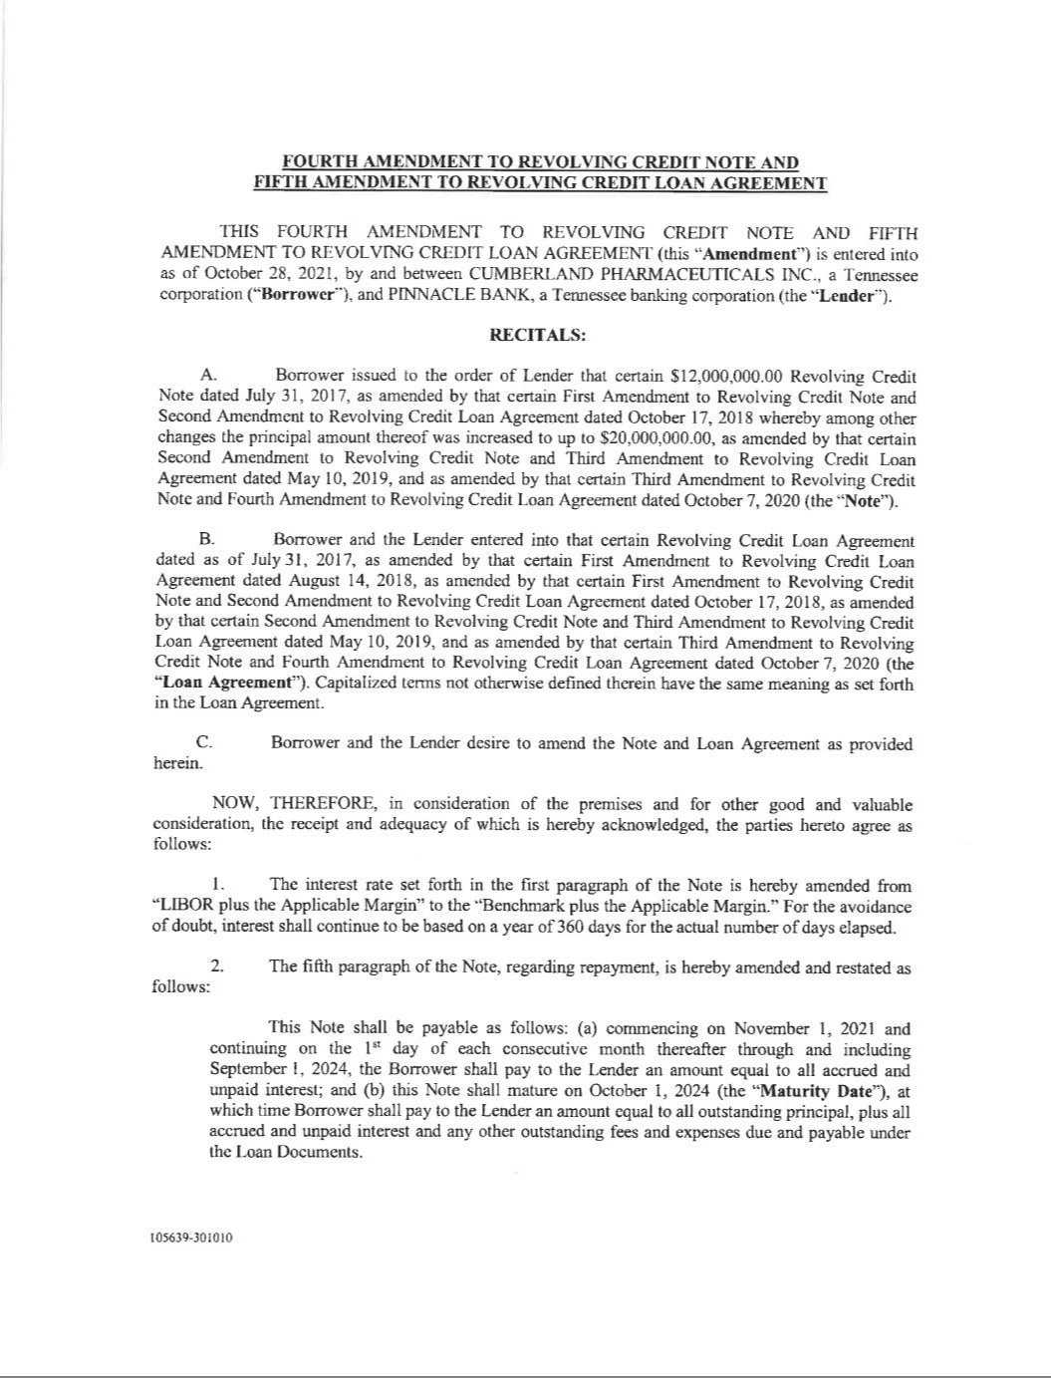

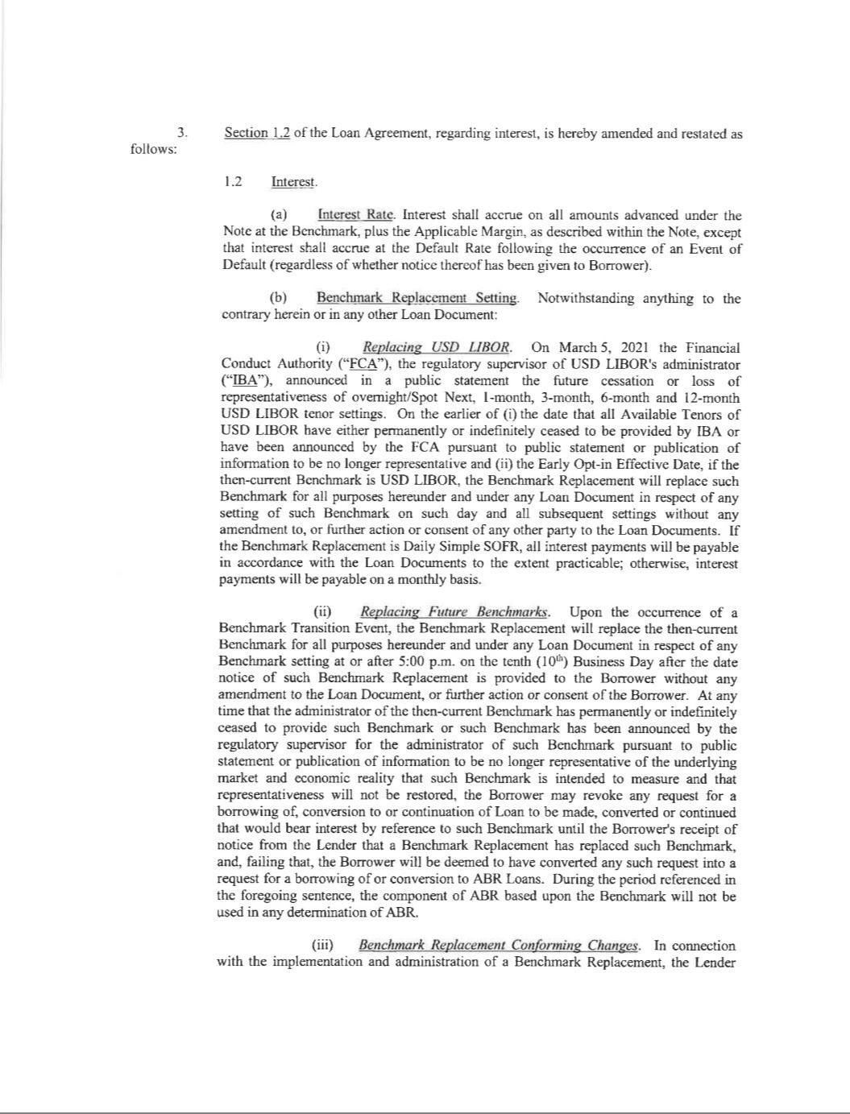

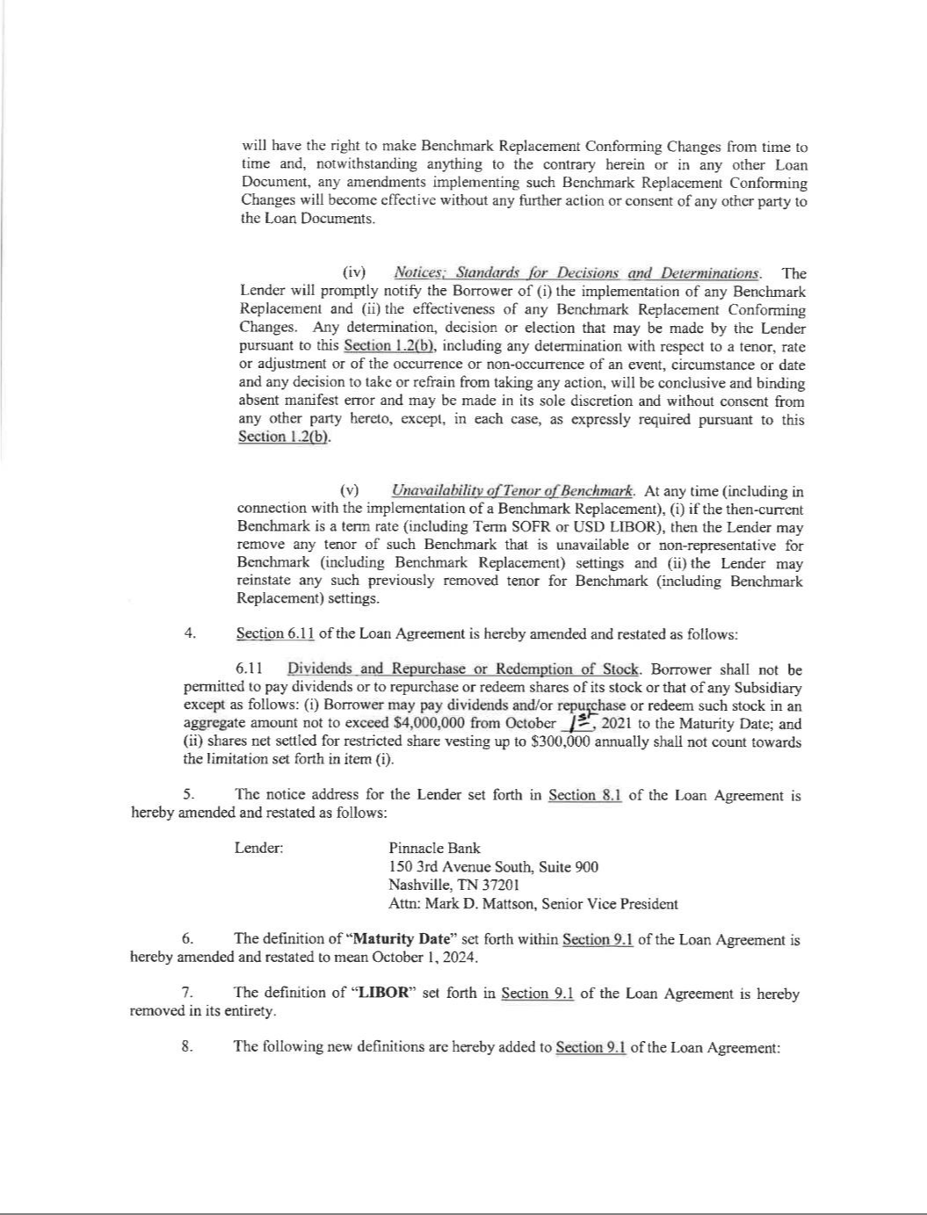

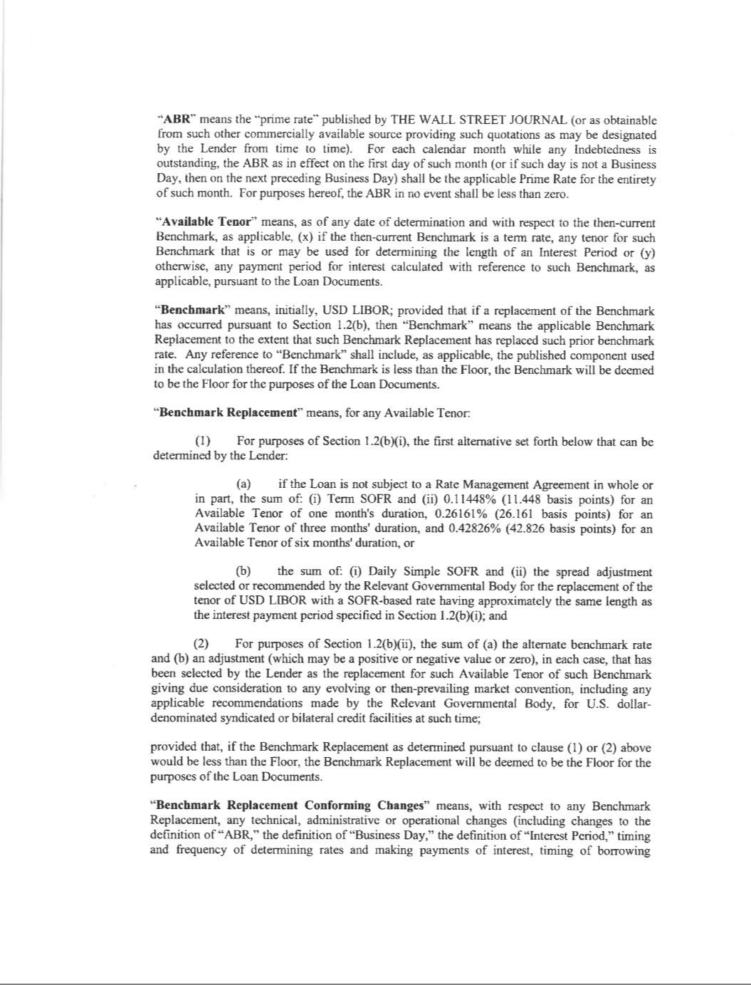

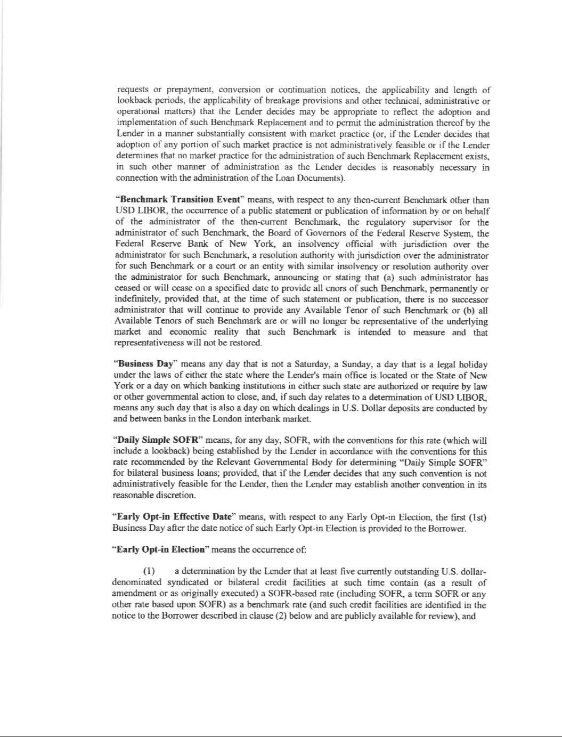

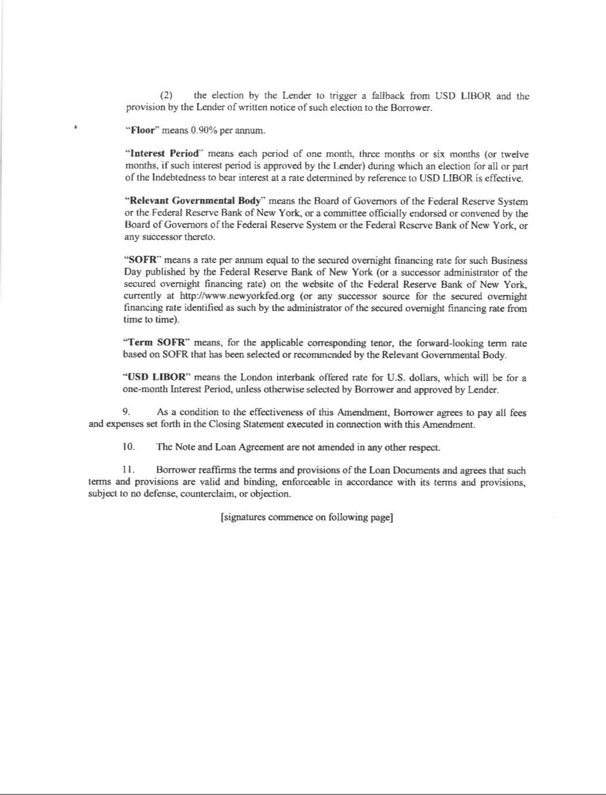

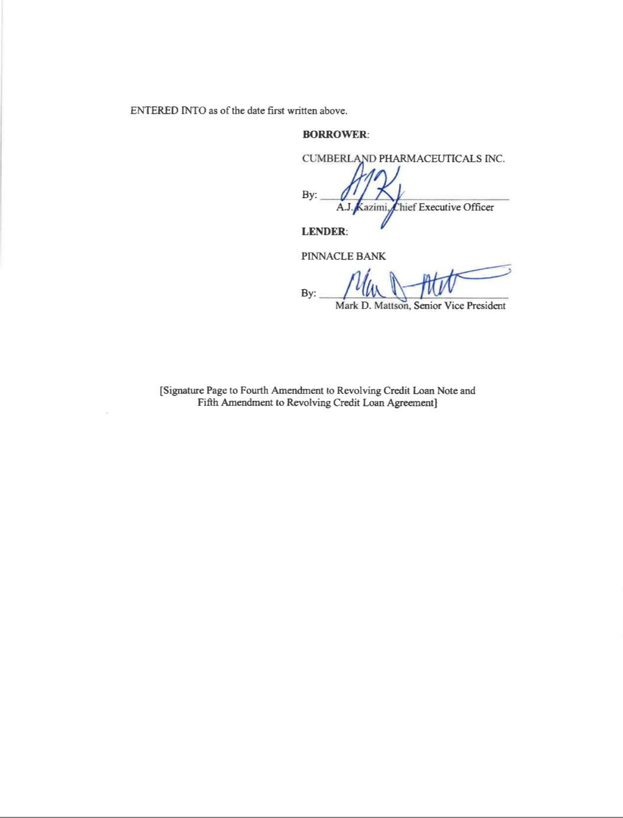

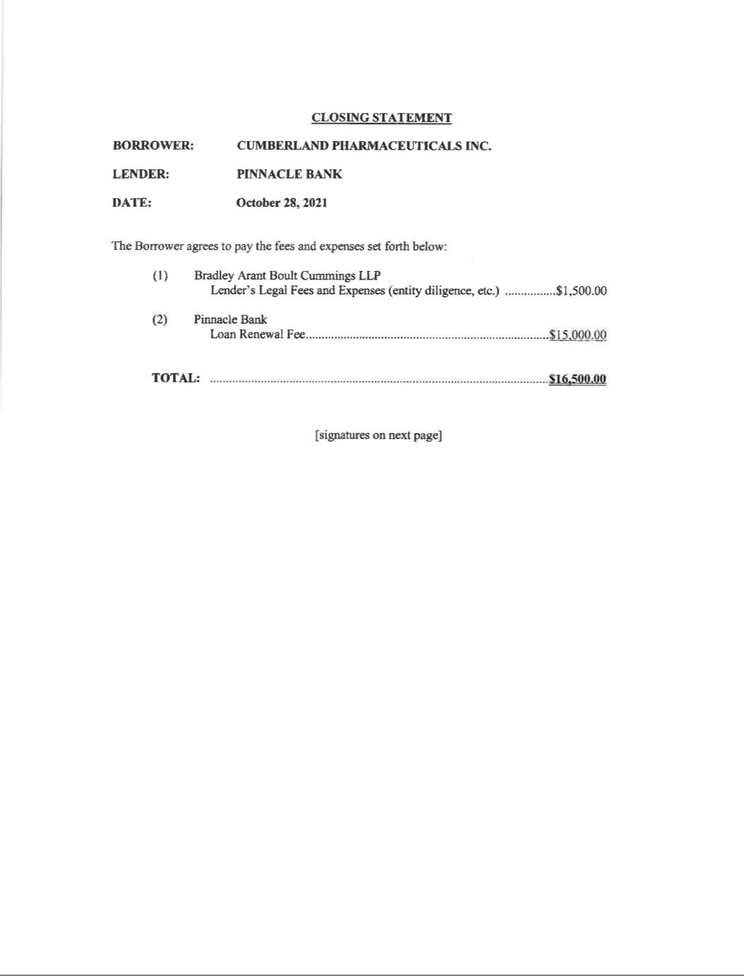

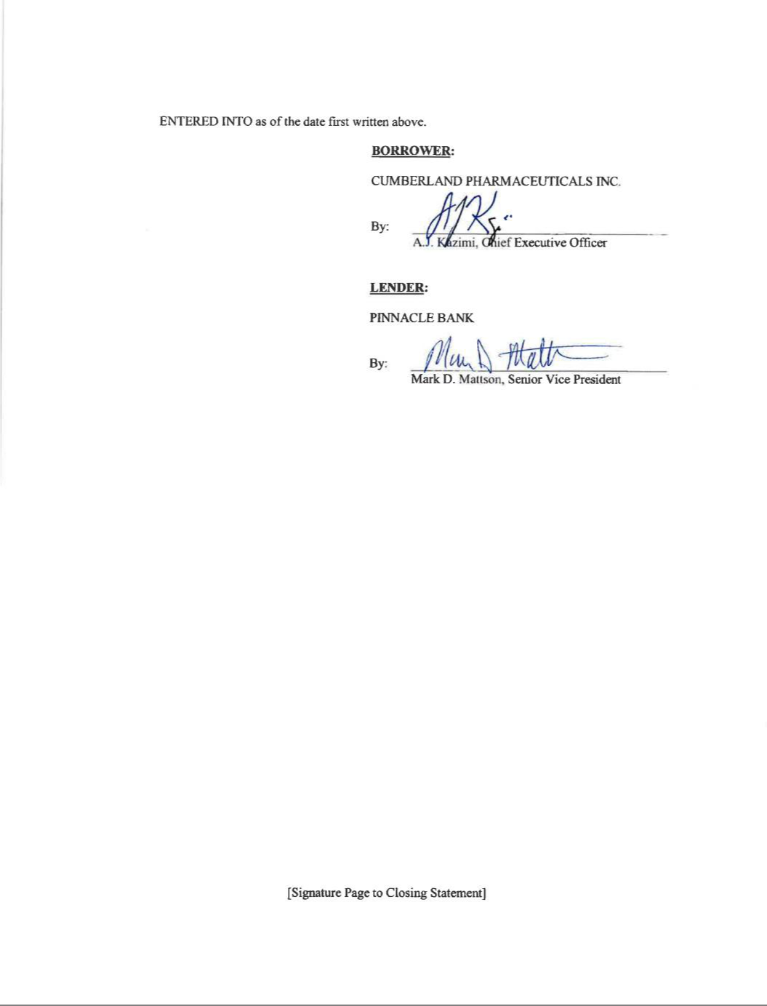

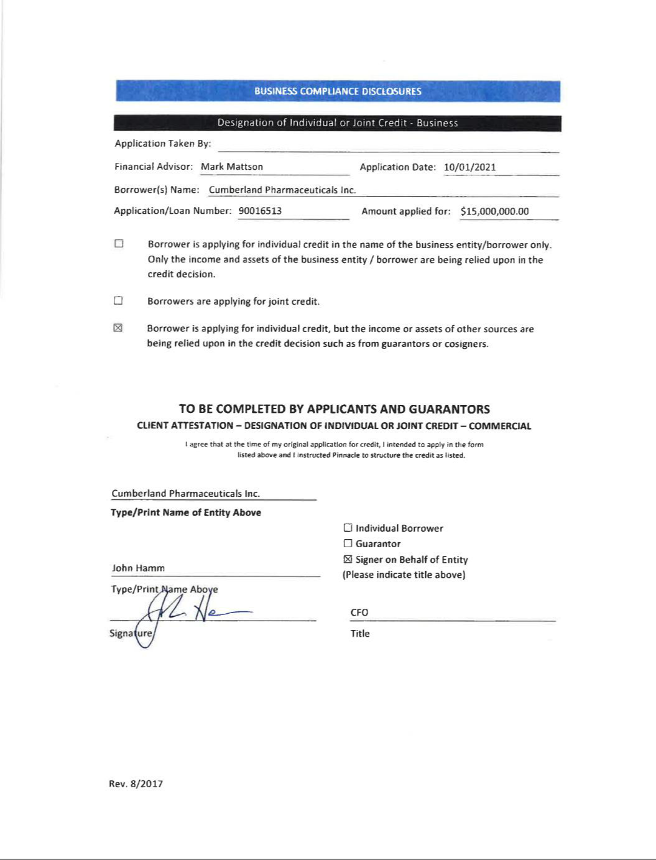

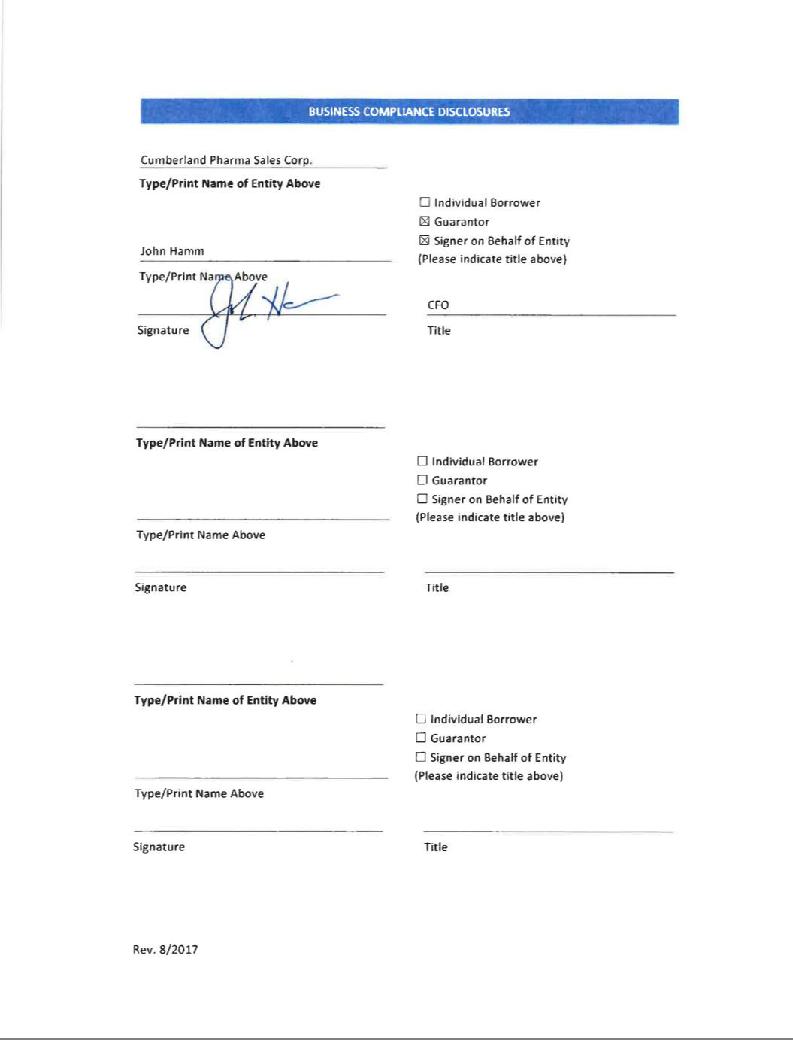

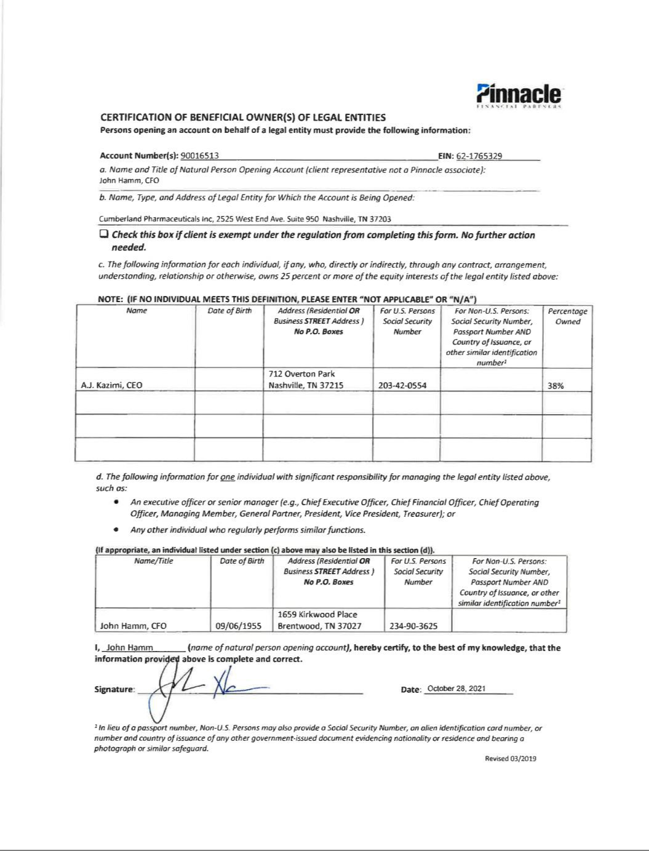

Exhibit 31.1

CERTIFICATION OF CHIEF EXECUTIVE OFFICER

PURSUANT TO SECTION 302 OF

THE SARBANES-OXLEY ACT OF 2002

I, A.J. Kazimi, certify that:

- I have reviewed this Form 10-Q of Cumberland Pharmaceuticals Inc.;

- Based on my knowledge, this report does not contain any untrue statement of a material fact or omit to state a material fact necessary to make the statements made, in light of the circumstances under which such statements were made, not misleading with respect to the period covered by this report;

- Based on my knowledge, the financial statements, and other financial information included in this report, fairly present in all material respects the financial condition, results of operations and cash flows of the registrant as of, and for, the periods presented in this report;

- The registrant’s other certifying officer and I are responsible for establishing and maintaining disclosure controls and procedures (as defined in Exchange Act Rules 13a-15(e) and 15d-15(e)) and internal control over financial reporting (as defined in Exchange Act Rules 13a-15(f) and 15d-15(f)) for the registrant and have:

  - Designed such disclosure controls and procedures, or caused such disclosure controls and procedures to be designed under our supervision, to ensure that material information relating to the registrant, including its consolidated subsidiaries, is made known to us by others within those entities, particularly during the period in which this report is being prepared;
  - Designed such internal control over financial reporting, or caused such internal control over financial reporting to be designed under our supervision, to provide reasonable assurance regarding the reliability of financial reporting and the preparation of financial statements for external purposes in accordance with generally accepted accounting principles;
  - Evaluated the effectiveness of the registrant’s disclosure controls and procedures and presented in this report our conclusions about the effectiveness of the disclosure controls and procedures, as of the end of the period covered by this report based on such evaluation; and
  - Disclosed in this report any change in the registrant’s internal control over financial reporting that occurred during the registrant’s most recent fiscal quarter (the registrant’s fourth fiscal quarter in the case of an annual report) that has materially affected, or is reasonably likely to materially affect, the registrant’s internal control over financial reporting; and

- The registrant’s other certifying officer and I have disclosed, based on our most recent evaluation of internal control over financial reporting, to the registrant’s auditors and the audit committee of the registrant’s board of directors (or persons performing the equivalent functions):

  - All significant deficiencies and material weaknesses in the design or operation of internal control over financial reporting which are reasonably likely to adversely affect the registrant’s ability to record, process, summarize and report financial information; and
  - Any fraud, whether or not material, that involves management or other employees who have a significant role in the registrant’s internal control over financial reporting.

November 12, 2021By: | /s/ A.J. Kazimi
 | A.J. | Kazimi
 | Chief Executive Officer

Exhibit 31.2

CERTIFICATION OF CHIEF FINANCIAL OFFICER

PURSUANT TO SECTION 302 OF

THE SARBANES-OXLEY ACT OF 2002

I, John Hamm, certify that:

- I have reviewed this Form 10-Q of Cumberland Pharmaceuticals Inc.;

- Based on my knowledge, this report does not contain any untrue statement of a material fact or omit to state a material fact necessary to make the statements made, in light of the circumstances under which such statements were made, not misleading with respect to the period covered by this report;

- Based on my knowledge, the financial statements, and other financial information included in this report, fairly present in all material respects the financial condition, results of operations and cash flows of the registrant as of, and for, the periods presented in this report;

- The registrant’s other certifying officer and I are responsible for establishing and maintaining disclosure controls and procedures (as defined in Exchange Act Rules 13a-15(e) and 15d-15(e)) and internal control over financial reporting (as defined in Exchange Act Rules 13a-15(f) and 15d-15(f)) for the registrant and have:

  - Designed such disclosure controls and procedures, or caused such disclosure controls and procedures to be designed under our supervision, to ensure that material information relating to the registrant, including its consolidated subsidiaries, is made known to us by others within those entities, particularly during the period in which this report is being prepared;
  - Designed such internal control over financial reporting, or caused such internal control over financial reporting to be designed under our supervision, to provide reasonable assurance regarding the reliability of financial reporting and the preparation of financial statements for external purposes in accordance with generally accepted accounting principles;
  - Evaluated the effectiveness of the registrant’s disclosure controls and procedures and presented in this report our conclusions about the effectiveness of the disclosure controls and procedures, as of the end of the period covered by this report based on such evaluation; and
  - Disclosed in this report any change in the registrant’s internal control over financial reporting that occurred during the registrant’s most recent fiscal quarter (the registrant’s fourth fiscal quarter in the case of an annual report) that has materially affected, or is reasonably likely to materially affect, the registrant’s internal control over financial reporting; and

- The registrant’s other certifying officer and I have disclosed, based on our most recent evaluation of internal control over financial reporting, to the registrant’s auditors and the audit committee of the registrant’s board of directors (or persons performing the equivalent functions):

  - All significant deficiencies and material weaknesses in the design or operation of internal control over financial reporting which are reasonably likely to adversely affect the registrant’s ability to record, process, summarize and report financial information; and
  - Any fraud, whether or not material, that involves management or other employees who have a significant role in the registrant’s internal control over financial reporting.

November 12, 2021By: | /s/ John Hamm
 | John | Hamm
 | Chief Financial Officer

Exhibit 32.1

CERTIFICATION OF CHIEF EXECUTIVE AND

CHIEF FINANCIAL OFFICER

PURSUANT TO 18 U.S.C. SECTION 1350,

AS ADOPTED PURSUANT TO SECTION 906

OF THE SARBANES-OXLEY ACT OF 2002

In connection with the Quarterly Report on Form 10-Q for the fiscal quarter ended September 30, 2021 of Cumberland Pharmaceuticals Inc. (the “Company”), as filed with the Securities and Exchange Commission on the date hereof (the “Report”), I, A.J. Kazimi, Chief Executive Officer and John Hamm, Chief Financial Officer of the Company, certify, pursuant to Section 906 of the Sarbanes-Oxley Act of 2002 (18 U.S.C. section 1350), that:

- The Report fully complies with the requirements of Section 13(a) or 15(d) of the Securities Exchange Act of 1934; and

- The information contained in the Report fairly presents, in all material respects, the financial condition and results of operations of the Company.

/s/ A. J. Kazimi

A.J. Kazimi

Chief Executive Officer

November 12, 2021

/s/ John Hamm

John Hamm

Chief Financial Officer

November 12, 2021

